|  |  |
| --- | --- |
| AVIATION STATE ENGAGEMENT FORUM | |
| WESTERN AUSTRALIA | Submission date: 25/11/2021 |

|  |  |
| --- | --- |
| TITLE | Proposal to establish “The Capes Broadcast Area” for the Southwest of Western Australia. |
| SUBMITTED BY | Daniel Smith, CASA OAR: [daniel.r.smith@casa.gov.au](mailto:daniel.r.smith@casa.gov.au) |
| CONSULTATION SUMMARY | To seek members’ feedback on the proposed “The Capes Broadcast Area” for SW Western Australia. |
| KEY ISSUES | * Confusion on when Multicom 126.7 should be used * Incorrect frequency usage arriving at unmarked ALA’s in the area * Aircraft remaining on the Busselton CTAF incorrectly * Reduction on frequency congestion for Bunbury and Busselton CTAF |
| FEEDBACK TO | Daniel Smith, CASA OAR: [daniel.r.smith@casa.gov.au](mailto:daniel.r.smith@casa.gov.au) |
| CLOSE DATE | Thursday, 16 December 2021 |
| ATTACHMENTS | Nil. |

**BACKGROUND**

During a visit to Busselton and Bunbury discussing CTAF changes, it was reported that a need for frequency alignment was required by introducing a Broadcast Area for the Southwest Capes of Western Australia.

Busselton and Bunbury share a common traffic advisory frequency (CTAF) frequency 127.00, there is however a reasonably significant level of local traffic away from the aerodromes between the southwest capes, including:

• Scenic and tourist flights;

• Flying training by Three flying schools;

• Private ALA movements in the area;

• Agricultural operations (crop spraying) from farm strips at certain times of the year;

• DFES spotter aircraft and water bombers during fire season.

There is a large amount of confusion on the requirements for frequency usage in the region. Pilots are using 126.7 for ALA’s that are not marked on maps. The recommendation in AIP is that area frequency be used as transiting pilots are not aware of local ALA’s. Establishing a broadcast area will reduce confusion and have all local traffic operating on the one frequency, increasing situational awareness.

**OVERVIEW**

Current:

Overall changes to the airspace surrounding Broome. The proposed area is as follows below.

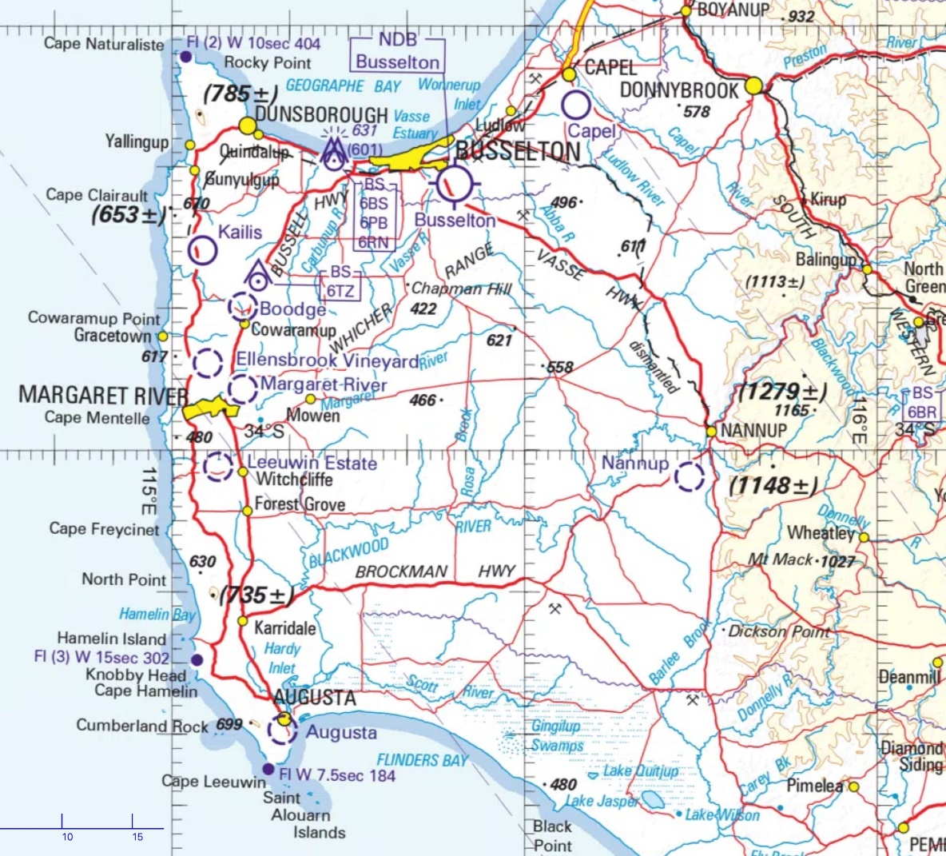

Figure 1: Proposed broadcast area WAC Chart Airservices 2020.

Suggested “Capes” Broadcast Area.

Surface to 10,000 feet above mean sea level.

Frequency: 132.25 MHz

Changes:

* Broadcast area to be established H24 in the area depicted above.
* Broadcast area to be from 10,000ft to SFC.
* 5NM buffer has been included for Busselton IFP.
* To increase situational awareness and have all pilots operating on a single frequency in the area.

**FEEDBACK**

Email: dan.r.smith@casa.gov.au

Phone: Daniel Smith 08 9366 2825

Mail: GPO Box 2005 Canberra ACT 2601