Overview
We are seeking feedback on a proposal to relocate the visual approach point (VAP) known as The Oaks (THK) and its accompanying visual flight rules (VFR) route to the west of Camden Airport.
The proposal addresses a risk of aircraft flying close to each other while on different frequencies around Camden Airport and The Oaks aerodrome.
Pilots will typically transit THK when approaching the Camden Airport control zone and contact Camden tower for clearance at 2,500 ft above mean sea level (AMSL) to overfly The Oaks aerodrome circuit. However, the Sydney VTC permits, without recommending, that aircraft could operate as low as 1,900 ft AMSL at THK which is The Oaks circuit altitude. Aircraft flying within The Oaks circuit use a different frequency than those aircraft approaching Camden tower, generating an airspace risk within the area.
A similar risk exists when pilots conduct a mid-field crosswind circuit entry from the west into The Oaks aerodrome. Aircraft could be approaching between 1,900 ft and 2,400 ft AMSL, creating potential conflict with aircraft inbound to Camden Airport via THK, particularly as they are likely to be operating on different frequencies.
The proposed change seeks to address this risk by redirecting aircraft approaching Camden Airport away from aircraft operating at The Oaks aerodrome. It is required to support the broader airspace changes in the Sydney Basin prior to the opening of Western Sydney International Airport.
The proposal
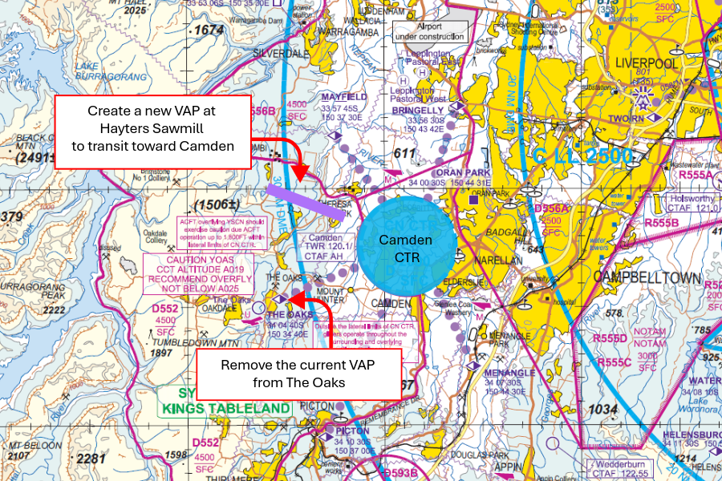
The image above shows the current position of The Oaks visual approach point on the Sydney visual terminal chart (VTC) and the proposed relocation over Hayters Sawmill (thick purple line).
Why your views matter
This consultation provides a platform for airspace users to provide feedback to increase safety and efficiency.
Completing the survey
Please submit your comments using the survey link at CASA's Consultation Hub (consultation.casa.gov.au).
If you would like to provide further feedback, please email OAR@casa.gov.au. Feedback submitted by email will be considered but cannot be published.
Further information about airspace regulation and the airspace change process is available on the CASA website.
What happens next
Once the consultation has closed, we will:
- review all comments received
- make responses publicly available on the consultation hub (unless you request that your submission remain confidential)
- publish a summary of the feedback received and outline next steps.
Information about how we consult and how to make a confidential submission is available on the CASA website. To be notified of any future consultations, you can subscribe to our consultation and rulemaking mailing list.

Personal information
- First name (Required)

- Last name (Required)

- What is your email address? (Required)

- Do your views officially represent those of an organisation? (Required)
☐ Yes, I am authorised to submit feedback on behalf of an organisation
☐ No, these are my personal views
If yes, please specify the name of your organisation:

- Which of the following best describes the group you represent? (Required)
Please select all that apply
☐ Air traffic controller
☐ Chief pilot
☐ Emergency services pilot
☐ Recreational/private pilot
☐ Student pilot
☐ Training organisation
☐ Other
If other, please specify:

Consent to publish submission
In order to promote debate and transparency, we intend to publish all responses to this consultation. This may include both detailed responses/submissions in full and aggregated data drawn from the responses received.
Where you consent to publication, we may include:
- your last name, if the submission is made by you as an individual
- your responses and comments
We will not include any other personal or demographic information in a published response.
Information about how we consult and how to make a confidential submission is available on the CASA website.
- Do you give permission for your response to be published? (Required)
☐ Yes - I give permission for my response/submission to be published.
☐ No - I would like my response/submission to remain confidential but understand that de-identified aggregate data may be published.
☐ I am a CASA officer.

Feedback
- How would the proposed changes to The Oaks (THK) visual approach point and associated VFR route impact your current arrival procedures into Camden Airport? (Required)
Consider workload, situational awareness, frequency management, and flight path changes

- What safety and operational considerations should be taken into account before implementing the proposed new VAP location and route? (Required)
Provide your comments

- Do you have any other feedback about the proposed new location for the visual approach point and VFR route (excluding points you have already raised)?
Provide your comments

