Overview
We are seeking feedback from the aviation industry on a preferred design for a proposed airspace change to the Sydney Control Zone (CTR). This would introduce a one-way (outbound only) visual flight rules (VFR) corridor to the southeast of Bankstown CTR.
We welcome feedback from operators in the Sydney area to better understand if there are any additional safety concerns that we should consider.
Airservices Australia will be seeking feedback on the proposed change from the local community, including businesses and residents.
Preferred design
In late 2024 we sought views on reclassifying a section of Sydney CTR airspace to introduce 2 one-way daytime-only VFR routes. The consultation raised safety concerns about the low-level nature of the corridor, the risk of mid-air collision and the likelihood of airspace incursions.
Based on feedback received from the initial proposal, we have worked with Airservices Australia to adjust the airspace design to address these safety concerns.
The preferred design proposes:
- reclassifying a section of Sydney airspace, located south of the Bankstown CTR, to Class D airspace from 1,000 ft to 1,500 ft above mean sea level (AMSL). This would be supported by a requirement to carry a transponder.
- the introduction of a one-way daytime-only VFR corridor within the proposed Class D airspace (the initial proposal included 2 one-way VFR routes in Class G airspace).
An additional volume of Class G would be established further south from surface to 1,500 ft AMSL.
If approved, this change would be enacted via an AIP SUP before charts are updated for the November AIRAC cycle. View the draft AIP SUP under Related documents below.
These changes are designed to enhance communication between aircraft and air traffic control, helping to maintain safety and efficiency within the corridor.
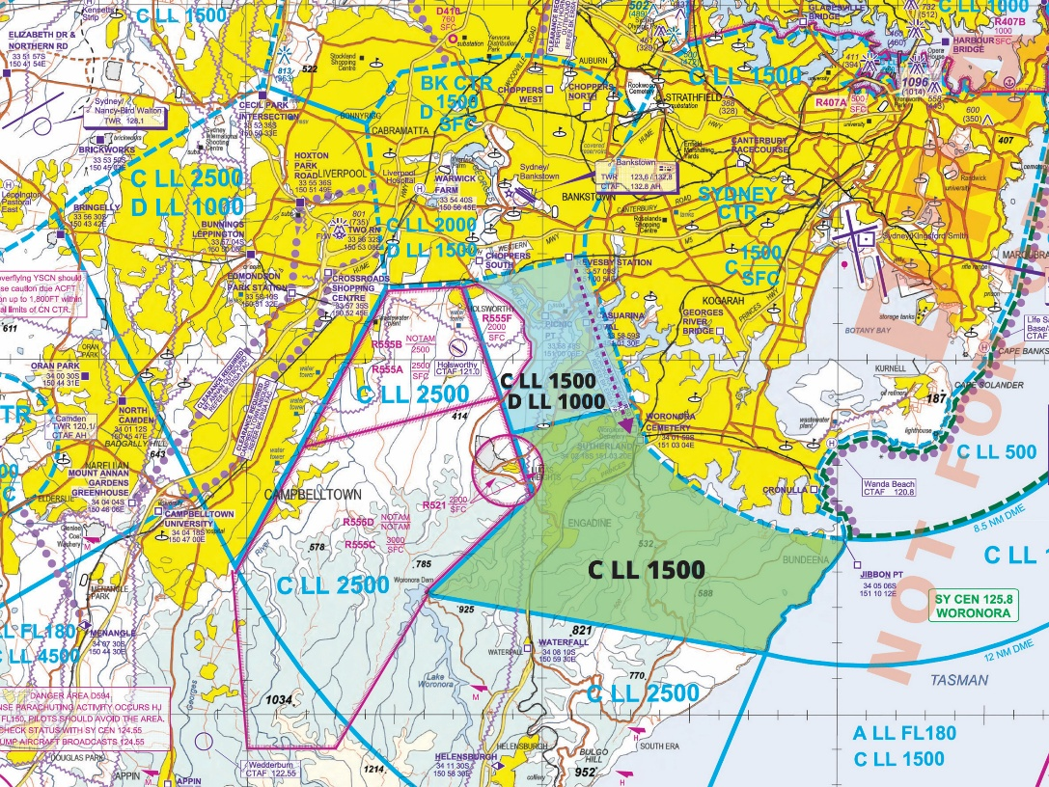
The chart above shows the proposed changes to Sydney airspace to create a Bankstown southeast VFR corridor. In the proposal, the blue area becomes Class D airspace with Class C above. The green area would be available as Class G airspace with Class C above. The proposed VFR outbound track through the corridor is shown in purple along the eastern boundary.
Background on the current airspace
The airspace surrounding Bankstown Airport is used by a range of aviation participants including flying schools, private business flights, charter, freight, recreational flights and emergency services activities.
The constrained nature of the Bankstown control zone coupled with sustained growth in air traffic in the Sydney region has created congestion in the airspace to the north and west of Bankstown Airport where the current VFR exit and entry routes are located. The introduction of Western Sydney International Airport also introduces further complexities to the Bankstown area.
The airspace to the south of Bankstown CTR is currently constrained by the Sydney CTR and therefore requires clearance to enter. As a result, the airspace is typically only used by operators such as emergency services, law enforcement agencies or those operating under Instrument Flight Rules (IFR).
How we assess and consider safety and risk
CASA regularly reviews airspace to assess whether it remains fit for purpose. That review process includes considering a range of airspace related risks associated with the location under consideration. More information about the airspace change process is available on the CASA website.
We work with Airservices Australia to ensure airspace designs meet Australian and international design standards. Airservices adheres to Flight Path Design Principles when designing, developing and implementing routes.
The preferred design for a one-way corridor in Class D airspace addresses the following risks raised in the 2024 consultation:
- the risk of head-to-head mid-air collision has been eliminated by making the corridor one-way
- the risk of nose-to-tail collision will be managed procedurally by Bankstown Tower regulating the flow of aircraft
- the risk of airspace incursions will be reduced through there being more lateral room in the corridor as well as the change of airspace classification ensuring that aircraft are known and communicating on the right frequency
- the one-way design and clear airspace classification simplifies the procedures for pilots.
We welcome industry feedback on whether this proposal helps to mitigate the identified risks and whether there are any additional safety concerns that we should consider.
Why your views matter
Why we are consulting
The feedback received will help us better understand if there are any additional safety concerns that we should consider.
What happens next
Once the consultation has closed, we will:
- review all comments received
- make responses publicly available on the consultation hub (unless you request that your submission remain confidential)
- publish a summary of the feedback received and outline next steps.
If you would like to provide further feedback, please email OAR@casa.gov.au. Feedback submitted by email will be considered but cannot be published.
Further information about airspace regulation and the airspace change process is available on the CASA website.
Information about how we consult and how to make a confidential submission is available on the CASA website. To be notified of any future consultations, you can subscribe to our consultation and rulemaking mailing list.

Personal information
- First name (Required)

- Last name (Required)

- What is your email address? (Required)

- Do your views officially represent those of an organisation? (Required)
☐ Yes, I am authorised to submit feedback on behalf of an organisation
☐ No, these are my personal views
If yes, please specify the name of your organisation:

Consent to publish submission
In order to promote debate and transparency, we intend to publish all responses to this consultation. This may include both detailed responses/submissions in full and aggregated data drawn from the responses received.
Where you consent to publication, we may include:
- your last name, if the submission is made by you as an individual
- the name of the organisation on whose behalf the submission has been made
- your responses and comments
We will not include any other personal or demographic information in a published response.
Information about how we consult and how to make a confidential submission is available on the CASA website.
- Do you give permission for your response to be published? (Required)
☐ Yes - I give permission for my response/submission to be published.
☐ No - I would like my response/submission to remain confidential but understand that de-identified aggregate data may be published.
☐ I am a CASA officer.

About you
- What best describes your primary role? (Required)
Please select all that apply
☐ Air transport pilot
☐ Chief pilot
☐ Commercial drone operator or organisation
☐ Commercial pilot
☐ Emergency services pilot
☐ Recreational drone or model aircraft operator/pilot
☐ Recreational/private pilot
☐ Student pilot
☐ Safety manager
☐ Other (please specify)

- Which sector are you primarily in? (Required)
Please select all that apply
☐ Aerial work
☐ Aerodrome services
☐ Air traffic controller
☐ Air transport operator – large (Part 121)
☐ Air transport operator – small (Part 135/charter)
☐ Business aviation
☐ Emergency services
☐ Flight training
☐ Government organisation
☐ Private flying
☐ Sport and recreation aviation
☐ Remotely piloted aircraft systems (drones)
☐ Other (please specify)

- Which flight rules do you operator under? (Required)
☐ IFR only
☐ VFR only
☐ Both IFR and VFR
☐ Not applicable

- Do you conduct operations under an Approved Self-Administering Aviation Organisation (ASAO)?
Please select all that apply
☐ No, I do not conduct operations under an ASAO
☐ Australian Parachute Federation
☐ Australian Sport Rotorcraft Association
☐ Australian Warbirds Association Limited
☐ Gliding Federation Australia
☐ Recreational Aviation Australia
☐ Sports Aviation Federation of Australia
☐ Other (please specify)

- What type of aircraft do you operate?
Please select all that apply
☐ Aeroplane
☐ Air ship
☐ Gyroplane
☐ Hang glider/ Paraglider (including powered variant)
☐ Helicopter
☐ Hot air balloon
☐ Powered-life aircraft
☐ Powered parachute
☐ Remotely piloted aircraft (RPAS or drone)
☐ Not applicable

Feedback
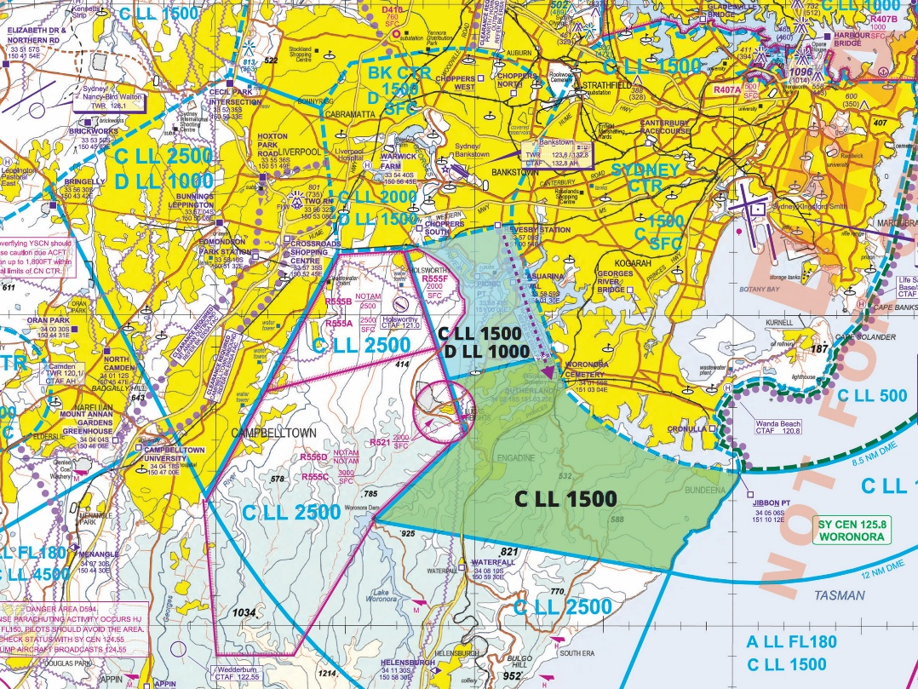
The chart above shows the proposed changes to Sydney airspace to create a Bankstown southeast VFR corridor. In the proposal, the blue area becomes Class D airspace with Class C above. The green area would be available as Class G airspace with Class C above. The proposed VFR outbound track through the corridor is shown in purple along the eastern boundary.
- Do you have any safety concerns with the proposed one-way VFR corridor in Class D airspace? (Required)
☐ Yes
☐ No
If yes, please specify

- Does the proposed design and procedures as outlined in the draft AIP SUP (available to read at consultation.casa.gov.au) generate any operational concerns or impediments? (Required)
☐ Yes
☐ No
If yes, please specify

