Ballina controlled airspace – preferred design

Overview

CASA is seeking feedback on the preferred airspace design for the introduction of controlled airspace around Ballina.

We are asking for feedback from Ballina area airspace users including local flying schools, aero clubs, operators, and industry bodies. Your feedback will help us finalise the design to support the Airspace Change Proposal (ACP).

**The preferred design**

Earlier this year [we sought feedback](https://consultation.casa.gov.au/stakeholder-engagement-group/ballina-airspace-design/) from the aviation industry on the preliminary design while Airservices Australia [consulted the local community](https://engage.airservicesaustralia.com/ballina-controlled-airspace). Through our consultation we received many suggestions intended to enhance safety, operational efficiency and equitable access in the area.

Based on the feedback received, we have adjusted the airspace design. The key changes reflected in the updated design are:

* modifications to portions of the lower limit of the controlled airspace to reduce the impact on a number of affected stakeholders
* introduce Standard Instrument Departure (SIDs) into Lismore to accommodate the departure procedure particularly during Instrument Meteorological Conditions (IMC)
* adjustments to some of the arrival and departure procedures into Ballina based upon operators’ and stakeholder feedback.

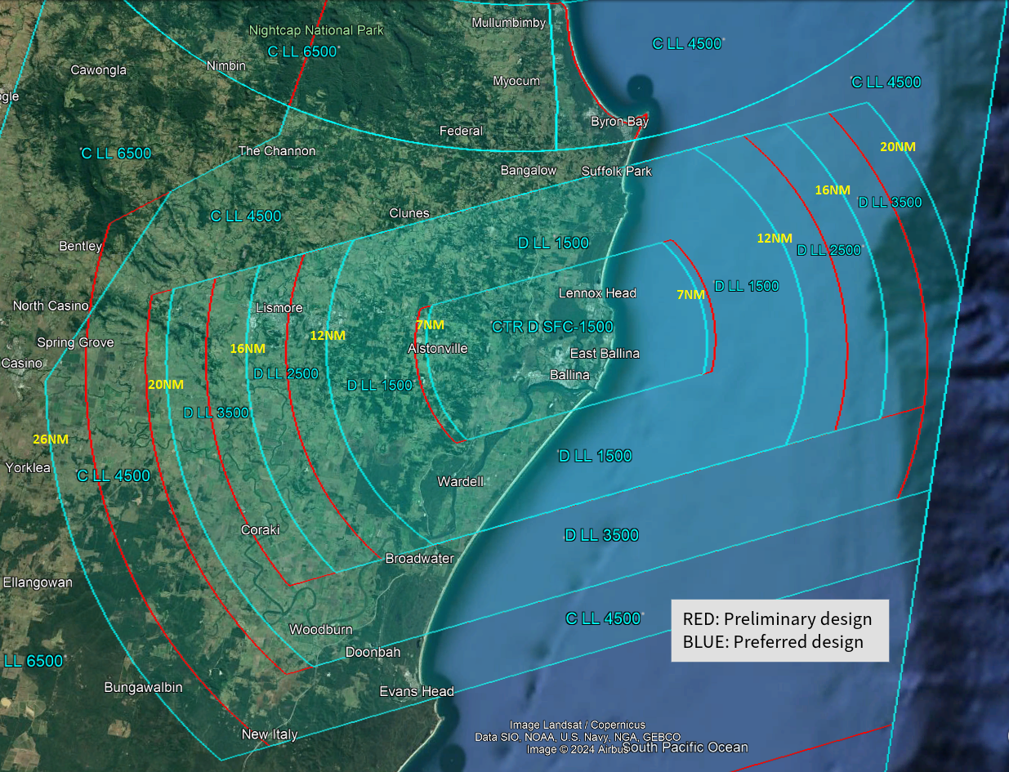

*The above image compares the preliminary design with the updated preferred design. The preferred design is highlighted in blue with the preliminary design marked in red.*

The airspace architecture has been designed to contain a series of instrument flight procedures as well as standard arrival and departure paths. A key principle of the preferred design is to retain the current airspace usage patterns where possible.

Airservices Australia has released the preferred flightpath designs for consultation. Visit [Engage Airservices](https://engage.airservicesaustralia.com/ballina-controlled-airspace) to see the flightpaths and interactive map for additional detail.

**Background**

Airspace around Ballina Airport will be controlled by air traffic controllers in 2025 as CASA and Airservices Australia move to develop services to accommodate the airport’s growth.

This follows an [airspace review of the Ballina region in 2022](https://consultation.casa.gov.au/stakeholder-engagement-group/ballina-airspace-review/). This review included feedback from industry and subsequent discussions with Airservices Australia on timing for the establishment of controlled airspace and air traffic services.

Why your views matter

**Why we are consulting**

The feedback received will help us to finalise the Airspace Change Proposal for the Ballina region with Airservices Australia.

**What happens next**

Once the consultation has closed, we will:

* review all comments received
* make responses publicly available on the consultation hub (unless you request your submission remain confidential)
* provide an update through the Consultation Hub on any intended changes and next steps.

If you would like to provide further feedback, please email [OAR@casa.gov.au](mailto:OAR@casa.gov.au). Feedback submitted by email will be considered but cannot be published publicly.

Further information about [airspace regulation](https://www.casa.gov.au/operations-safety-and-travel/airspace/airspace-regulation) and the [airspace change process](https://www.casa.gov.au/operations-safety-and-travel/airspace/airspace-regulation/airspace-change-process) is available on the CASA website.

Information about how we consult and how to make a confidential submission is available on the [CASA website](https://www.casa.gov.au/rules/changing-rules/how-casa-changes-rules). To be notified of any future consultations, you can subscribe to our [consultation and rulemaking mailing list](https://updates.communication.casa.gov.au/link/id/zzzz5e8be6d10ee5b225/page.html?prompt=1).

**Personal information**

1. First name (Required)

2. Last name (Required)

3. Email address (Required)

4. Do your views officially represent those of an organisation?

(Required)

* Yes, I am authorised to submit feedback on behalf of an organisation
* No, these are my personal views

If yes, please specify the name of your organisation

**Consent to publish submission**

In order to promote debate and transparency, we intend to publish all responses to this consultation. This may include both detailed responses/submissions in full and aggregated data drawn from the responses received.

Where you consent to publication, we may include:

* **your last name**, if the submission is made by you as an individual
* **your responses and comments**

We **will not** include any other personal or demographic information in a published response.

Information about how we consult and how to make a confidential submission is available on the [**CASA website**.](https://www.casa.gov.au/rules/changing-rules/consultation-industry-and-public)

5. Do you give permission for your response to be published? (Required)

* Yes - I give permission for my response/submission to be published.
* No - I would like my response/submission to remain confidential but understand that de-identified aggregate data may be published.
* I am a CASA officer.

**About you**

6. What best describes your primary role? Select all that apply

* Air transport pilot
* Air traffic controller
* Chief pilot
* Commercial pilot
* Recreational pilot/private pilot
* Remotely piloted aircraft systems pilot
* Student pilot
* Safety manager
* Other

If other, please specify:

7. Which sector are you primarily in? Select all that apply

* Aerial work
* Aerodrome services
* Air traffic controller
* Air transport operator – large (Part 121)
* Air transport operator – small (Part 135/charter)
* Business aviation
* Consultant and other professional services/unions
* Flight training
* Government organisation
* Private flying
* Sport and recreation aviation
* Remotely piloted aircraft systems
* Other

If other, please specify:

8. What flight rules do you operate under? (Required)

* IFR only
* VFR only
* Both IFR and VFR
* Not applicable

9. Do you conduct operations under an Approved Self-Administering Aviation Organisation (ASAO)? Select all that apply (Required)

* No, I do not conduct operations under an ASAO
* Australian Parachute Federation
* Australian Sport Rotorcraft Association
* Australian Warbirds Association Limited
* Gliding Federation of Australia
* Recreational Aviation Australia
* Sports Aviation Federation of Australia
* Other

If other, please specify:

10. What type of aircraft do you operate? Select all that apply (Required)

* Aeroplane
* Air ship
* Gyroplane
* Hang glider/ paraglider (including powered variant)
* Helicopter
* Hot air balloon
* Powered-lift aircraft
* Powered parachute
* Remotely piloted aircraft (RPAS or drone)
* Not applicable

**Feedback**

11. The preferred design has been modified following stakeholder feedback. Do you have any comments regarding the preferred design? Please do not include points that you have already raised.

12. The proposed design aims to safely accommodate air traffic in the region. Are you satisfied the design does this? (Required)

* Yes
* No

If no, please specify why: