Ballina airspace design – introduction of controlled airspace

Overview
To support the introduction of controlled airspace around Ballina, CASA is seeking feedback on the proposed preliminary airspace design. The design aims to safely accommodate continued growth of air traffic in the region.
We are asking for feedback from Ballina area airspace users including local flying schools, aero clubs, operators, and industry bodies. Your feedback will help us refine the design to support the Airspace Change Proposal (ACP).
Airservices Australia is leading consultation with the community via their Engage Airservices website.
The proposed design
The proposed airspace design aims to balance the variety of operations in the Ballina area to maximise access while enhancing safety.
The airspace architecture proposes a series of controlled airspace steps commencing with a Control Zone in the immediate vicinity of the airport (7 nm along the extended centreline of either runway end and 3.5 nm laterally) with vertical limits of the controlled zone extending from the surface (SFC) to 1,500 ft above mean sea level (AMSL).
A series of control area steps are then proposed to commence from 1,500 ft to 8,500 ft AMSL. The steps extend approximately 20 nm to the east, 32 nm to the west, and out to 45 nm to the southwest to capture the main direction of arrivals in approach airspace.
Proposed changes also include:
- aligning the northern lateral boundary with the existing controlled airspace in the vicinity of the Gold Coast approximately 10 nm from Ballina
- categorising the airspace between the SFC and 4,500 ft AMSL as Class D
- categorising the airspace from 4,500 ft to 8,500 ft AMSL to be Class C to align with the adjacent current Class C steps.
Proposed airspace concept:
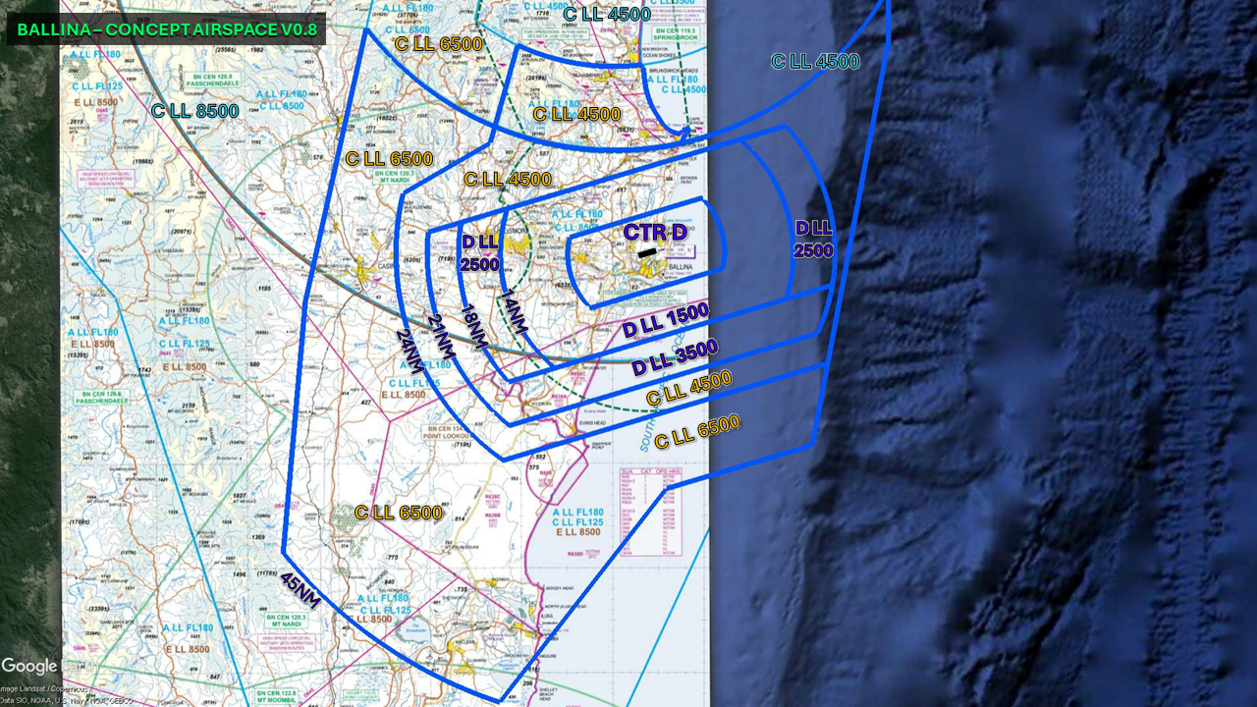

The airspace architecture has been designed to contain a series of instrument flight procedures as well as standard arrival and departure paths. A key principle of the proposed design is to retain the current airspace usage patterns where possible.
The maps provided below show the the proposed flightpaths for both runways when the Evans Head restricted airspace is activated.
Airservices Australia have developed an interactive map which provides additional detail.

Flightpaths - Runway 06 - Restricted airspace off:

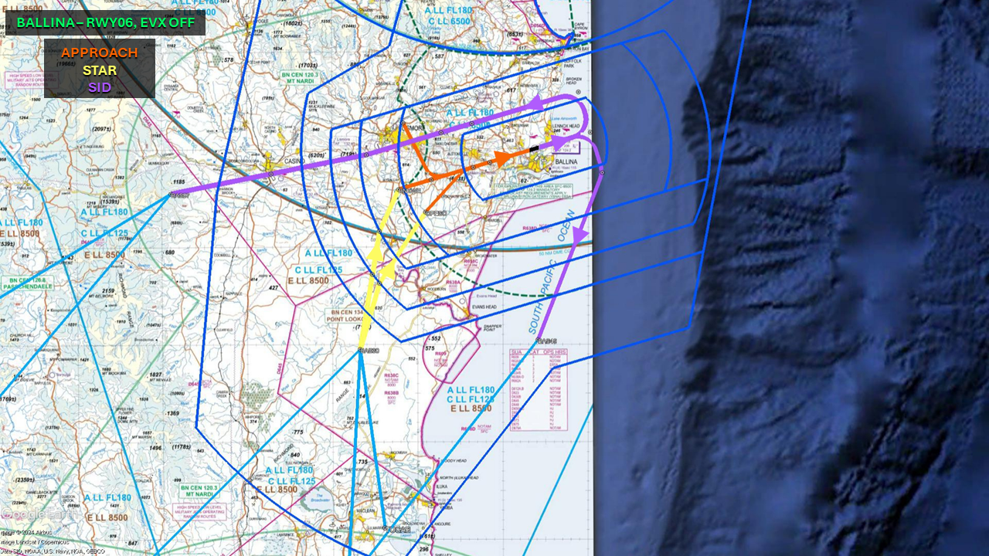
Flightpaths - Runway 06 - Restricted airspace on:

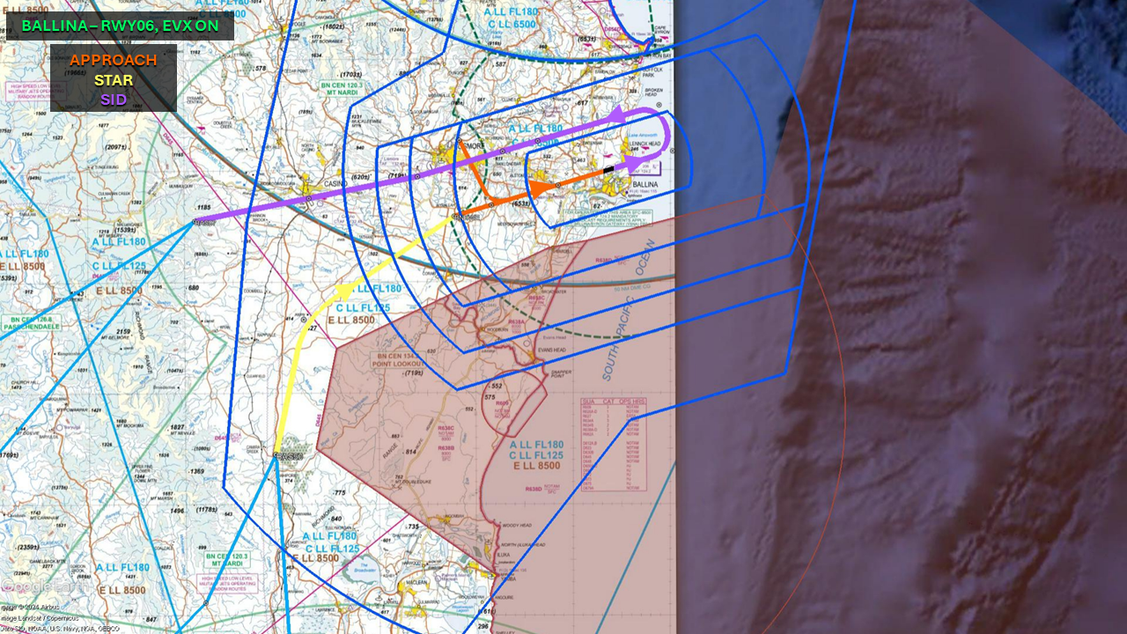

Flightpaths - Runway 24- Restricted airspace off:

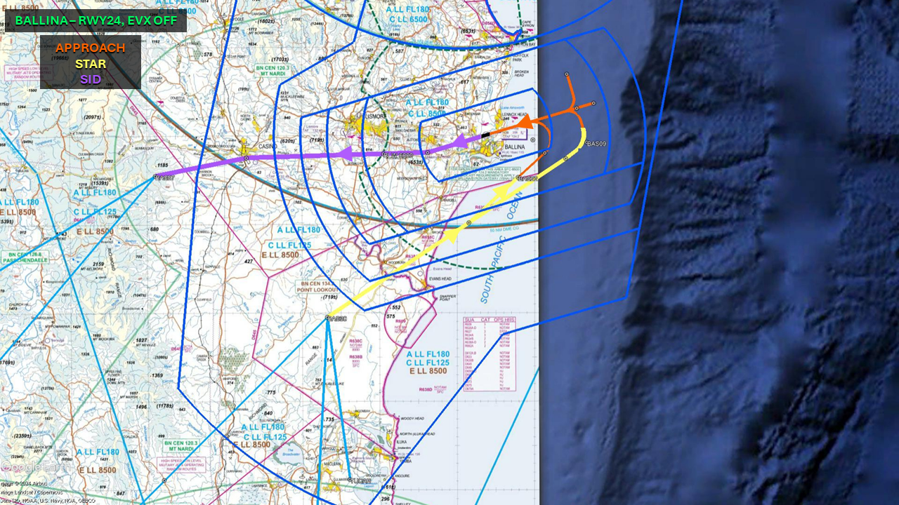
Flightpaths - Runway 24- Restricted airspace on:

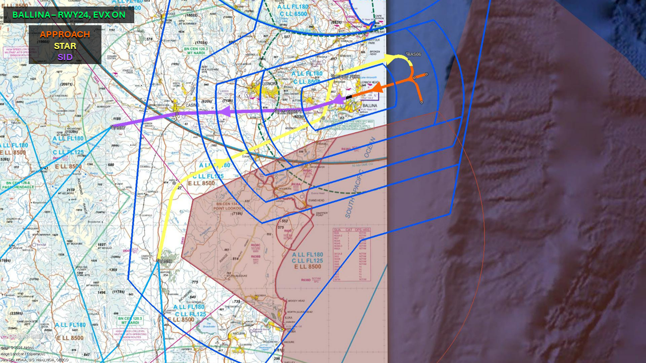
Background
Airspace around Ballina Airport will be controlled by air traffic controllers in 2025 as CASA and Airservices Australia move to develop services to accommodate the airport’s growth.
This follows an airspace review of the Ballina region in 2022. This review included feedback from industry and subsequent discussions with Airservices Australia on timing for the establishment of controlled airspace and air traffic services.

Why your views matter
Why we are consulting
The feedback received will help inform the final design in preparation for the Airspace Change Proposal for the Ballina region with Airservices Australia.
What happens next
Once the consultation has closed, we will:
- review all comments received
- make responses publicly available on the consultation hub (unless you request your submission remain confidential)
- provide an update through the Consultation Hub on any intended changes and next steps.
If you would like to provide further feedback, please email OAR@casa.gov.au. Feedback submitted by email will be considered but cannot be published publicly.
Further information about airspace regulation and the airspace change process is available on the CASA website.
Information about how we consult and how to make a confidential submission is available on the CASA website. To be notified of any future consultations, you can subscribe to our consultation and rulemaking mailing list.

Personal information
1. First name (Required)
2. Last name (Required)
3. Email address (Required)
4. Do your views officially represent those of an organisation?
(Required)
- Yes, I am authorised to submit feedback on behalf of an organisation
- No, these are my personal views
If yes, please specify the name of your organisation
Consent to publish submission
In order to promote debate and transparency, we intend to publish all responses to this consultation. This may include both detailed responses/submissions in full and aggregated data drawn from the responses received.
Where you consent to publication, we may include:
- your last name, if the submission is made by you as an individual
- your responses and comments
We will not include any other personal or demographic information in a published response.
Information about how we consult and how to make a confidential submission is available on the CASA website.
5. Do you give permission for your response to be published? (Required)
- Yes - I give permission for my response/submission to be published.
- No - I would like my response/submission to remain confidential but understand that de-identified aggregate data may be published. I am a CASA officer.
About you
6. What best describes your primary role? Select all that apply
- Air transport pilot
- Chief pilot
- Commercial pilot
- Recreational pilot/private pilot
- Remotely piloted aircraft systems pilot
- Student pilot
- Safety manager
- Other
If other, please specify
7. Which sector are you primarily in? Select all that apply
- Aerial work
- Aerodrome services
- Air traffic controller
- Air transport operator – large (Part 121)
- Air transport operator – small (Part 135/charter)
- Business aviation
- Flight training
- Private flying
- Sport and recreation aviation
- Remotely piloted aircraft systems
- Government organisation
- Consultant and other professional services/unions
- Other
If other, please specify

8. What flight rules do you operate under? (Required)
- IFR only
- VFR only
- Both IFR and VFR
- Not applicable
9. Do you conduct operations under an Approved Self-Administering Aviation Organisation (ASAO)? Select all that apply (Required)
- No, I do not conduct operations under an ASAO
- Australian Parachute Federation
- Australian Sport Rotorcraft Association
- Australian Warbirds Association Limited
- Gliding Federation Australia
- Recreational Aviation Australia
- Sports Aviation Federation of Australia
- Other
If other, please specify
10. What type of aircraft do you operate? Select all that apply (Required)
- Helicopter
- Aeroplane
- Air ship
- Gyroplane
- Hang glider/ paraglider (including powered variant)
- Hot air balloon
- Powered-lift aircraft
- Remotely piloted aircraft (RPAS or drone)
- Not applicable

Feedback
11. The proposed design aims to safely accommodate air traffic in the region. Are you satisfied the design does this? (Required)
- Yes
- No
If no, please specify why:
12. Do you have any concerns with the placement of the airspace steps? (Required)
- Yes
- No
If yes, please specify:
13. Does the proposed design generate operational impediments? (Required)
- Yes
- No
If yes, please specify:
14. Are there any modifications to the airspace design that you would like to be considered within the final design? (Required)
- Yes
- No
If yes, please specify:
15. Do you have any final comments regarding the design? Please do not include points that you have already raised.

