Ballina airspace concept – Class C and Class D proposal

Overview
To support the introduction of controlled airspace around Ballina, CASA is seeking feedback on a proposal to use Class C instead of Class D airspace between 4500 feet and 8500 feet. The feedback will help finalise a draft airspace design prior to further consultation with industry and the community soon.
Background
Airspace around Ballina Airport will be controlled by air traffic controllers from 2025 as CASA and Airservices Australia move to develop services to accommodate the airport’s growth.
This follows an airspace review of the Ballina region in 2022. This review included extensive feedback from industry and subsequent discussions with Airservices Australia on timing for the establishment of controlled airspace and air traffic services.
Airspace concept
In developing the final airspace design of the Ballina region, Airservices Australia has provided CASA with an alternative airspace concept for consideration. It includes:
- extending the existing Class C airspace lower level in the vicinity of Ballina from 8500 ft to 4500 ft
- establishing Class D airspace below the Class C lower level from 4500 ft to the surface.
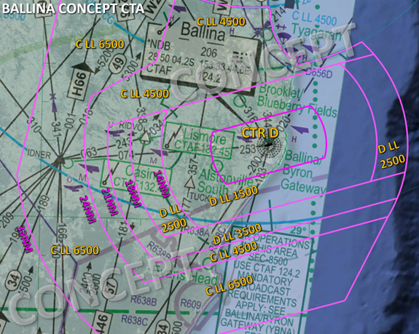
Figure 1: Airspace Concept C/D ERC overlay
In developing the airspace concept the following has been considered:
- the airspace risk to be managed
- the way the airspace is used
- pilot and controller workload
- frequency congestion
- aircraft equipment
- standardised airspace
- containment of Instrument Flight Procedures (IFP)
- published Flight Path Design Principles.
Why is extending Class C part of the airspace concept?
We have been engaging with industry about the introduction of controlled airspace around Ballina in collaboration with Airservices Australia. This included early discussion about the potential for a Class D CTR and surrounding control area CTA from the surface to 8500 ft.
After further consideration, the airspace concept has been refined and Airservices has asked CASA to consider an alternative airspace classification.
Airservices has proposed Class C airspace between 4500 ft and 8500 ft.
We want your feedback on the airspace concept of Class C and Class D airspace around Ballina.
The most notable differences between Class C and Class D are the provision of an IFR and VFR separation service, that all aircraft are required to be fitted with surveillance equipment, and radio calls by VFR are not shortened.
The proposed airspace concept potentially provides:
- Improved safety for IFR and VFR aircraft
Extending Class C airspace down to 4500 ft in the vicinity of Ballina will provide improved safety and service provision for IFR and VFR aircraft through the provision of separation and traffic information services supported by electronic surveillance.
- Alignment with existing Class C airspace steps
The proposed Class C airspace above 4500 ft will align/abut with the existing Class C airspace steps above the Gold Coast (see Figure 1 above or download at the bottom of this page). Establishing a base of Class C airspace which is standardised with adjoining CTA steps and ATC sectors reduces complexity as well as the likelihood of error regarding adjoining CTA boundaries and the level of service being provided or expected.
- Support for equitable access
Terrain clearance, particularly those VFR operators preferring to remain outside/underneath controlled airspace (OCTA) to the west of Ballina and Gold Coast CTA steps, has also been considered. The concept is intended to support equitable access such as OCTA transit as well as flights in and out of YLIS (Lismore) for example.
- Reduced frequency congestion
There will be comparatively fewer clearances required to enter, leave and/or re-enter CTA as a result of the extension and alignment with existing CTA between Ballina and Gold Coast.
Our understanding of the potential impact on airspace users
Airservices has provided CASA an analysis of traffic through the proposed Class C airspace volumes. The analysis indicates a very high rate of transponder carriage by VFR traffic through the airspace.
VHF radio carriage is obliged in both Class D and Class C airspace. VHF radio use by aircraft operating under the VFR in the airspace changes with the use of Class C airspace.
The difference in the Visual Meteorological Conditions (VMC) criteria in Class C versus Class D is not expected to have a significant impact on operations in the airspace.
The existing high rate of transponder carriage indicates that the economic and cost impact on airspace users by deciding to use Class C instead of Class D in between 4500 ft and 8500 ft will be low.
The proposed changes are expected to provide a positive impact to the region by improving the level of safety for operations in the airspace.
CASA has not identified any environmental impacts resulting from the architectural changes to airspace design.

Why your views matter
Why we are consulting
The feedback received will help us to finalise the draft airspace design of the Ballina region with Airservices Australia.
What happens next
Once the consultation has closed, we will:
- review all comments received
- make responses publicly available on the consultation hub (unless you request your submission remain confidential)
- provide an update through the Consultation Hub on any intended changes and next steps.
If you would like to provide further feedback, please email OAR@casa.gov.au. Feedback submitted by email will be considered but cannot be published publicly.
The full airspace design of the Ballina region will be published for feedback in the coming months.
Further information about airspace regulation and the airspace change process is available on the CASA website.
Information about how we consult and how to make a confidential submission is available on the CASA website. To be notified of any future consultations, you can subscribe to our consultation and rulemaking mailing list.
Personal information
1. First name (Required)
2. Last name (Required)
3. Email address (Required)
4. Do your views officially represent those of an organisation?
(Required)
- Yes, I am authorised to submit feedback on behalf of an organisation
- No, these are my personal views
If yes, please specify the name of your organisation

Consent to publish submission
In order to promote debate and transparency, we intend to publish all responses to this consultation. This may include both detailed responses/submissions in full and aggregated data drawn from the responses received.
Where you consent to publication, we may include:
- your last name, if the submission is made by you as an individual
- your responses and comments
We will not include any other personal or demographic information in a published response.
Information about how we consult and how to make a confidential submission is available on the CASA website.
5. Do you give permission for your response to be published? (Required)
- Yes - I give permission for my response/submission to be published.
- No - I would like my response/submission to remain confidential but understand that de-identified aggregate data may be published. I am a CASA officer.
About you
6. What best describes your primary role? Select all that apply
- Air transport pilot
- Chief pilot
- Commercial pilot
- Recreational pilot/private pilot
- Remotely piloted aircraft systems pilot
- Student pilot
- Safety manager
- Other
If other, please specify
7. Which sector are you primarily in? Select all that apply
- Aerial work
- Aerodrome services
- Air traffic controller
- Air transport operator – large (Part 121)
- Air transport operator – small (Part 135/charter)
- Business aviation
- Flight training
- Private flying
- Sport aviation
- Remotely piloted aircraft systems
- Government organisation
- Consultant and other professional services/unions
- Other
If other, please specify
8. What flight rules do you operate under? (Required)
- IFR only
- VFR only
- Both IFR and VFR
- Not applicable
9. Do you conduct operations with a sport aviation body? Select all that apply (Required)
- No, I do not conduct operations with a sport aviation body
- Australian Balloon Federation
- Australian Parachute Federation
- Australian Skydiving Association
- Australian Sport Rotorcraft Association
- Australian Warbirds Association Limited
- Gliding Federation
- Australia Recreational Aviation
- Australia Sports Aviation Federation of Australia
- Other
If other, please specify
10. What type of aircraft do you operate? Select all that apply (Required)
- Helicopter
- Aeroplane
- Gyroplane
- Hot air balloon
- Air ship
- Powered-lift aircraft
- Not applicable
Feedback
11. Do you have any feedback or concerns regarding the concept for Class C and Class D airspace around Ballina?(Required)
- Yes (please provide feedback below).
- No, I am satisfied with the concept.

