Consultation - Proposed new remotely piloted aircraft (RPA) registration and RPA operator accreditation scheme (PP 1816US)
Overview
In 2019, CASA proposes to introduce a remotely piloted aircraft (RPA) registration and RPA operator accreditation requirement, as a way of monitoring the safe and lawful operation of RPAs. The registration and accreditation requirements are proposed to apply (with certain exceptions) to the following RPA:
- RPA more than 250 grams operated recreationally and
- all RPA operated commercially, including excluded RPA operations, regardless of weight.
The RPA registration and accreditation requirements are not proposed to apply to the following:
- RPA 250 grams or less operated recreationally or
- Model aircraft at CASA-approved model airfields or
- RPA operated recreationally indoors.
This consultation seeks your comments on the detail of the proposed scheme.
The aim of the proposed new rules is to increase safety through increased compliance with the requirements:
- ensuring everyone who flies a drone over 250 grams knows the rules
- helping CASA to target the right safety information to the users who need it most
- making it easier for authorities to identify when someone is breaking the rules.
Accreditation will be free. You will have to do an online education course – basically, watch a video and answer a quiz on the drone rules that apply to you. However, if you already hold a drone licence you will not have to do this course.
The cost of registration has yet to be determined by CASA. The cost will depend on whether you fly your drone for fun or profit. It is likely to be a $20 or less annual fee (per person) for recreational drones and for some model aircraft operators. There will also be an annual registration fee likely to range from $100 to $160 per drone, for each commercial drone.
Why we are consulting
As part of the development of aviation rules, CASA consults with the community to ensure the rules will work in practice as they are intended.
We have a responsibility under section 9 of the Civil Aviation Act 1988 for the safety regulation of civil air operations, including drones, in Australian territory.
The Government supported the introduction of a mandatory accreditation and registration system for drones last year. This was in response to the recommendation from a Senate Standing Committee on Rural and Regional Affairs and Transport inquiry.
How to complete this consultation
The consultation will ask you questions in relation to the detail of the registration and accreditation scheme. Each question will include key points and further reading from the relevant sections of the following two documents:
- Policy Proposal – Proposed new remotely piloted aircraft (RPA) registration and RPAS operator accreditation scheme
- Annex A - Policy statement - Proposed new remotely piloted aircraft (RPA) registration and RPAS operator accreditation scheme.
These documents include content about how the scheme will work in practice. They are attached below under ‘Related’. Please note, throughout these documents CASA uses the term remotely piloted aircraft (RPA) to refer to a drone.
Recent industry feedback
CASA has previously consulted with the community on drone registration and accreditation.
In November 2018, a group of drone industry experts met to consider drone registration and accreditation. This technical working group, made up of industry representatives, was established by the Aviation Safety Advisory Panel (ASAP) to direct our engagement with industry and to seek input on regulatory and associated policy approaches. The group strongly supported the introduction of a scheme. However, there were some concerns expressed about the impact on some model aircraft owners and operators.
In August/September 2017, CASA published a drone discussion paper. The majority of respondents also supported some form of registration, training and proficiency when the weight of the drone was taken into account.
What happens next
CASA will register and review each submission received through this online response form. We will make all submissions publicly available here on the Consultation Hub unless you have requested that your submission remain confidential. We will also publish a summary of consultation which will summarise all the feedback we received.
Once we have considered public feedback, CASA will be working to an overarching commencement date of 1 July 2019. To minimise risks associated with the supporting information technology systems, a staged implementation is planned whereby registration and accreditation are progressively introduced:
• 1 July 2019 – RPA operator certificate (ReOC) holders and RePL holders who own their own drone (registration only)
• 1 September 2019 – Excluded RPA operators (Sub 2k and flying over your own land) (accreditation and registration)
• November 2019 – Recreational drone operators (accreditation and registration)

Page: Table of contents
In 2019, CASA plans to introduce a scheme to ensure all drones weighing more than 250 grams are registered and the people flying them are accredited. Any drones 250 grams and under that are flown commercially will also need to be registered.
The first 2 sections of the consultation are about the consultation and ask you for some information about yourself.
The next 3 sections of the consultation relate to the proposed scheme.
When you have completed the consultation, click the ‘Finish’ button at the bottom right of this page.
The following Fact Bank provides a snapshot of the steps you will need to take under the scheme depending on who you are and what you fly your drone for. Please note, CASA uses RPA (remotely piloted aircraft) to refer to drones.
FACT BANK – What you will have to do
Fact Bank Content
Policy Proposal - Proposed new remotely piloted aircraft (RPA) registration and RPAS operator accreditation

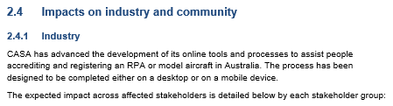
To enlarge Table 1: Requirements for RPA registration and accreditation, please click on the link below.
RPAS Policy Proposal Table

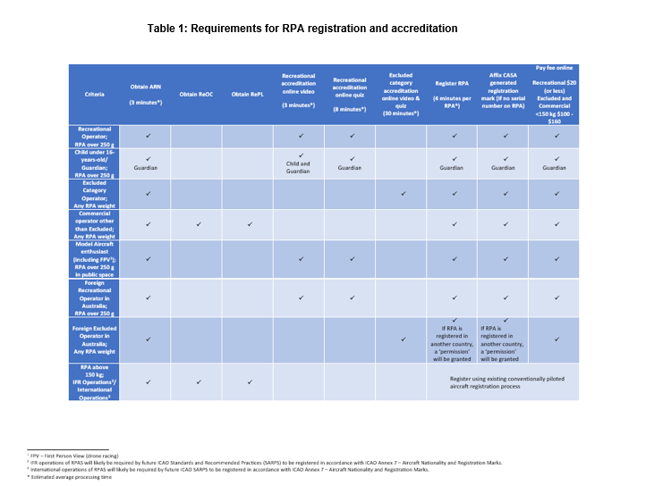
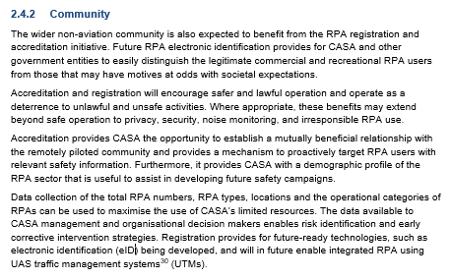

Page | Topic | Questions
1 | Personal information | 10 questions
2 | Consent to Publish your submission | 1 question
3 | Registration | 4 Questions
4 | Accreditation | 2 Questions
5 | Registration and accreditation – considerations | 2 Questions

Page 1: Personal information

First name?
(Required)

Last name?
(Required)

Email address?
If you enter your email address, you will automatically receive an acknowledgement email when you submit your response.
Email

Do your views officially represent those of an organisation?
(Required)
Please select only one item
☐ Yes
☐ No
If yes, please specify the name of the organisation.

Who are you?
Please select one of the options below – if more than one category applies choose the highest level of qualification.
(Required)
Please select only one item
☐ Recreational drone owner and/or pilot
☐ Model aircraft owner and/or pilot
☐ Excluded drone operator
☐ RePL holder (but not a ReOC holder)
☐ ReOC holder
☐ I am not currently a drone owner or flyer but plan to own one in the future
☐ I am not a drone owner or flyer
☐ Other (Please specify below)
Please specify 'Other' if selected
Do you own or fly a drone weighing more than 250 grams?
(Required)
Please select only one item
☐ Yes
☐ No
☐ I don’t own or fly a drone
☐ Don’t know

How did you hear about this consultation?
This information is not mandatory but will help CASA to provide more targeted safety information in the future.
☐ CASA email
☐ CASA Facebook
☐ CASA Twitter
☐ CASA Linkedin)
☐ Facebook (not CASA)
☐ Twitter (not CASA)
☐ Linkedin (not CASA)
☐ Drone forum
☐ Drone organisation
☐ Media eg newspaper, radio, television
☐ Other

What is your age group?
This information is not mandatory but will help CASA to provide more targeted safety information in the future.
☐ 16 and under
☐ 17-25
☐ 26-35
☐ 36-45
☐ 46-55
☐ 56-65
☐ 56-65
☐ 66 +

What is your gender?
This information is not mandatory but will help CASA to provide more targeted safety information in the future.
☐ male
☐ female
☐ other

Where do you live?
Please enter your Post Code below

Page 2: Consent to publish your submission
In order to promote debate and transparency, we intend to publish all responses to this consultation. This may include both detailed responses/submissions in full and aggregated data drawn from the responses received.
Where you consent to publication, we will include:
- your name, if the submission is made by you as an individual or the name of the organisation on whose behalf the submission has been made
- your responses and comments
We will not include any other personal or demographic information in a published response, including the gender, age or postcode of the respondent.
We will not publish responses of any person who discloses their age as under 16.

Do you give permission for your response to be published?
(Required)
Please select only one item
☐ Yes - I give permission for my response/submission to be published.
☐ No - I would like my response/submission to remain confidential but understand that de-identified aggregate data may be published.
☐ I am a CASA officer.
Information about how we consult and how to make a confidential submission is available on the CASA website <https://www.casa.gov.au/rules-and-regulations/landing-page/consultation-process>

Page 3: Registration
Question 1
Policy aim: CASA plans to introduce a national scheme to register all drones weighing more than 250 grams to monitor the safe and lawful operation of drones. Any drones 250 grams and under that are flown commercially will also need to be registered.
Registration will be mandatory whether the drone is flown for fun or profit. However, there are some exemptions. See Question 2
Key Points
CASA has chosen drones weighing over 250 grams because:
- The drone is large enough to create a potential hazard to manned aircraft.
- It is a common weight in international standards (USA, UK, China, Germany, Brazil).
- It makes it relatively easy for drone owners to work out if they need to register. (The European system measures potential energy so takes into account mass and speed, but this is harder for an owner to understand and comply with).
FACT BANK - Further information – Choosing what to register
Fact bank content
Policy Proposal - Proposed new remotely piloted aircraft (RPA) registration and RPAS operator accreditation
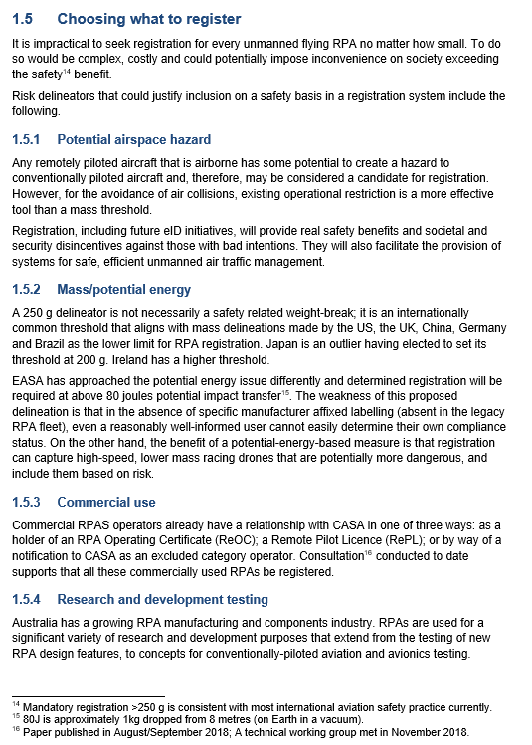
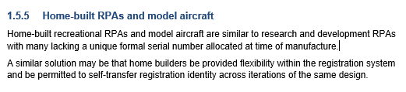

Do you agree that all drones over 250 grams should be registered? (noting that there are some exemptions – see Question 2)
☐ Yes
☐ Yes, with changes. (Please specify below)
☐ No, requires changes (Please specify below)
☐ Don’t know
If you have selected – Yes, with changes or No, with changes – please enter your comments here.

Question 2
Policy aim: CASA has exempted some drones from registration, because to register every drone would be complex, costly and potentially impose inconvenience on society, exceeding any safety benefit.
Key points
The exemptions are:
- Flying indoors which is no risk to manned aircraft
- Model aircraft being flown only at CASA-approved model airfields which are under the supervision of peers and therefore pose few safety risks to unmanned aircraft and people.
- Drones greater than 150 kilograms because they already require registration through another aviation rule.
FACT BANK – Further information – What RPAs would NOT have to be registered?
Fact bank content
Policy Proposal - Proposed new remotely piloted aircraft (RPA) registration and RPAS operator accreditation
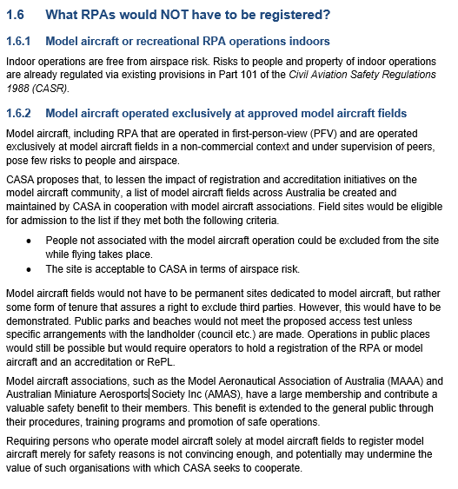
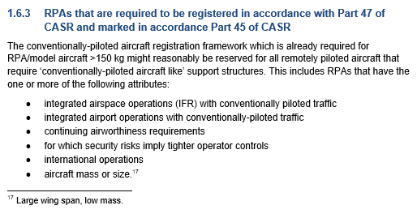
Annex A - Policy statement – Proposed new remotely piloted aircraft (RPA) registration and RPAS operator accreditation
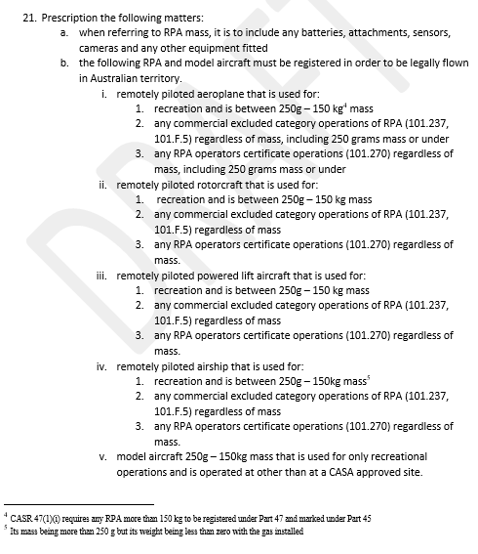
Does the proposed scheme ensure the right drone operations are exempted from registration?
☐ Yes
☐ Yes, with changes. (Please specify below)
☐ No, requires changes (Please specify below)
☐ Don’t know
If you have selected – Yes, with changes or No, with changes – please enter your comments here.

Question 3
Policy aim: A fee will be charged to register drones under the new registration scheme.
Key points
- The recreational and model aircraft registration fee has been set to encourage participation.
- The proposed annual cost of registration will be:
  - Recreational and model aircraft
    - Less than $20 per person per year
  - Excluded and remotely piloted aircraft operator certificate (ReOC) per drone
    - Between $100 to $160 per drone per year
- Most of CASA’s funding comes from a fuel excise, in other words, the conventionally piloted aviation industry. The registration fee is an attempt to, over time recoup some funding for drone safety management from people who own and operate drones.
FACT BANK – Further information– Benefits and costs of a RPA registration system
Fact bank content
Policy Proposal - Proposed new remotely piloted aircraft (RPA) registration and RPAS operator accreditation
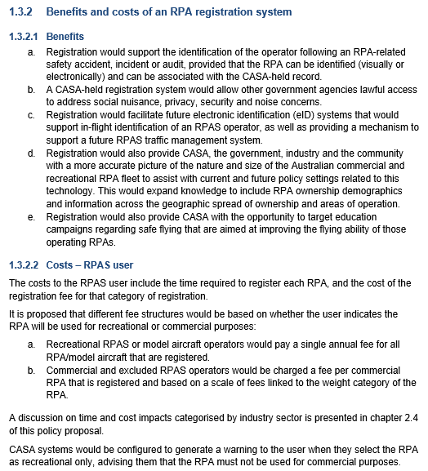

FACT BANK – Further information – Cost recovery considerations registration
Fact bank content
Policy Proposal - Proposed new remotely piloted aircraft (RPA) registration and RPAS operator accreditation
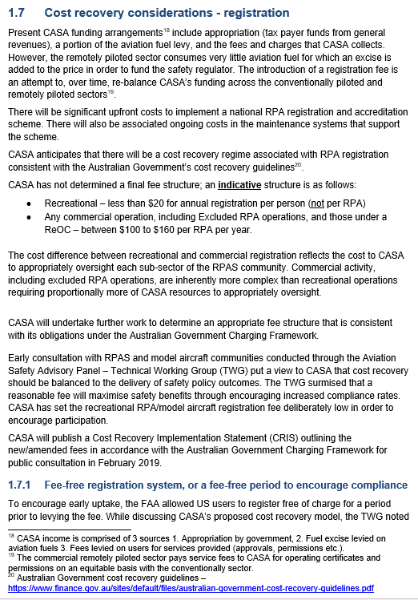
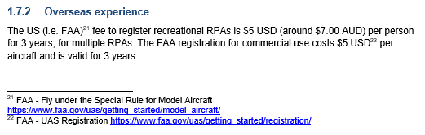
Has the right balance been reached with the registration fees?
☐ Yes
☐ Yes, with changes. (Please specify below)
☐ No, requires changes (Please specify below)
☐ Don’t know
If you have selected – Yes, with changes or No, with changes – please enter your comments here.

Question 4
Policy aim: Drone registration is for one year, with annual fees due thereafter.
Key points
- CASA intends to let you know well in advance that your registration is going to expire so you will have time to renew.
- You will have to make sure that your contact details are up to date.
- If you’re not planning to fly your drone, you do not have to register it.
FACT BANK - Further information – Expiry of registration
Fact bank content
Annex A - Policy statement - Proposed new remotely piloted aircraft (RPA) registration and RPAS operator accreditation
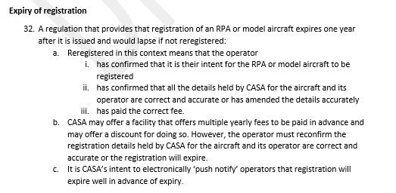

Should registration be required annually?
☐ Yes
☐ Yes, with changes. (Please specify below)
☐ No, requires changes (Please specify below)
☐ Don’t know
If you have selected – Yes, with changes or No, with changes – please enter your comments here.

Page 4: Accreditation
Question 1
Policy aim: CASA plans to introduce a scheme to ensure anyone 16 years if age and older flying a drone weighing more than 250 grams has the knowledge to safely and lawfully operate a drone.
Key Points
- In practice this means anyone 16 years and over flying a drone weighing more than 250 grams:
  - for fun, i.e. for recreation only
  - under the excluded category i.e. commercial under 2 kg or over your own land
- Under the proposed scheme, if you hold a remote pilot’s licence (RePL) you are already accredited you do not need to complete more training.
- Accreditation will take the form of an online education course i.e. watching a video and answering a quiz.
- Two different accreditations will be available:
  - Simple online course for recreational operators
  - A slightly more detailed course for the excluded category than it will be for recreational operators.
- Accreditation will be free.
- The benefits of accreditation are:
  - flyers will be more likely to know the rules
  - likelihood of a decrease in accidents/incidents
  - increase CASA’s understanding of the drone community through better demographic information
  - better targeting of CASA’s safety messages to flyers who need it
  - better targeting of CASA’s surveillance and auditing activities.
FACT BANK: Further information – Accreditation – background
Fact bank content
Policy Proposal - Proposed new remotely piloted aircraft (RPA) registration and RPAS operator accreditation

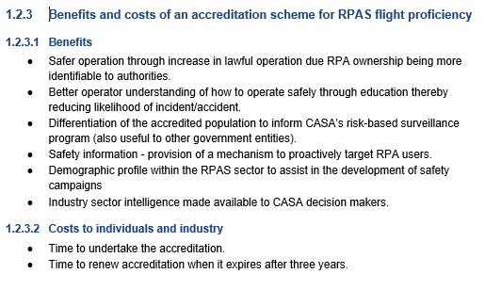

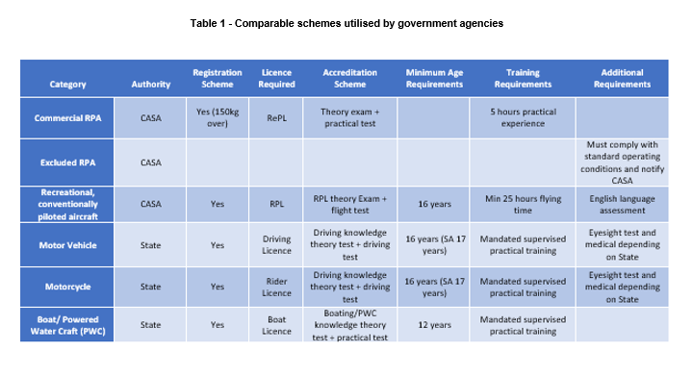
Is the accreditation scheme aimed at the right drone flyers?

☐ Yes
☐ Yes, with changes. (Please specify below)
☐ No, requires changes (Please specify below)
☐ Don’t know
If you have selected – Yes, with changes or No, with changes– please enter your comments here.

Question 2
Policy aim: Accreditation will expire after three years.
Key points
- If you are still flying, you will be required to undertake the course again.
- CASA plans to tell you well in advance when your accreditation is about to expire so you will have time to renew.
- Manned pilots undergo a flight review every two years to satisfy CASA that they remain competent to fly, so it is reasonable to ensure that drone pilots should do the same.
- However, we want to ensure that the process is not too onerous or time consuming, so it’s only an online course (no practical) and we set the expiry of accreditation at three years.
- Drone technology and uptake are evolving quickly and that may mean that the rules will change over time, re-accreditation ensures you remain up to date.
FACT BANK Further information – Accreditation to expire after 3 years
Fact bank content
Annex A – Policy statement - Proposed new remotely piloted aircraft (RPA) registration and RPAS operator accreditation
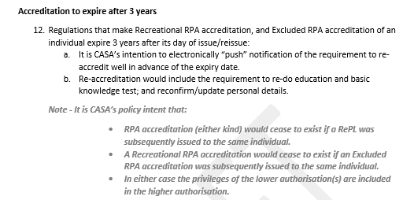

Is three years an appropriate time to need to repeat your accreditation?
☐ Yes
☐ No – but 5 years is ok
☐ No – but 2 years is ok
☐ No – but 1 year is ok
☐ No – accreditation should never expire

comments

PAGE 5: Registration and accreditation – considerations
Question 1
Policy aim: You cannot register a drone unless you are 16 years of age or older. If you fly a drone weighing more than 250 grams and you are under 16 years of age you need to be supervised. The supervisor must be 18 years of age or older and accredited.
Key Points
In setting the age limits for drone activities, CASA considered other activities:
- The law considers most Australians are considered mature enough to drive a car at 16 years of age. However, to gain a full licence and drive without limitations on your licence, you need to be older.
- At the age of 18, you are considered responsible enough to do things like vote, apply for a home loan and marry.
- There is no agreed age for registering or flying a drone internationally.
FACT BANK - Further information – International comparisons
Fact bank content
Policy Proposal - Proposed new remotely piloted aircraft (RPA) registration and RPAS operator accreditation
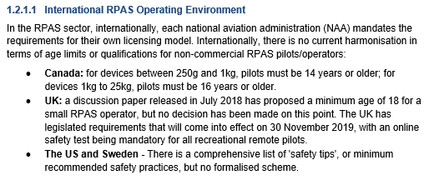
FACT BANK – Age to register
Fact bank Content
Annex A - Policy statement - Proposed new remotely piloted aircraft (RPA) registration and RPAS operator accreditation

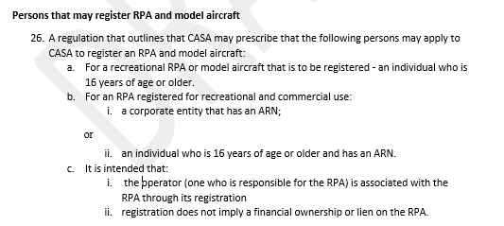
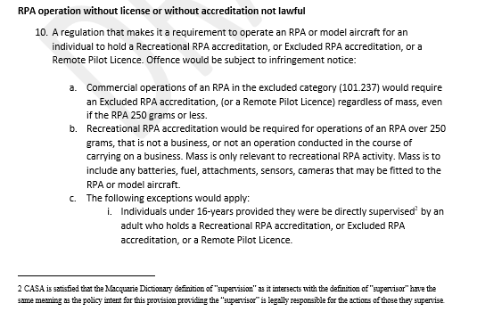

Is 16 the right age to take responsibility to fly a drone without supervision?
☐ Yes
☐ No – but 18 years is ok
☐ No – but 17 years is ok
☐ No – but 15 years is ok
☐ No – but 14 years is ok
☐ Don’t know

Question 2
Is 18 the right age to supervise a drone flyer younger than 16?
☐ Yes
☐ No but 16 is okay
☐ No but 17 is okay
☐ No but 19 is okay
☐ No but 20 is okay
☐ No but 21 is okay
☐ Don’t know

