Changes to publishing standards and calculation of visibility minima – CD 1904AS

Overview
Amendments to: Part 173 Manual of Standards (MOS)

Part 173 of the Civil Aviation Safety Regulations 1998 (CASR) sets the Australian standards for instrument flight procedure design. The regulation and its associated MOS was introduced in 2003.

CASA is proposing to amend the Part 173 Manual of Standards (MOS) to permanently set in place a longstanding temporary exemption arrangement relating to instrument flight procedure publishing standards, and to clarify the requirements for calculating visibility minima.

Publishing standards

The MOS includes the publishing standards for flight instrument procedures. The standards include the text format - for example the way latitude and longitude values are depicted on an instrument approach chart, and the pictorial layout for instrument flight procedure charts. The MOS also contains the procedures and formula for calculating the visibility minima that appear on all Australian instrument approach procedures.

The MOS reflects publishing standards that were in use at the time it was first issued. Since then, there have been changes to the regulatory arrangements for publication of aeronautical data such as instrument flight procedure charts. Most significantly, Part 175 (Aeronautical information management) came into effect in 2014. Part 175 introduced a scheme for aeronautical information management whereby information (including instrument flight procedure charts) must comply with a data product specification (DPS).

Until recently, it has not been possible to amend the MOS to reflect the changed situation. Instead, and for several years, CASA has granted exemptions from the publishing requirements in the MOS to the small class of Part 173 certified designers. The terms of these exemptions reflect the current and ongoing arrangements according to Part 175.

However, instruments of exemption are time-limited. This means CASA has had to renew the exemptions from time to time; processes that have a time and cost impact.

CASA proposes to change the MOS to reflect the terms of the latest exemption. In effect, CASA intends to replace the whole of Section 8.9 (including the sample charts and publishing standards) with a broad requirement for procedures to be prepared in accordance with a DPS given to the designer under regulation 175.160 of CASR.

Calculation of instrument approach visibility minima

There has been an ongoing issue with the Section 8.1 standards for determining visibility minima. Due to the formatting of the requirements, the standards have sometimes been interpreted as requiring designers to adjust vertical minima to account for the visibility minima available for a particular situation. However, the intended policy requirement is that the visibility minima must be adjusted taking into account the vertical minima, and not vice versa. Further, the calculation standards have been found restrictive compared to international standards, specifically in terms of allowing an operational benefit (reduced visibility minima) for runways equipped with approach lighting systems that are shorter than the standard 900 m length.

To address these issues, CASA proposes to consolidate paragraphs 8.1.6.1, 8.1.6.2 and subsection 9.1.1 into a single section. The new section will have standards to the effect that visibility minima calculations will be on the basis of runway alignment and length of approach lighting (if any) provided for the runway. The precise technical details can be found in the draft instrument for amending the MOS that is included on this webpage.

Consequential and editorial amendments

The proposed changes require some consequential amendments. CASA is also taking the opportunity to consolidate various definitions into a new definitions section and to make some minor editorial changes in the document.

Documents for review

A copy of the Summary of Proposed Change and the draft MOS amending instrument called ‘Manual of Standards (MOS) Part 173 Amendment Instrument 2019 (No. 1)’, are provided below in the ‘Related’ section.

Why we are consulting

This consultation is seeking feedback on the proposal to amend Part 173 MOS for the purpose of finally setting in place the temporary exemption arrangements pertaining to publishing standards and to consolidate and simplify the standards pertaining to visibility minima calculations.

General comments and file upload option

There is a general comments box at the end of the consultation. You can add your comments on matters related to the regulatory amendment, which have not already been addressed in the consultation. This page also contains a file upload for an additional document should you wish to provide one.

Comments on the proposal to amend Part 173 MOS should be submitted through the online response form.

What happens next

Once the consultation has closed, we will register and review each submission received through the online response form. We will make all submissions publicly available on the Consultation Hub, unless you request that your submission remain confidential. We will also publish a Summary of Consultation which summarises the feedback received.

Information about how we consult and how to make a confidential submission is available on the CASA website <https://www.casa.gov.au/rules-and-regulations/landing- page/consultation-process> .

To be notified of any future consultations, you can subscribe to our consultation and rulemaking mailing list <https://mailinglist.casa.gov.au/?p=subscribe&id=3>.

Page: About this consultation
This consultation asks for your feedback on CASA’s proposal to amend the existing Part 173 MOS standards for publishing instrument flight procedure charts and for calculating visibility minima.
The proposed changes will involve replacing several subsections from the MOS and making some editorial amendments. The fact banks below will help you to understand the proposed changes.
General comments
The last page of this consultation is a General comments page, where you can make additional comments on the proposed changes.
File upload
Should you wish to support your comments with an additional document, we have provided a file upload facility within the general comments page for your convenience.
We will ask you for:
- personal information, such as your name, any organisation you represent, and your email address
- your consent to publish your submission
- your responses to the proposed changes in the regulations
- any comments you may want to provide
- demographic information to help us understand your interest in the regulations
Our website<https://www.casa.gov.au/rules-and-regulations/landing- page/consultation-process> contains more information on making a submission and what we do with your feedback.

Page 1: Personal information

First name
(Required)

Last name
(Required)

Email address
If you enter your email address, you will automatically receive an acknowledgement email when you submit your response.

Email

Do your views officially represent those of an organisation?
(Required)
Please select only one item
☐ Yes, I am authorised to submit feedback on behalf of an organisation
☐ No, these are my personal views

If yes, please specify the name of your organisation.

Demographic question where applicable
Which of the following best describes the group you represent?

Please select only one item
☐ CASR Part 173 Instrument flight procedure designers
☐ CASR Part 175 aeronautical information service providers
☐ Aerodrome operators
☐ Air operators
☐ Pilots
☐ Other
Please specify if you have selected “Other”.

Page 2: Consent to publish submission
In order to promote debate and transparency, we intend to publish all responses to this consultation. This may include both detailed responses/submissions in full and aggregated data drawn from the responses received.

Where you consent to publication, we will include:

- your last name, if the submission is made by you as an individual
- the name of the organisation on whose behalf the submission has been made
- your responses and comments

We will not include any other personal or demographic information in a published response.

Information about how we consult and how to make a confidential submission is available on the CASA website <https://www.casa.gov.au/rules-and-regulations/landing- page/consultation-process> .

Do you give permission for your response to be published?
(Required)
Please select only one item
☐ Yes - I give permission for my response/submission to be published.
☐ No - I would like my response/submission to remain confidential but understand that de-identified aggregate data may be published.
☐ I am a CASA officer.

Page 3: Proposal no. 1 – Amend the publishing standards in Section 8.9

Proposal

- Replace the entire section 8.9 (Publishing) of Part 173 MOS – a total of 11 pages – with new standards that require a designer to:
  - comply with format and drafting conventions specified in a data product specification (DPS) given to the designer under regulation 175.160 of CASR
  - ensure that its operations manual includes a description of the processes and documents used to present the standards, rules and procedures mentioned in the DPS.

Question: Do you agree with the proposed changes to section 8.9 of the MOS?

Note: For brevity, the fact banks below show only 3 samples of the section to be omitted. However, a total of 11 pages that constitute section 8.9 would be omitted. The final fact bank on this page shows the proposed new Section 8.9 in its entirety.

Fact Bank: Sample 1 of section 8.9 to be omitted

Fact Bank: Sample 2 of section 8.9 to be omitted

Fact Bank: Sample 3 of section 8.9 to be omitted

Fact Bank: Proposed new Section 8.9

Note: The entire new section fits on one page.

Radio buttons
☐ Agree
☐ Agree with changes (please specify suggested changes below)
☐ Disagree (please set out your reasoning and alternative suggestions below)
☐ Undecided / Not my area of expertise
Comment
Page 4: Proposal no. 2 - Amend the standards in subsection 8.1.6 for calculating visibility minima, and omit Chapter 9

Proposal

- Replace Paragraphs 8.1.6.1 and 8.1.6.2 (including Figure 8-2, Table 8-1 and the note after Table 8-1) with new standards that consolidate and update the requirements in the original text as well as the relevant requirements of Chapter 9
- Omit Chapter 9 in its entirety.
  - In the process, revise the formulae in subsection 9.1.1 and amalgamate into paragraphs 8.1.6.1B, 8.1.6.1C and 8.1.6.3.

Question: Do you agree with the proposed changes to Section 8.1.6 and the proposed omission of Chapter 9?

Fact Bank: MOS paragraphs 8.1.6.1 & 8.1.6.2 – current standards and proposed changes

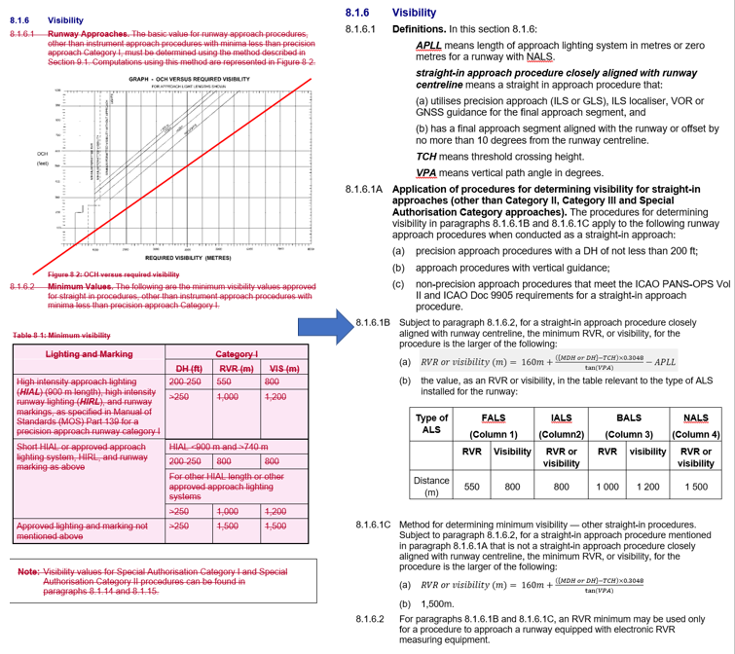

Fact Bank: Proposed deletion of section 9.1.1, and relocation of amended formulae to 8.1.6.1B and 8.1.6.1C

Note: This fact bank shows the wording in subsection 9.1.1 to be omitted and a graphical description of changes to the formulae.

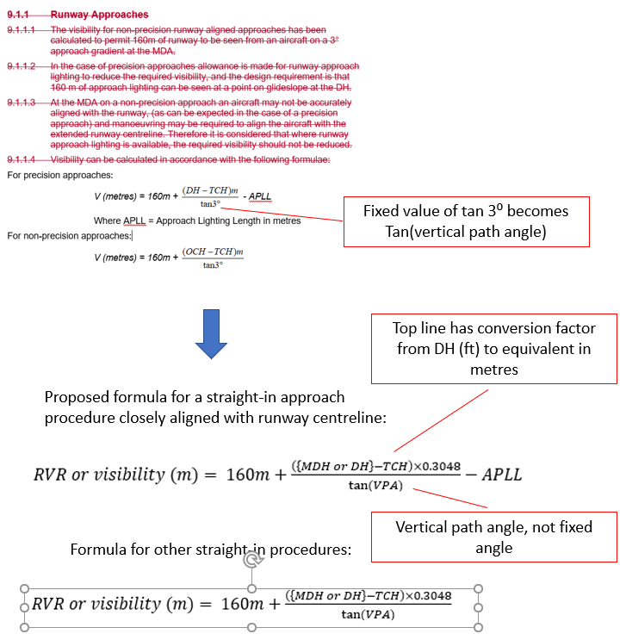

Fact Bank: Proposed amendment to paragraph 8.1.6.3 (Derivation of circling area visibility minima).

Note: This shows – with tracked changes – the proposal to move the chapter 9 information about circling area minima to paragraph 8.1.6.3.

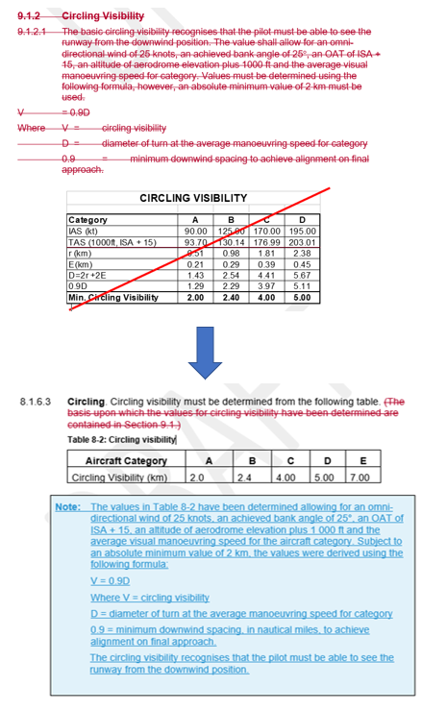

Radio buttons
☐ Agree
☐ Agree with changes (please specify suggested changes below)
☐ Disagree (please set out your reasoning and alternative suggestions below)
☐ Undecided / Not my area of expertise
Comment

Page 5: Proposal no. 3 – Dictionary, consequential and editorial amendments

Proposal

- Consolidate common definitions and abbreviations into a specific definitions section at the end of Chapter 1
  - Note: Definitions unique to a particular part of the MOS will not be moved.
- Make the series of consequential amendments to paragraphs 2.1.1.1 (r), 6.1.2.3 and 6.1.3.1 (b) as a result of changes to Section 8.9, subsection 8.1.6 and omitting Chapter 9.
- Make a number of editorial amendments to standardise terms such as ‘PinS’ and to ensure consistent use of abbreviations and terms.

Question: Do you agree with the proposed Dictionary, consequential and editorial amendments?

Fact Bank: Proposed dictionary

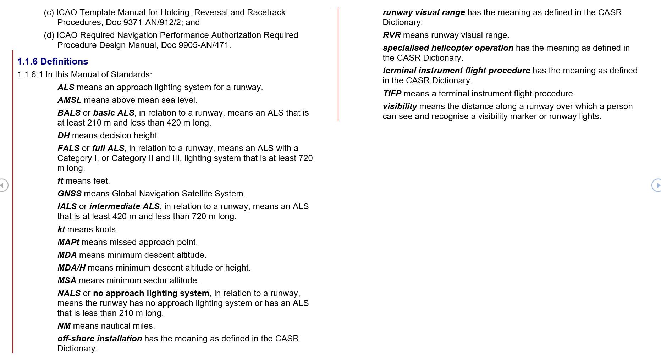

Fact Bank: Consequential amendments to paragraphs 2.1.1.1 (r), 6.1.2.3 and 6.1.3.1 (b)

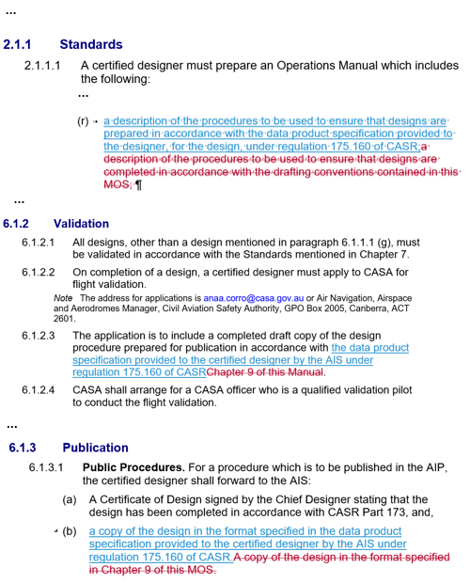

Fact Bank: Editorial amendments to Part 173 MOS

Note: The fact bank is an extract from the proposed MOS amending instrument.

Radio buttons
☐ Agree
☐ Agree with changes (please specify suggested changes below)
☐ Disagree (please set out your reasoning and alternative suggestions below)
☐ Undecided / Not my area of expertise
Comment

Page 6: General comments

Do you have any additional comments about the proposed changes?

(Please note, this should not include points you have already raised)

Comments

File upload option

You may wish to upload a file as part of your submission. Select 'Browse' below and navigate to the file you would like to include. Please note pdf is preferred.

