Proposed new Part 131 Manual of Standards - Balloons and Hot Air Airships - (CD 2103OS)

Overview
The general operational rules in Part 131 of Civil Aviation Safety Regulations (CASR) and the proposed Part 131 Manual of Standards (MOS), will apply to all Part 131 aircraft pilots and operators. The MOS will provide much of the complex or technical detail of the Part 131 regulations and is intended to provide easy to read compliance detail for operators of Part 131 aircraft.

Please note:
- A Part 131 aircraft means a hot air balloon, a hot air airship, a gas balloon, or a mixed gas and hot air balloon.
- An operator of a Part 131 aircraft means the holder of an Air Operator’s Certificate (AOC) or other approval, or a person, organisation or enterprise (not necessarily the owner) engaged in aircraft operations involving the aircraft.

There are only a few proposed changes for recreational balloon operations. Additional requirements are proposed for balloon transport operators conducting scenic flights for paying passengers. While some rules are necessarily prescriptive, there are provisions in others for the operator to assess the hazards and risks to ensure that a proposed flight will have a safe outcome.

There are 17 principal changes in the Part 131 MOS. These changes include standards for lighter-than-air aircraft, changes to existing terminology, minimum height requirements for flights above a populous area or public gathering, requirements for flights over water and procedures for balloon transport operators, that would ensure a final reserve fuel for emergency use. Details on these changes and others are provided on Page 3 of this survey. You will also have an opportunity to provide comment on this page and other pages specific to the subject matter.

Currently operational rules that apply to balloons and hot air airships are found in many of the Civil Aviation Regulations (CARs) and Civil Aviation Orders (CAOs). The proposed Part 131 MOS will bring the technical operational rules and standards that apply to Part 131 aircraft into one document, making it easier for operators to find information.

When Part 131 of CASR commences on 2 December 2021, any applicable CARs and CAOs that are no longer required will be repealed.

Changes in the presentation of the rules as they currently exist, may mean operators will need to make changes to their documentation and in some cases changes to operating procedures.

Integration of Part 131 with Part 91 of CASR – General operating and flight rules
Under the existing rules many of the general operating regulations that apply to all aircraft also apply to balloons and hot air airships, unless exempted under other provisions.

Part 91 will replace the existing general operating rules. While some Part 91 rules will apply to Part 131 aircraft, others will be turned off and replaced by an equivalent rule in Part 131. The rules that are disapplied for Part 131 are listed in regulation 91.030 of CASR.

Some rules in Part 91 are not applicable to Part 131 aircraft because of technical limitations. For example, regulations that apply to Instrument Flight Rules (IFR) flight or speed requirements, are not intended to apply to Part 131 aircraft. A Plain English Guide (PEG) is being drafted; this is a document that will provide explanation of both the Part 91 and Part 131 rules. Two Part 131 advisory circulars that set out recommended practices for pilots and operators have already been published and will be updated to reflect the new rules. These are:

- AC 131-01 v2.0 Airworthiness | Civil Aviation Safety Authority (casa.gov.au)
- AC 131-02 v1.0 Operations| Civil Aviation Safety Authority (casa.gov.au).

Previous consultations
Prior to the release of this consultation draft, CASA has consulted internally and externally via the Aviation Safety Advisory Panel Technical Working Group, consisting of representatives from CASA and the balloon industry. A face-to-face meeting was held in February 2020 and two video conferences were held in March and April 2021. Comments from the consultations have been considered in the drafting of the MOS.

Why we are consulting
CASA recognises the valuable contribution community and industry consultations make to the policy decision-making process and future regulatory change. We are consulting to ensure that the proposed new rules are clearly articulated and will work in practice and as they are intended.
Comments are sought from every sector of the community. This includes the general public, government agencies and all sectors of the aviation industry, whether as an aviator, aviation consumer and/or provider of related products and services.

This consultation seeks feedback on the proposed Part 131 MOS that supports Part 131 of CASR that was made into law in December 2019. The survey has been designed to give you the option to provide feedback on the survey in its entirety or to provide feedback on the policy topics applicable to you. The survey page titles will assist you in locating those areas that are of interest to you. You can decide on which of the topics you wish to comment and on how many or how few you wish to comment. Each topic includes a reference to the relevant chapter in the MOS so you don't have to read the entire document.

Your feedback will make a valuable contribution to our standards development and making process and help to inform any future regulatory change.

Documents for review
All documents related to this consultation are attached in the ‘related’ section at the bottom of the page. They are:
- Summary of proposed change on CD 2103OS, which provides background on the proposed standards
- Consultation Draft – Part 131 Manual of Standards
- CASR Part 103, 105 and 131 Regulations 2019 (F2020L01283)
- Civil Aviation Safety Amendment (Operations Definitions) Regulations 2019 (F2019L00557)
- Civil Aviation Safety Amendment (Part 91) Regulations 2018 (F2018L01783)
- MS Word copy of online consultation for ease of distribution and feedback within your organisation.
Comments on the CD 2103OS should be submitted through the online survey available below.

Note: The MS Word document is not to be used as an emailed submission unless there are extenuating circumstances and this form of submission has been agreed to by the consultation project lead.

The survey has been designed to give you the option to provide feedback on the survey in its entirety or to provide feedback on the policy topics applicable to you.

What happens next
At the end of the response period for public comment, we will review each comment and submission received. We will make all submissions publicly available on the CASA website, unless you request your submission remain confidential. We will also publish a Summary of Consultation which summarises the feedback received, outlines any intended changes and details our plans for the regulation.
All comments on the draft Part 131 MOS consultation will be considered. Relevant feedback that improves upon the proposed regulations and is consistent with the regulations and other CASA policy, will be incorporated into the final ruling.
CASA has set a date of 2 December 2021 to commence the proposed rules.
Post-implementation review
CASA will monitor and review the new rules during the transition phase and on an ongoing basis. We will also continue work on proposed further changes to the Part 131 regulations to better support balloon operations.

Give Us Your Views

Online Survey

Related documents

- Summary of proposed change (SPC) on CD 2103OS
- Consultation draft – Part 131 MOS

Related Links

- Part 91 of Civil Aviation Safety Regulations (F2018L01783)
- Part 91 Manual of Standards (F2020L01514)
- CASR Part 103,105 and 131 Regulations 2019 (F2020L01283)
- Civil Aviation Safety Amendment (Operations Definitions) Regulations 2019 (F2019L00557)

Audience & Interest groups

Audience
- CASA staff
- Sports aviation operators
- Hot air balloon operators
- Air traffic controller
- Forecaster/Meteorological service provider
- Self-administering Aviation Organisations
- Balloon Instructors and flight examiners
- Balloon Manufacturers
- Balloon Pilots
- Balloon Sports aviation operators
- Traveling public/passengers on balloon scenic flights
- Tethered gas balloon operators
- Balloon AOC holders and applicants
- Balloon pilots holding a CP(B)L
- Sport and recreational balloon owners and pilots

Interest
- Operational standards
- Equipment standards
- Self administration aviation activities
- Sport and recreational ballooning
- In-house training for CASA FOIs

Page 1: Consultation Contents
Proposed policy - Part 131 Manual of Standards
This consultation is seeking feedback on the proposed policy for a tailored set of standards for the operation of manned free balloons and hot air airships. These aircraft will be known as Part 131 aircraft when Part 131 of the Civil Aviation Safety Regulations becomes applicable on 2 December 2021.

Each reader of this consultation will be looking at the proposed content of the MOS from their own perspective. You may be the owner of a balloon, a pilot, a sport aviation body, a commercial operator with an Air Operator’s Certificate (AOC), or another interested party. Feedback from your personal perspective is important to the outcome of this instrument and we encourage you to comment on those topics that particularly affect your interest in lighter-than-air flight. If you just want to comment on the main changes as a whole, there is a page of principal changes. If you want to provide more detailed feedback, the content of the MOS is provided in more detail.

This consultation is comprised of 10 pages. The first 2 pages contain questions that are administrative in nature, enabling us to protect your privacy and ensure we have obtained feedback from all stakeholders. The pages that follow request feedback on the proposed Chapters of the Part 131 MOS. These 8 pages are as identified below.

When you have completed the sections on which you wish to provide feedback, select the ‘Finish’ button at the bottom right of this page.

Fact bank: Table of policy topics contained on each page

Page 3:  Principal Changes | - Fact bank: Operation of lighter-than-air aircraft and tethered balloons  - Fact bank: Changes to key terminology  - Fact bank: Balloon flights within and outside Australia  - Fact bank: Document, record and information requirements  - Fact bank: Flight over a populous area  - Fact bank: Definition of suitable landing area  - Fact bank: Flight over water  - Fact bank: Oxygen and fuel  - Fact bank: Passengers and loading weight  - Fact bank: Equipment on board  - Fact bank: Induction and ongoing competency of flight and ground support crew
Page 4:  Definitions, specialised balloons and personnel fatigue | - Policy topic 1 – Definitions (Chapter 1)  - Policy topic 2 – Reserved - Additional requirements for specialised balloon operations (Chapter 11)  - Policy topic 3 – Reserved - Personnel fatigue management (Chapter 4)
Page 5:  VMC, VFR and Standard visual signals | - Policy topic 4 - VMC and VFR  - Policy topic 5 - Visual Flight Rules (Chapter 19)  - Policy topic 6 - Standard visual signals (Chapter 15)
Page 6:  Flight documents and reporting and recording | - Policy topic 7 – Flight related documents (Chapter 5)  - Chapter 5, section 5.01 - Flights conducted wholly within Australia.  - Chapter 5, section 5.04 - Documents to be kept with a person on the ground during flight.  - Policy topic 8 – Reporting and recording information (Chapter 6)
Page 7:  Flights, preparation, notifications, checks, radio usage and air traffic | - Policy topic 9 – Flights over populous areas, public gatherings and other areas (Chapter 8)  - Policy topic 10 – Dropping things from aircraft (Chapter 9)  - Policy topic 11 – Flight preparation (Chapter 12)  - Policy topic 12 – Flight notification requirements (Chapter 13)  - Policy topic 13 – Matters to be checked before take-off (Chapter 14)  - Policy topic 14 – Air Traffic Services Prescribed requirements (Chapter 15)  - Policy topic 15 – Use of radio – Broadcasts and reports (Chapter 16)  - Policy topic 16 – Operations at non-controlled aerodromes (Chapter 17)  - Policy topic 17 – Flights over water (Chapter 18)  - Policy topic 18 – Operation of a tethered Part 131 aircraft other than a subpart 131.Z tethered gas balloon (Chapter 20)
Page 8:  Equipment, fuel and ballast and Oxygen | - Policy topic 19 – Emergency and survival equipment information (Chapter 7)  - Policy topic 20 – Fuel and ballast requirements (Chapter 21)  - Policy topic 21 – Use of supplemental oxygen equipment (Chapter 10)  - Policy topic 22 – Equipment (Chapter 26)
Page 9:  Safety, passengers, personnel, and training | - Policy topic 23 – Carriage of persons requiring assistance (Chapter 22)  - Policy topic 24 – Passengers – Safety briefings and instructions (Chapter  - Policy topic 25 – Loading weights (Chapter 24)  - Policy topic 26 – Carriage of passengers (Chapter 25)  - Policy topic 27 – Flight crew – qualifications and training (Chapter 27)  - Policy topic 28 – Ground support personnel (Chapter 28)  - Policy topic 29 – Tethered gas balloons (Chapter 29)

Page | Content
1 | Personal information (required)
2 | Consent to publish submission (required)
3 | Principal changes
4 | Definitions, specialised balloons and personnel fatigue
5 | VMC, VFR and Standard visual signals
6 | Flight documents and reporting and recording
7 | Flights, preparation, notifications, checks, radio usage and air traffic
8 | Equipment, fuel and ballast and oxygen
9 | Safety, passengers, personnel, and training
10 | General comments

Page 2: Personal information

First name
(Required)

Last name
(Required)

Email address
If you enter your email address you will automatically receive an acknowledgement email when you submit your response.

Email

Do your views officially represent those of an organisation?
(Required)
Please select only one item

☐ Yes, I am authorised to submit feedback on behalf of an organisation
☐ No, these are my personal views.

If yes, please specify the name of your organisation.

Which of the following best describes the group you represent?

You may select more than one item

☐ Balloon owner/operator
☐ Balloon pilot - private
☐ Balloon pilot - commercial
☐ Sport aviation body or club
☐ Balloon AOC holder
☐ Hot air airship owner/pilot
☐ Other
Please specify “Other” if selected.
Page 2: Consent to publish submission
In order to provide transparency and promote debate, we intend to publish all responses to this consultation. This may include both detailed responses/submissions in full and aggregated data drawn from the responses received.

Where you consent to publication, we will include:

- your last name, if the submission is made by you as an individual
- the name of the organisation on whose behalf the submission has been made
- your responses and comments

We will not include any other personal or demographic information in a published response.

Information about how we consult and how to make a confidential submission is available on the CASA website <https://www.casa.gov.au/rules-and-regulations/landing- page/consultation-process> .

Do you give permission for your response to be published?
(Required)
Please select only one item
☐ Yes - I give permission for my response/submission to be published.
☐ No - I would like my response/submission to remain confidential but understand that de-identified aggregate data may be published.
☐ I am a CASA officer.

Page 3: Principal changes

Principal changes include:

Fact bank: Operation of Part 131 aircraft and tethered gas balloons
- The standards for the operation of Part 131 aircraft would be detailed in the Part 131 MOS.
- Requirements for the operation of permanently tethered gas balloons would be set out in Chapter 29 of the MOS.

Fact bank: Changes to key terminology
A summary of these changes in both the Part 131 regulations and the MOS is as follows:
    - Balloon charter is now balloon transport.
    - A specialised balloon operation is a new term that applies to activities which were previously considered aerial work. It may be either a commercial or recreational activity.
    - Balloon flying training in accordance with Part 5 of CAR will now be a prescribed activity under an amended regulation 206 of CAR.
    - Private operations are now recreational operations.
    - The chief pilot is now called the head of flying operations (HOFO).
    - Ground crew are included in ground support personnel who may or may not be operational safety-critical personnel (this is a defined term) depending on their duties.

Fact bank: Balloon flights within and outside Australia
- For flights in balloons within Australian territory there is no change in the documents that must be carried except that:
  - the holder of a Part 131 ASAO pilot authorisation must carry the authorisation if conducting the flight under that authorisation
  - all pilots must carry a form of photo identification.
- If you are thinking of a flight into or out of Australian territory or in a foreign country, then the documents required by the Chicago Convention would be listed in the MOS.

Fact bank: Document, record and information requirements
- The MOS proposes that a balloon transport operator must ensure that a flight note and passenger list are left with a person on the ground for the duration of the flight. Regulation 131.280 requires operators to include procedures for this activity in their exposition.
- For any flights within Australian territory, electronic copies of required documents would be acceptable.
- Certain information about a flight would be required to be recorded as soon as practicable after each flight. There would be little change from current requirements in the information recorded.
- If any emergency equipment such as life jackets are to be carried on a flight, information concerning this equipment would need to be available for communication to a rescue coordination centre.

Fact bank: Flight over a populous area
The minimum height for flight over a populous area or public gathering is proposed to be 1000 ft above the highest feature or obstacle within a horizontal radius of 100m (currently 300m) unless the aircraft is:
    - Taking off or conducting manoeuvres necessary to achieve a safe landing.
    - Engaged in a missed approach.
    - Conducting an air display.
    - Engaged in a procedure to determine the suitability of a landing area for a landing.

Fact bank: Definition of suitable landing area
A suitable landing area for a Part 131 aircraft is proposed to mean a place where, in the reasonable opinion of the pilot in command given the prevailing conditions, the aircraft can be safely landed without causing a hazard to persons or property on the ground or on the aircraft.

Fact bank: Flight over water
The requirements for the pilot in command of a Part 131 aircraft that is planning to fly, or may reasonably be expected to unintentionally fly, over a body of water where in the event of an emergency the pilot may need to land or ditch on the water would be detailed. It is proposed that the pilot in command of a Part 131 aircraft, and the operator of a balloon transport operation, must assess the risks to the aircraft of a flight over water and the chances of survival of persons on the aircraft in the event of a landing or ditching in the water. The results of this assessment will inform the necessary mitigation measures such as determining the search and rescue facilities available and the emergency and survival equipment that it may be necessary to carry on board.

Fact bank: Oxygen and fuel
- The rules about the use of supplemental oxygen equipment for high altitude flight above 10 000 ft above mean sea level (AMSL) would be based on the FAA requirements and will align with the rules for other small aircraft in Australia.
- Balloon transport operators would be required to have procedures that would ensure a final reserve fuel for emergency use that would normally remain in the balloon fuel tanks at the completion of a flight.

Fact bank: Passengers and loading weight
Methods for calculating the maximum (and if relevant the minimum) loading weight would be detailed. In addition to using actual or standard passenger weights balloon transport operators would be authorised to use an exposition derived weight that is calculated utilising procedures described in an operator’s exposition. CASA would publish appropriate guidance material.

Fact bank: Equipment on board
The requirements for equipment that may be fitted to or carried on any Part 131 aircraft conducting VFR flight by day or night would be clearly detailed in one chapter of the MOS. The requirements for flight instruments, radio communications, transponders, fire extinguishers, oxygen equipment and night lighting would be detailed. A new requirement is proposed for the wearing of pilot restraint harnesses. It is proposed that the pilot in command, or the pilot in command under supervision operating the controls, of a balloon transport operation must wear a pilot restraint harness at least for take-off and landing.

Fact bank: Induction and ongoing competency of flight and ground support crew
The procedures for the induction training and ongoing competency checking would be set out. The interval for emergency procedures competency checks would be increased from 12 months to 24 months.

Please provide any comments you may have on the principal changes proposed.

Page 4: Definitions, specialised balloons and personnel fatigue

Policy topic 1 – Definitions (Chapter 1)
Proposed policy
The proposed Definitions etc. used in the MOS are listed in Chapter 1, section 1.06 of the MOS.

Comments on Policy topic 1 – Definitions etc.

Policy topic 2 – Reserved - Additional requirements for specialised balloon operations (Chapter 11)
Proposed policy
CASA proposes to reserve this Chapter to preserve the MOS structure for any future provisions that would be appropriate following consultation.

Comments on Policy topic 2 (Chapter 11).

Policy topic 3 – Reserved - Personnel fatigue management (Chapter 4)
Proposed policy
CASA proposes to reserve this Chapter at this time. Our intent is to eventually move the requirements of CAO 48.1 Instrument 2019 into the Part 131 MOS.

Note: Guidance material, and a template for operations manual inclusion, are available from the following CASA webpages:
Fatigue management resources
(https://www.casa.gov.au/safety-management/fatigue-management/fatigue-management-resources)

Sample operations manual supplements for appendices 1 to 6
(https://www.casa.gov.au/safety-management/fatigue-management/fatigue-management-resources/sample-operations-manuals-appendices-1-6)

Comments on Policy topic 3 (Chapter 4).

Page 5: VMC, VFR and Standard visual signals

Policy topic 4 – VMC and VFR
Proposed policy
Visual meteorological conditions (VMC) (Chapter 2, Division 2.2)

There are no proposed changes to the VMC requirements. The fact bank below contains Table 2.02 (3) in Part 131 MOS, which sets out the VMC criteria for airspace classes A, B, C, D, E and G.

FACT BANK - Table 2.02 (3) - VMC criteria
For Table 2.02 (3), for a class of airspace mentioned in column 1 of an item, at a height mentioned in column 2 of the same item, the VMC criteria are those mentioned in columns 3, 4 and 5 of the same item.
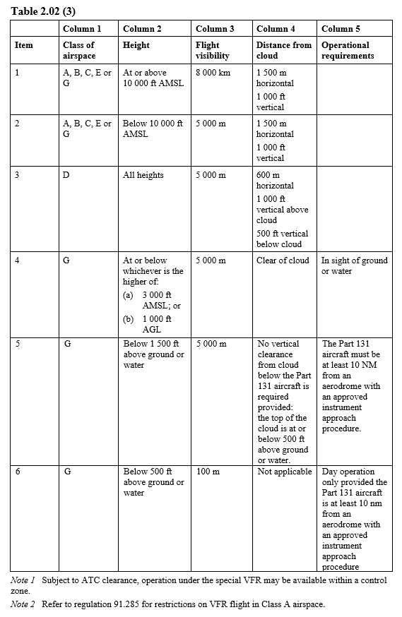
Comments on Policy topic 4 - VMC and VFR

Policy topic 5 – Visual Flight Rules (Chapter 19)
Proposed policy
CASA proposes a requirement for VFR to comply with the VMC criteria or special VFR for the airspace in which the flight is to be conducted.

The proposed requirements for VFR for flight at night are also detailed in Chapter 19.

Comments on Policy topic 5 (Chapter 19)

Policy topic 6 – Standard visual signals (Chapter 15)
Proposed policy
The pilot of a Part 131 aircraft will rarely be affected by standard visual signals. However, these signals do apply to Part 131 aircraft and Division 2.3 of Chapter 2 of the Part 91 MOS prescribes:
- light, hand and ground signals
- the requirements and circumstances for their display.
To avoid repetition, pilots and operators will be directed to the Part 91 MOS for the details. Chapter 2, Division 2.3 of the Part 91 MOS, defines and sets out the light signals to aircraft on an aerodrome or in flight, and the ground signals for aircraft at aerodromes.

Comments on Policy topic 6 (Chapter 15).

Page 6: Flight documents and reporting and recording

Policy topic 7 – Flight related documents (Chapter 5)
Chapter 5, section 5.01 - Flights conducted wholly within Australia

Proposed policy
There is no proposed change to the requirement for particular documents to be carried on a flight. However, there is now a proposed requirement that the pilot in command of a flight conducted under a Part 131 ASAO authorisation, must carry the Part 131 ASAO pilot authorisation for the flight and all pilots must carry a photographic form of identification.

For flights within Australia, all the documents that are required to be carried including pilot authorisations, medical certificates, aircraft flight manual (AFM), maps and charts may be carried as electronic copies.

For flights conducted into or out of Australian territory or entirely in a foreign country, a journey log as required by the Chicago Convention would be required to be completed. This requirement may be satisfied by the usual pilot and aircraft logbook entries.

Comments on Policy topic 7 - Chapter 5, Section 5.01

Chapter 5, section 5.04 - Documents to be kept with a person on the ground during flight.

Proposed policy
This proposed provision will only apply to balloon transport operators. A passenger list and flight note must be left with the ground support person responsible for retrieving the balloon when it lands. These documents may be electronic copies but must be readily available at any time.

Comments on Policy topic 7, Ch 5, Section 5.04

Policy topic 8 – Reporting and recording information (Chapter 6)
Proposed policy
There are no proposed changes to the information that must be reported and recorded, but the requirements would vary depending on the flight activity being conducted. The proposed policy is the requirements remain the same.

For hot air balloon operators without access to a metered supply of LPG, accurate recording of fuel usage is not practical. Recording of fuel usage for a flight would not be required. Operators with suitable facilities may record fuel usage for their records.

Comments on Policy topic 8 – Reporting and recording (Chapter 6)

Page 7: Flights, preparation, notifications, checks, radio usage and air traffic

Policy topic 9 – Flights over populous areas, public gatherings and other areas (Chapter 8)
Proposed policy
This chapter would apply to all Part 131 aircraft. CASA proposes that a Part 131 aircraft must maintain an altitude of at least 1000 feet above the highest obstacle within a horizontal radius of 100m over a populous area or public gathering unless:
- the Part 131 aircraft is taking-off, or is conducting manoeuvres to conduct a safe landing
- is engaged in a missed approach
- the pilot in command is engaged in an air display
- is engaged in a procedure to determine the suitability of a landing area for a landing.

Comments on Policy topic 9 (Chapter 8)

Policy topic 10 – Dropping things from aircraft (Chapter 9)
Proposed policy
There are no new requirements proposed in this Chapter. The proposed policy is that the current requirements for what may be dropped from a Part 131 aircraft remain the same.

Dropping of parachutists would be required to be conducted in accordance with Part 105 of CASR – Parachuting from aircraft.

Comments on Policy topic 10 (Chapter 9)

Policy topic 11 – Flight preparation (Chapter 12)
Proposed policy
CASA proposes that the pilot in command of a Part 131 aircraft, must study the authorised weather forecast and any other reasonably available weather information for the planned flying area before flight. Chapter 12 details these proposed requirements.

Comments on Policy topic 11 (Chapter 12)

Policy topic 12 – Flight notification requirements (Chapter 13)
Proposed policy
The only change proposed to existing flight notification requirements would be the inclusion of requirements about a responsible person for receipt of a flight note.

The proposed policy for circumstances which would require a flight note to be left with a responsible person on the ground and the requirements for flight notifications when flight in a Part 131 aircraft is conducted in controlled airspace, are set out in Chapter 13 of the MOS.

Comments on Policy topic 12 (Chapter 13)

Policy topic 13 – Matters to be checked before take-off (Chapter 14)
Proposed policy
There are no new requirements for matters to be checked before take-off proposed in this chapter of the MOS. However, Chapter 14 brings together in one place, requirements previously found in different documents.

Comments on Policy topic 13 (Chapter 14)

Policy topic 14 – Air traffic services prescribed requirements (Chapter 15)
Proposed policy
There are no new requirements proposed for air traffic services prescribed requirements but having the rules in one place will be of benefit to operators.

The proposed Chapter 15 of the MOS sets out the requirements for a Part 131 aircraft conducting a flight in or at a:
- control zone
- control area
- controlled aerodrome
- class of airspace or a portion of a class of airspace.

Comments on Policy topic 14 (Chapter 15)

Policy topic 15 – Use of radio – Broadcasts and reports (Chapter 16)
Proposed policy
There are no new requirements proposed for use of radio. The proposed Chapter 16 of the MOS details the radio broadcasts and reports the pilot in command of a Part 131 aircraft must make, during flight in the vicinity of controlled and non-controlled aerodromes, and in airspace Classes A to G.

Comments on Policy topic 15 (Chapter 16)

Policy topic 16 – Operations at non-controlled aerodromes (Chapter 17)
Proposed policy
There are no changes proposed to requirements for operations at non-controlled aerodromes. Proposed Chapter 17 of the MOS sets out the requirements for the operation of a Part 131 aircraft in the vicinity of a non-controlled aerodrome.
Comments on Policy topic 16 (Chapter 17)

Policy topic 17 – Flights over water (Chapter 18)
Proposed policy
CASA proposes new requirements for the flight of a Part 131 aircraft over a body of water such as the sea, a lake, bay, or estuary, where in the event of an emergency a landing or ditching in the water may occur. These new requirements are set out in Chapter 18 of the MOS.

We propose that the pilot in command (and a balloon transport operator) must assess the operation by considering the risk considerations and then decide on the risk mitigation measures that are appropriate.
FACT BANK - Flights over water
Content:
Section 18.02 in Chapter 18 would set out the risk considerations for a flight over water

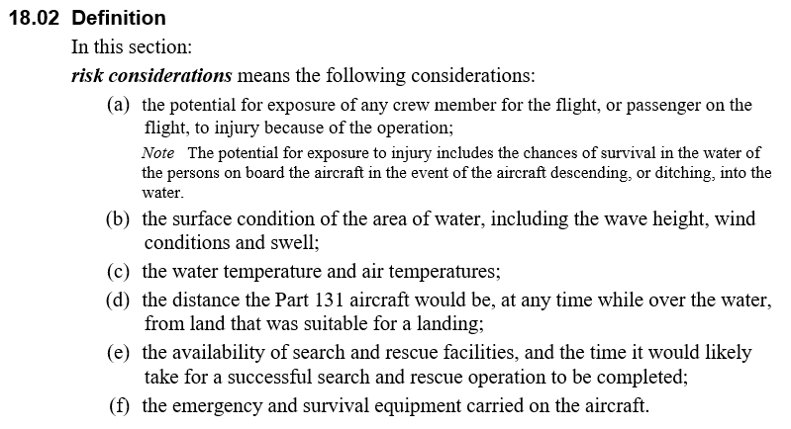

Comments on Policy topic 17 (Chapter 18)

Policy topic 18 – Operation of a tethered Part 131 aircraft other than a subpart 131.Z tethered gas balloon (Chapter 20)
Proposed policy
CASA proposes Chapter 20 of the MOS replace the existing regulation 260 of CAR with new requirements. We propose that a person would require a written approval to operate a balloon in tethered flight on the movement area of a runway of an aerodrome, or within 4000 meters of an aerodrome, or at a height above 300 feet above ground level (AGL). The approval would be granted by CASA under regulation 131.035 or if at an active controlled aerodrome, granted by the ATC service operating at the controlled aerodrome.

It is proposed that a person would not be permitted to tether a balloon so as to obstruct an aircraft taking-off or landing at a rotorcraft landing area or a runway.

Comments on Policy topic 18 (Chapter 20)

Page 8: Equipment, fuel and ballast and oxygen

Policy topic 19 – Emergency and survival equipment information (Chapter 7)
Proposed policy
Proposed section 7.01 – Information about emergency supply equipment, would only apply to balloon transport operators, but would be recommended for any flight carrying emergency or survival equipment. It is proposed that if any of the equipment listed is carried on a flight, then that information about the equipment, must be available for communication to a rescue coordination centre before the flight begins. The information must be in the documents provided to the person on the ground during flight.

The emergency and survival equipment listed would include life jackets, a pyrotechnic signaling device, emergency first aid kit, portable ELT, and water supplies carried as an item of survival equipment.

FACT BANK - Table 7.01 Emergency and survival equipment information
Content
Table 7.01 in Chapter 7 of the Part 131 MOS sets out the emergency and survival equipment and related information. See Table below.

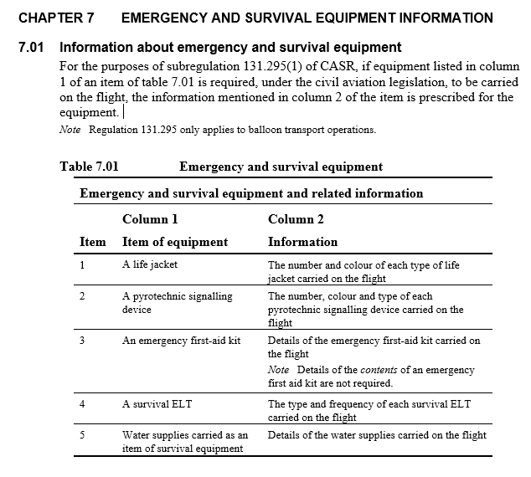

Comments on Policy topic 19 (Chapter 7)

Policy topic 20 – Fuel and ballast requirements (Chapter 21)
Proposed policy
There are some new definitions proposed for fuel and ballast requirements in Chapter 21 of the MOS. CASA also proposes that:
- The pilot in command must determine before take-off, the amount of usable fuel that must be carried for a proposed flight.
- For a balloon transport operation, a ‘final reserve fuel’ of 20 mins flying time would be required to be carried.
- The pilot in command would be required to monitor fuel usage during flight and implement procedures if usable fuel reaches specified amounts remaining.
FACT BANK - Fuel and ballast requirements
Content
Section 21.04 specifies the amount of fuel that must be carried for a flight.

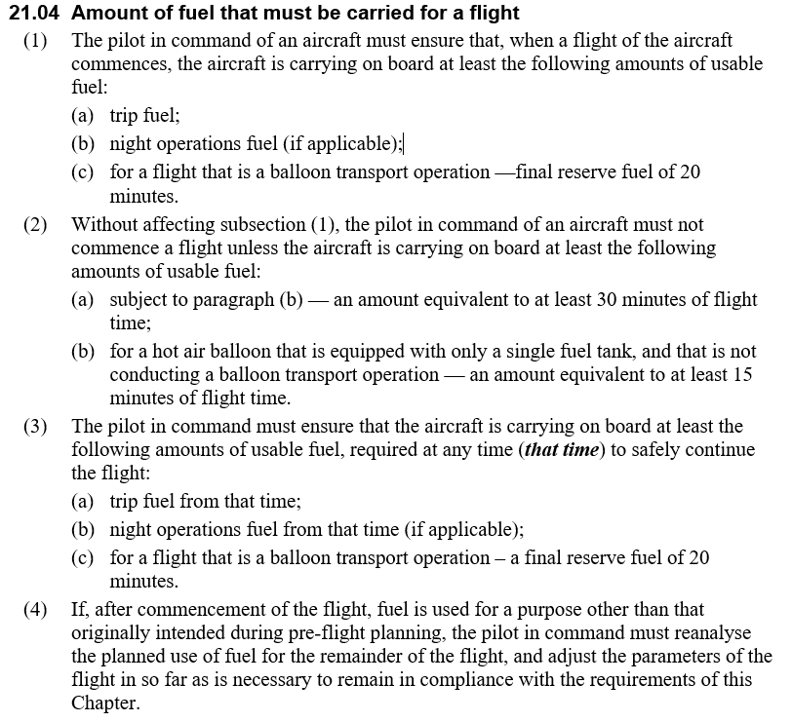
FACT BANK - New definitions for fuel and ballast requirements
Content
Section 21.02 New definitions for fuel and ballast
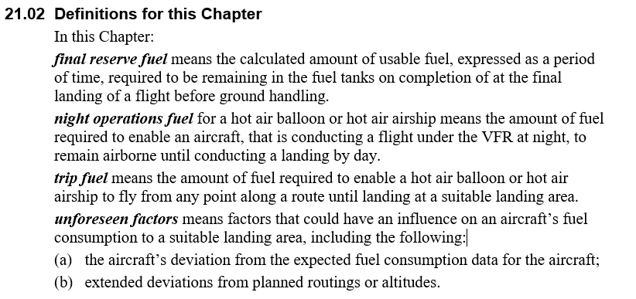

Comments on Policy topic 20 (Chapter 21)

Policy topic 21 – Use of supplemental oxygen equipment (Chapter 10)

Proposed policy
Proposed requirements for supplemental oxygen for flights above 10 000 feet AMSL are set out in Chapter 10 of the MOS. The requirements are based on the FAA rules and align with the rules that apply to small aircraft in Australia.

Comments on Policy topic 21 (Chapter 10)

Policy topic 22 – Equipment (Chapter 26)
Proposed policy
This proposed chapter would set out in one place, the equipment required to be fitted to, or carried on, a Part 131 aircraft for VFR flight by day or night. The requirements for radios, transponders, fire extinguishers, oxygen equipment and emergency equipment would also be set out in this chapter.

A new equipment requirement is proposed that where fitted, a pilot restraint harness must be worn for take-off and landing.

The placarding requirements for experimental Part 131 aircraft are identical to those for all experimental aircraft, and the requirements are detailed in Chapter 27 of the Part 91 MOS.

The general requirements for the operation of surveillance equipment including a transponder and when a transponder is to be carried, will be clearly set out. The operator of a Part 131 aircraft without engine driven electrical power generation, operating in Class C airspace below FL 290, may use:
- an approved ADS-B out configuration
or
- an approved mode S transponder with Class B TABS position source device configuration
or
- an approved transponder.

The optional surveillance equipment requirements will also be detailed.

Comments on Policy topic 22 (Chapter 26)

Page 9: Safety, passengers, personnel, and training

Policy topic 23 – Carriage of persons requiring assistance (Chapter 22)
Proposed policy
This chapter sets out the proposed requirements for the carriage on a flight, of a person who is likely to require assistance. It includes accommodating persons who use a wheelchair in an approved balloon basket.

Comments on Policy topic 23 (Chapter 22)

Policy topic 24 – Passengers – Safety briefings and instructions (Chapter 23)
Proposed policy
This chapter sets out the proposed matters and circumstances which must be included and adhered to in the safety briefings and instructions given to passengers on a Part 131 aircraft, before take-off and before landing. This includes who may give a safety briefing, what must be included in the briefing and requirements for briefing passengers who may not speak English.

Comments on Policy topic 24 (Chapter 23)

Policy topic 25 – Loading weights (Chapter 24)
Proposed policy
In this chapter, CASA proposes the methods for calculating the total weight of the aircraft on take-off to ensure the maximum loading weight permitted by the aircraft flight manual (AFM) is not exceeded.

This chapter also includes proposed methods for calculating the minimum loading weight when such a weight is specified in the AFM, along with an exposition-derived weight for calculating passenger weight for balloon transport operators.

Comments on Policy topic 25 (Chapter 24)

Policy topic 26 – Carriage of passengers (Chapter 25)
Proposed policy
There are no new requirements proposed for carriage of passengers on Part 131 aircraft in this chapter. However, this chapter brings together in one place the policy on requirements relating to:
- maximum number of passengers
- communications with passengers
- location of passengers on the aircraft
- carriage of children as passengers.

Comments on Policy topic 26 (Chapter 25)

Policy topic 27 – Flight crew – qualifications and training (Chapter 27)
Proposed Policy
CASA proposes the pilot of a Part 131 aircraft must be authorised by CASA or a Part 131 Approved Self-Administering Organisation (ASAO).

It is proposed the existing requirements for balloon class endorsement, night VFR flight, currency, and experience would not change. Balloon transport operations would be required to have induction training and area familiarisation for flight crew. Balloon transport operators would also be required to ensure flight crew are trained in emergency procedures and checked for competency every 24 months (the current requirement is for an annual check). The requirements for individuals conducting training and checking would be detailed.

It is also proposed that CASA may test nominated individuals in order to be satisfied of the individual’s competency to perform the role of a training and checking person.

Comments on Policy topic 27 (Chapter 27)

Policy topic 28 – Ground support personnel (Chapter 28)
Proposed policy
This chapter of the MOS would only apply to ground support personnel engaged by a balloon transport operator.

CASA proposes ground support personnel would be required to undertake induction training before carrying out unsupervised ground support for a balloon flight and be checked for competency every 24 months. The proposed requirements for individuals conducting training and checking are detailed in this chapter.

It is also proposed that CASA may test the operator’s nominated individual for training and checking, to ensure CASA is satisfied of their competency to perform the role of a training and check person.

Comments on Policy topic 28 (Chapter 28)

Policy topic 29 – Tethered gas balloons (Chapter 29)
Proposed policy
CASA proposes that a permanently tethered gas balloon must be operated in accordance with the AFM or operator’s instruction manual.

It is also proposed that a tethered gas balloon must be more than 4000 metres from a certified or military aerodrome and the crown of the balloon must not exceed 300 ft above ground level (AGL) during flight.

Comments on Policy topic 29 (Chapter 29)

Page 10: General comments

Do you have any additional comments about the proposed policy?
(Please note, this should not include points you have already raised in this consultation)

Please include in these comments any impact this change may have on you or your operation which has not already been covered in this consultation.

Comments

