Changes to air traffic control standards for operations to parallel runways - CD 1903AS

Overview
Amendments to: Part 172 Manual of Standards (MOS)

CASA proposes to change the air traffic control (ATC) standards for parallel runway operations, including those in use at Sydney (Kingsford Smith) aerodrome, and in the near future, Brisbane aerodrome.

Parallel runways enable busy aerodromes to efficiently and safely handle large numbers of aircraft movements. To ensure the safety of aircraft when operating in close proximity — as occurs during parallel runway operations — there are international standards for minimum lateral displacement between parallel runways, and the associated flight guidance and monitoring equipment, operations, and pilot/controller training.

The Australian standards for parallel runway operations are based on International Civil Aviation Organization (ICAO) standards originally introduced in 1995. The local standards are specified in Section 10.4 of the Part 172 Manual of Standards (MOS). Consistent with the original ICAO standards, the MOS only allows instrument landing system (ILS) for final approach guidance during parallel runway operations and requires ATC to manually vector all arriving aircraft onto final approach.
In November 2018, ICAO amended its standards for parallel runway operations. The changes include the ability to use GNSS Landing System (GLS), RNP APCH AR, and Approach Procedures with Vertical Guidance (APV), in addition to ILS, for final approach guidance. In addition to vectoring, ATC may now also clear aircraft to intercept final approach for a parallel approach operation using a published arrival and approach procedure.

CASA is proposing to adopt the new ICAO standards for use in Australia. To do this, CASA proposes to omit the relevant sections of the MOS. By this action, under the hierarchy in Division 172.C.2 of CASR, the provisions in PANS-ATM section 6.7 Operations on parallel or near-parallel runways will become the applicable standard for operations in Australia.

It should be noted that CASA is not proposing to amend the existing MOS standards for Independent Parallel Visual Approaches, Dependent Parallel Visual Approaches, or Simultaneous Opposite Direction Parallel Runway Operations (SODPROPS) – Subsections 10.4.5, 10.4.6 and 10.4.8 respectively.

The proposed change is structured to become binding on 8 November 2019 but allows an ATS provider to 'opt in' prior to that date.

Documents for review

A copy of the Summary of Proposed Change and other documents related to this consultation are provided below in the ‘Related’ section. This includes a downloadable Word copy and PDF of this consultation for ease of distribution and feedback within your organisation. Please use the on-line consultation form for your response. The word document and PDF should not be used as an emailed submission.

The Summary of Proposed Policy CD 1903AS, comprises three parts:

- Summary of Proposed Change
- Annex A - The draft amending instrument called 'Manual of Standards Part 172 Amendment Instrument 2019 (No. 1)' 303.0 KB (PDF document)
- Annex B - Table comparing the existing MOS standards and proposed (ICAO) provisions for operations to parallel runways 969.1 KB (PDF document)

Why we are consulting

This consultation is seeking feedback on the proposal to adopt the ICAO PANS-ATM standards for operations to parallel runways instead of the existing equivalent standards specified in Section 10.4 of the Part 172 MOS.

General comments and file upload option

There is a general comments box at the end of the consultation. You can add your comments on matters related to the regulatory amendment, which have not already been addressed in the consultation. This page also contains a file upload for an additional document should you wish to provide one.

Comments on the proposal to adopt the ICAO PANS-ATM standards for operations to parallel runways should be submitted through the online response form.

What happens next

Once the consultation has closed, we will register and review each submission received through the online response form. We will make all submissions publicly available on the Consultation Hub, unless you request that your submission remain confidential. We will also publish a Summary of Consultation which summarises the feedback received.

Information about how we consult and how to make a confidential submission is available on the CASA website <https://www.casa.gov.au/rules-and-regulations/landing- page/consultation-process> .

To be notified of any future consultations, you can subscribe to our consultation and rulemaking mailing list <https://mailinglist.casa.gov.au/?p=subscribe&id=3>.

Page: About this consultation
This consultation asks for your feedback on CASA’s proposal to adopt the ICAO PANS-ATM standards for operations to parallel runways, instead of the existing equivalent standards specified in Section 10.4 of the Part 172 MOS.
The proposed changes will involve omitting several subsections from the MOS and then making a consequential amendment to another part of the MOS. Accordingly, the consultation will involve a question pertaining to the subsection to be omitted and any other change to be made.
General comments
The last page of this consultation is a General comments page, where you can make additional comments on the proposed changes.
File upload
Should you wish to support your comments with an additional document, we have provided a file upload facility within the general comments page for your convenience.
We will ask you for:
- personal information, such as your name, any organisation you represent, and your email address
- your consent to publish your submission
- your responses to the proposed changes in the regulations
- any comments you may want to provide
- demographic information to help us understand your interest in the regulations
Our website<https://www.casa.gov.au/rules-and-regulations/landing- page/consultation-process> contains more information on making a submission and what we do with your feedback.

Page 1: Personal information

First name
(Required)

Last name
(Required)

Email address
If you enter your email address, you will automatically receive an acknowledgement email when you submit your response.

Email

Do your views officially represent those of an organisation?
(Required)
Please select only one item
☐ Yes, I am authorised to submit feedback on behalf of an organisation
☐ No, these are my personal views

If yes, please specify the name of your organisation.

Demographic question where applicable
Which of the following best describes the group you represent?

Please select only one item
☐ Air traffic service provider
☐ Air traffic controller
☐ Aircraft owner/operator
☐ Pilot
☐ Other
Please specify if you have selected “Other”.

Page 2: Consent to publish submission
In order to promote debate and transparency, we intend to publish all responses to this consultation. This may include both detailed responses/submissions in full and aggregated data drawn from the responses received.

Where you consent to publication, we will include:

- your last name, if the submission is made by you as an individual
- the name of the organisation on whose behalf the submission has been made
- your responses and comments

We will not include any other personal or demographic information in a published response.

Information about how we consult and how to make a confidential submission is available on the CASA website <https://www.casa.gov.au/rules-and-regulations/landing- page/consultation-process> .

Do you give permission for your response to be published?
(Required)
Please select only one item
☐ Yes - I give permission for my response/submission to be published.
☐ No - I would like my response/submission to remain confidential but understand that de-identified aggregate data may be published.
☐ I am a CASA officer.

Page 3: Proposal no. 1 - Independent Parallel Approaches in IMC

Proposal

- Delete subsection 10.4.2 of Part 172 MOS.
- Make the following PANS-ATM references as the applicable standards in Australia for independent parallel approaches:

  - subsection 6.7.3.2 — Requirements and procedures for independent parallel approaches
  - subsection 6.7.3.3 — Suspension of independent parallel approaches to closely-spaced parallel runways
  - subsection 6.7.3.5 — Determination that an aircraft is established on RNP AR.

Question: Do you agree with the proposed deletion of subsection 10.4.2 Independent parallel approaches in IMC?

The fact banks below, contain a comparison of Subsection 10.4.2 of Part 172 MOS and PANS-ATM.

Please note: To keep the relevant MOS standard in numeric order, it is necessary for the equivalent PANS-ATM provision to be out of numeric sequence.

For brevity, several notes within PANS-ATM (which have no compliance implication) have been omitted.

Fact Bank: Comparison of Subsection 10.4.2 of Part 172 MOS and PANS-ATM – 1
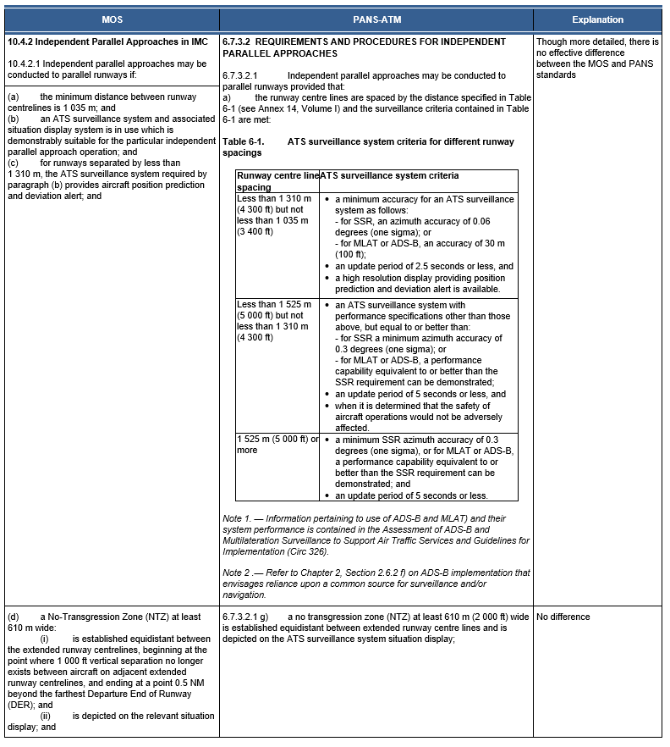

Fact Bank: Comparison of Subsection 10.4.2 of Part 172 MOS and PANS-ATM – 2

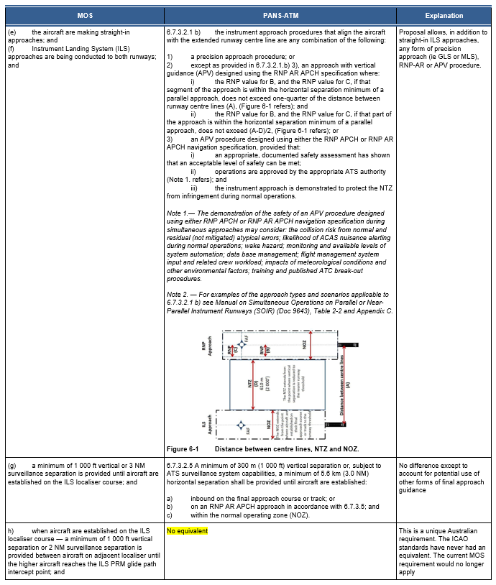

Fact Bank: Comparison of Subsection 10.4.2 of Part 172 MOS and PANS-ATM – 3
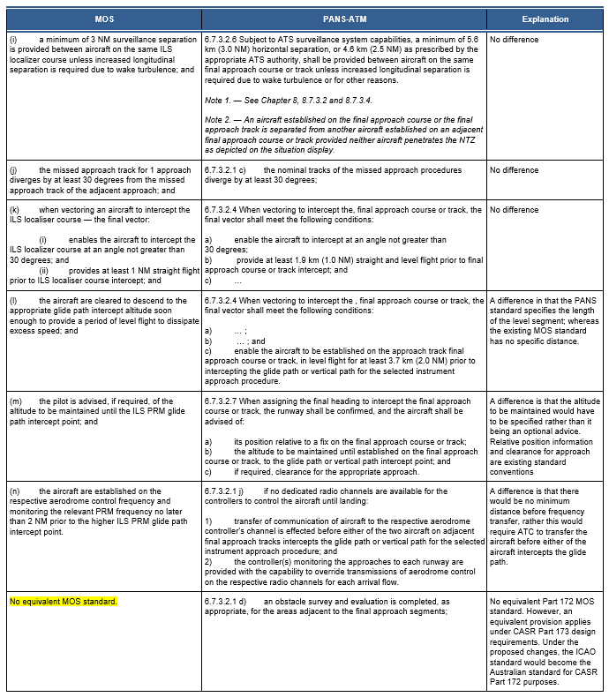

Fact Bank: Comparison of Subsection 10.4.2 of Part 172 MOS and PANS-ATM – 4

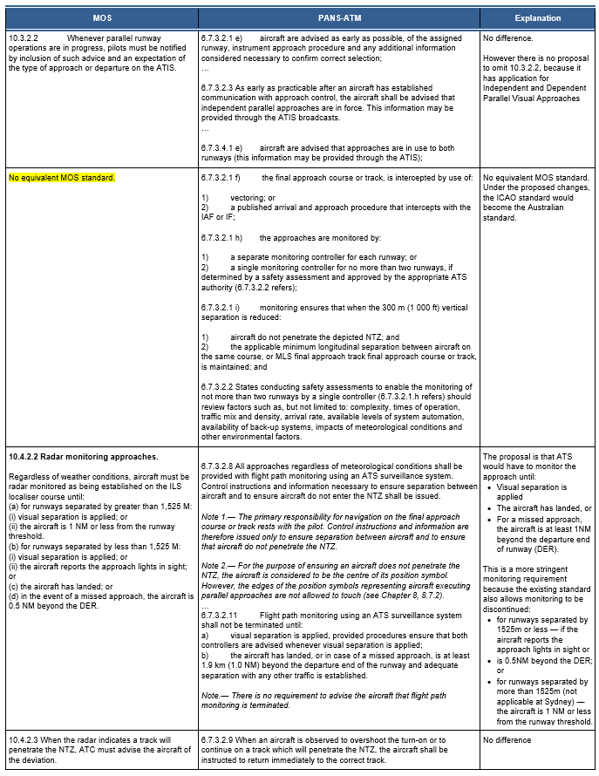

Fact Bank: Comparison of Subsection 10.4.2 of Part 172 MOS and PANS-ATM – 5

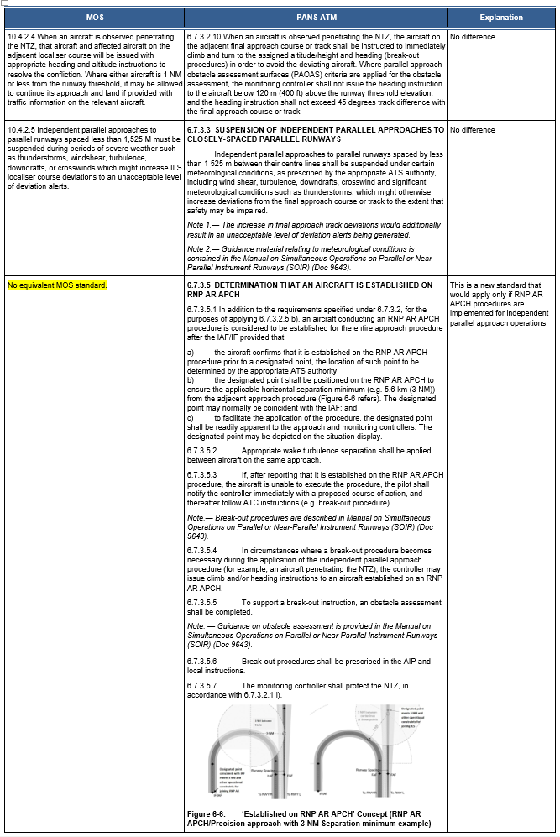

Radio buttons
☐ Agree
☐ Agree with changes (please specify suggested changes below)
☐ Disagree (please set out your reasoning and alternative suggestions below)
☐ Undecided / Not my area of expertise
Comment
Page 4: Proposal no. 2 - Dependent Parallel Approaches in IMC

Proposal

- Delete subsection 10.4.3 of Part 172 MOS.
- Make the following PANS-ATM reference as the applicable standard in Australia for dependent parallel approaches: 6.7.3.4 — Requirements and procedures for dependent parallel approaches.

Question: Do you agree with the proposed deletion of subsection 10.4.3 Dependent parallel approaches in IMC?
The fact banks below, contain a comparison of Subsection 10.4.3 of Part 172 MOS and PANS-ATM.

Please note: To keep the relevant MOS standard in numeric order, it is necessary for the equivalent PANS-ATM provision to be out of numeric sequence.

For brevity, several notes within PANS-ATM (which have no compliance implication) have been omitted.

Fact Bank: Comparison of Subsection 10.4.3 of Part 172 MOS and PANS-ATM – 1

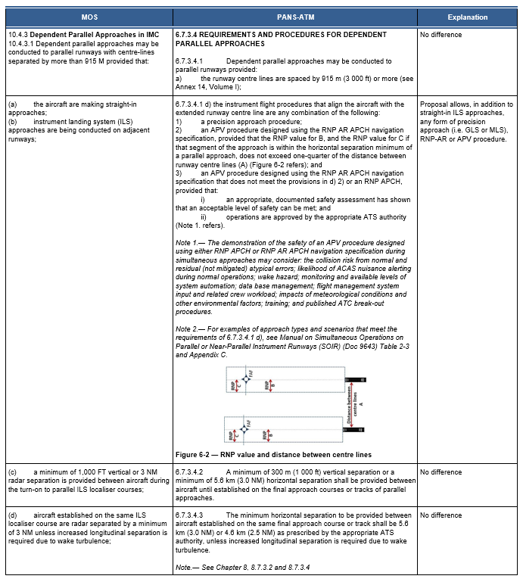

Fact Bank: Comparison of Subsection 10.4.3 of Part 172 MOS and PANS-ATM – 2

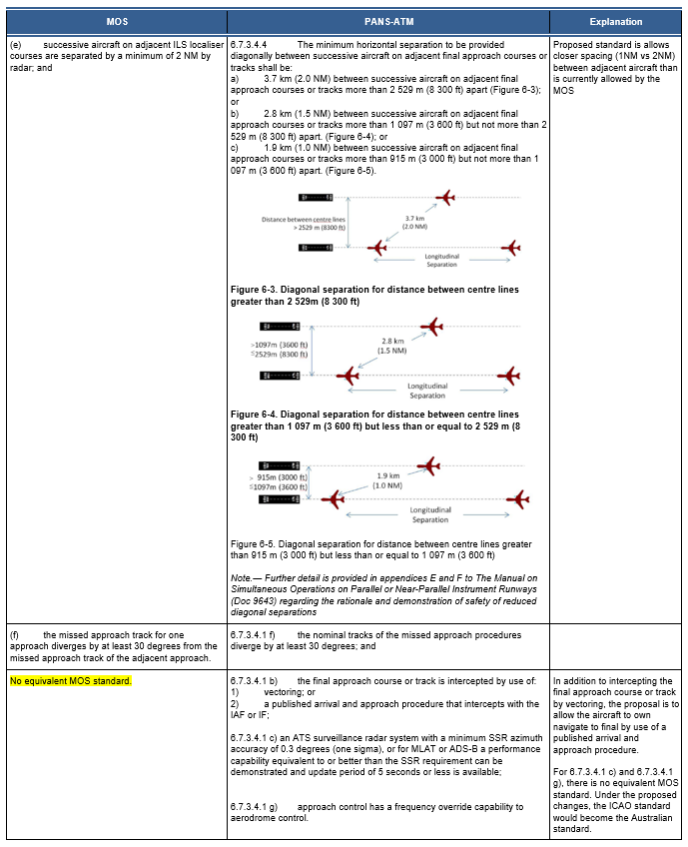

Radio buttons
☐ Agree
☐ Agree with changes (please specify suggested changes below)
☐ Disagree (please set out your reasoning and alternative suggestions below)
☐ Undecided / Not my area of expertise
Comment

Page 5: Proposal no. 3 - Independent Parallel Departures

Proposal

- Delete subsection 10.4.4 of Part 172 MOS.
- Make the following PANS-ATM reference as the applicable standard in Australia for dependent parallel approaches: 6.7.2.2 — Requirements and procedures for independent parallel departures.

Question: Do you agree with the proposed deletion of subsection 10.4.4 — Independent Parallel Departures?
The fact bank below, contains a comparison of Subsection 10.4.4 of Part 172 MOS and PANS-ATM.

Please note: To keep the relevant MOS standard in numeric order, it is necessary for the equivalent PANS-ATM provision to be out of numeric sequence.

For brevity, several notes within PANS-ATM (which have no compliance implication) have been omitted.

Fact Bank: Comparison of Subsection 10.4.4 of Part 172 MOS and PANS-ATM

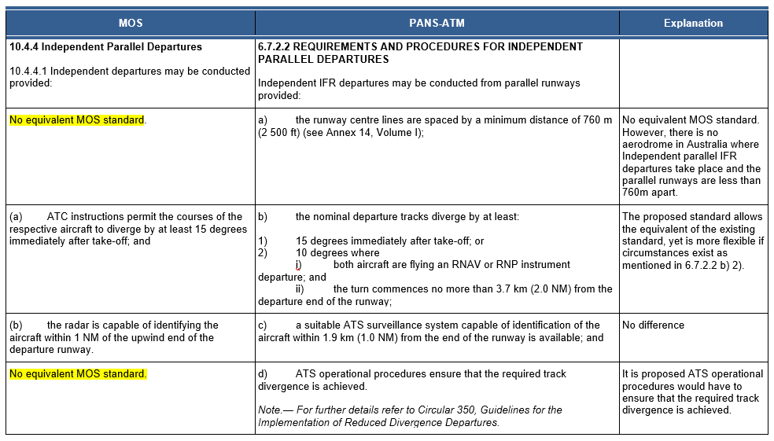

Radio buttons
☐ Agree
☐ Agree with changes (please specify suggested changes below)
☐ Disagree (please set out your reasoning and alternative suggestions below)
☐ Undecided / Not my area of expertise
Comment

Page 6: Proposal no. 4 – Segregated Parallel Operations in IMC

Proposal

- Delete subsection 10.4.7 of Part 172 MOS.
- Make the following PANS-ATM reference as the applicable standard in Australia for dependent parallel approaches: 6.7.3.6 — Requirements and procedures for segregated parallel operations.

Question: Do you agree with the proposed deletion of subsection 10.4.7 — Segregated Parallel Operations in IMC?

The fact bank below, contains a comparison of Subsection 10.4.7 of Part 172 MOS and PANS-ATM.

Please note: To keep the relevant MOS standard in numeric order, it is necessary for the equivalent PANS-ATM provision to be out of numeric sequence.

For brevity, several notes within PANS-ATM (which have no compliance implication) have been omitted.

Fact Bank: Comparison of Subsection 10.4.7 of Part 172 MOS and PANS-ATM

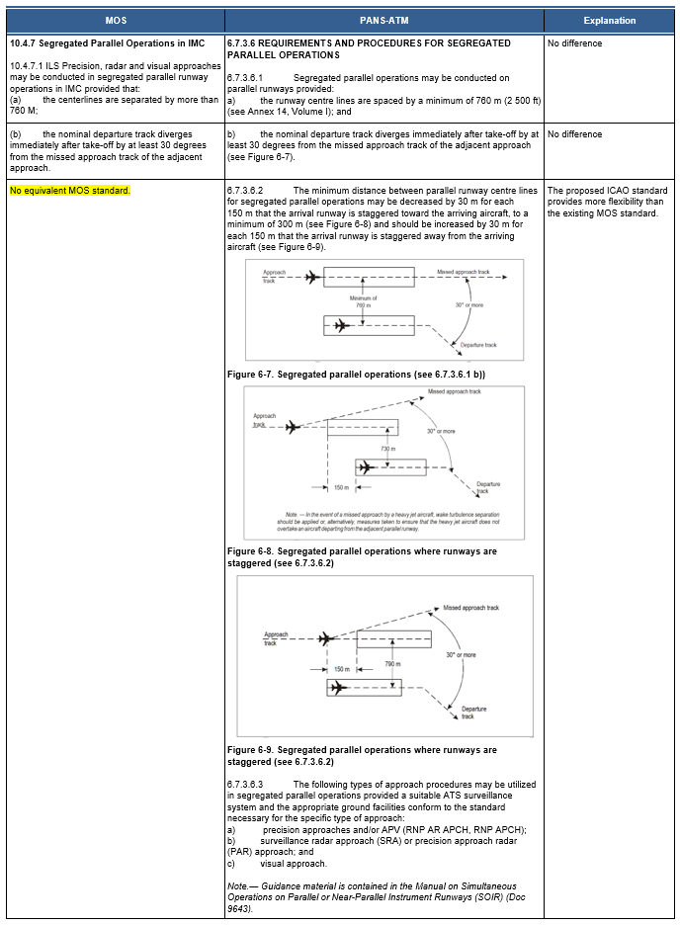

Radio buttons
☐ Agree
☐ Agree with changes (please specify suggested changes below)
☐ Disagree (please set out your reasoning and alternative suggestions below)
☐ Undecided / Not my area of expertise
Comment

Page 7: Consequential amendment

Proposal

- Replace paragraphs 10.5.5.3 with a new paragraph 10.5.5.3, which has wording compatible with the new arrangement for referring to PANS-ATM for the standards for independent or dependent parallel approaches
- Temporarily add paragraphs 10.5.5.3A and 10.5.5.3B to enable an ‘opt-in’ arrangement, whereby an ATS provider can voluntarily introduce the new ICAO standards on a date prior to the standards becoming binding on 8 November 2019.

Question: Do you agree with the proposed consequential amendment to subsection 10.5.5 of the Part 172 MOS?

FACT BANK: Part 172 MOS Section 10.5.5 indicating changes

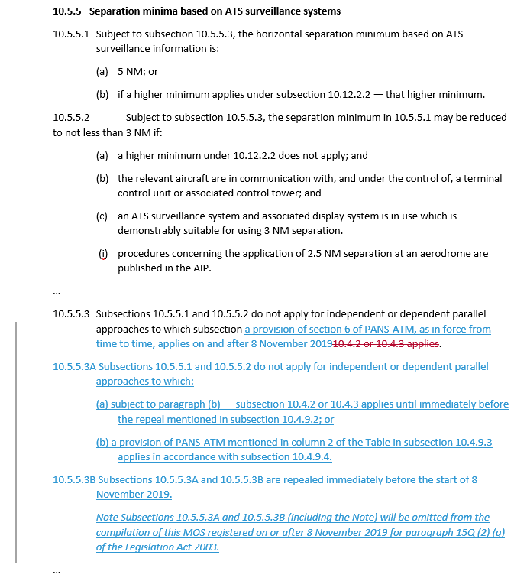

Radio buttons
☐ Agree
☐ Agree with changes (please specify suggested changes below)
☐ Disagree (please set out your reasoning and alternative suggestions below)
☐ Undecided / Not my area of expertise
Comment

Page 8: General comments

Do you have any additional comments about the proposed changes?

(Please note, this should not include points you have already raised)

Comments

File upload option

You may wish to upload a file as part of your submission. Select 'Browse' below and navigate to the file you would like to include. Please note pdf is preferred.

