Consultation - Update to aeroplane flight simulator standards - Part 60 Manual of Standards – Synthetic training devices (CD 1815FS)

Overview

In 2003, CASA aligned technical requirements for aeroplane flight simulators with the International Civil Aviation Organization (ICAO), the United States Federal Aviation Administration (FAA) and the Joint Aviation Authorities of Europe (JAA) standards.

The Part 60 Manual of Standards (MOS) Chapter 3, was the result of a direct “cut and paste” of the standards detailed in:
- ICAO Manual of Criteria for the Qualification of Flight Simulators, Doc 9625-AN/938 Second Edition 2003
- FAA’s proposed FAR Part 60 Appendix A
- Joint Aviation Requirements Aeroplane Flight Simulators (JAR-STD 1A Amendment 3 dated 1 July 2003).

Since CASA’s alignment of the Part 60 MOS Chapter 3 with ICAO, FAA and JAA standards in 2003, ICAO, the European Aviation Safety Agency (EASA) and the FAA have all updated their aeroplane flight simulator standards.

The proposed new rule set

This amendment will update the standards in the Part 60 MOS to directly reference the latest ICAO, FAA and EASA standards.

Directly referencing the latest ICAO, FAA and EASA standards in the MOS avoids the need for CASA to compile a new MOS, based on the international standards.

Principal changes that would occur

The amended Part 60 MOS will directly reference the latest ICAO, FAA and EASA standards for flight simulators. Since the current MOS was published, changes to these three standards have included updated standards aimed at increasing the scope of the Validated Training Envelope. These updated standards include:

- Increasing fidelity to support stall and upset prevention and recovery training (UPRT) requirements
- Increasing the fidelity of the simulation of engine and airframe icing effects
- Upgrade of the capabilities of the instructor operating station (IOS) to ensure adequate feedback to the instructor in UPRT training sequences.

Why we are consulting

As part of the development of aviation rules, CASA consults with the community to ensure the rules will work in practice as they are intended.

CASA recognises the valuable contribution that community and industry consultation makes to the regulatory development process. This consultation is seeking feedback on the proposed updates to Part 60 MOS.

On this page under the heading, ‘Related’, you will find the following documents:

- Summary of proposed change CD 1815FS (Please read the document before providing your feedback in the online survey)
- exposure draft of the Part 60 MOS
- a downloadable PDF and Word copy of this consultation (This is for ease of distribution and feedback within your organisation).

Closing date for comment

Comments on the draft Part 60 MOS should be submitted through the online response form by close of business 10 April 2019.

What happens next

Once the consultation has closed, we will review each submission received through the online response form. We will make all submissions publicly available on the Consultation Hub, unless you request that your submission remain confidential. We will also publish a summary of consultation which summarises the feedback received.

Information about how we consult and how to make a confidential submission is available on the CASA website <https://www.casa.gov.au/rules-and-regulations/landing- page/consultation-process> .

To be notified of any future consultations, you can subscribe to our consultation and rulemaking mailing list <https://mailinglist.casa.gov.au/?p=subscribe&id=3>.

Page 1: About this consultation
This consultation is seeking feedback on the proposed policy to update MOS Part 60 to directly reference the latest ICAO, FAA and EASA standards.

We will ask you for:
- personal information, such as your name, any organisation you represent, and your email address
- your consent to publish your submission
- your responses to the proposed changes in the regulations
- demographic information to help us understand your interest in the regulations

Should you wish, an option is available to upload a file containing your additional feedback on the General comments page within this survey.

Our Website https://www.casa.gov.au/rules-and-regulations/landing-page/consultation-process contains more information on making a submission and what we do with your feedback.

Page 2: Personal information

First name
(Required)

Last name
(Required)

Email address
If you enter your email address, then you will automatically receive an acknowledgement email when you submit your response.

Email

Do your views officially represent those of an organisation?
(Required)
Please select only one item
☐ Yes
☐ No

If yes, please specify the name of your organisation.

Demographic information
Which of the following best describes the group you represent?

Please select only one item
☐ Flight training organisation
☐ Flight simulator manufacturer
☐ Flight simulator operator
☐ Other
Please specify if you have selected “Other”.

Page 3: Consent to publish submission
In order to promote debate and transparency, we intend to publish all responses to this consultation. This may include both detailed responses/submissions in full and aggregated data drawn from the responses received.

Where you consent to publication, we will include:
- your name, if the submission is made by you as an individual or the name of the organisation on whose behalf the submission has been made
- your responses and comments

We will not include any other personal or demographic information in a published response.
Information about how we consult and how to make a confidential submission is available on the CASA website https://www.casa.gov.au/rules-and-regulations/landing-page/consultation-process

Do you give permission for your response to be published?
(Required)
Please select only one item
☐ Yes - I give permission for my response/submission to be published.
☐ No - I would like my response/submission to remain confidential but understand that de-identified aggregate data may be published.
☐ I am a CASA officer.

Page 4: Proposed changes to Part 60 MOS

Question 1
Are the proposed changes to Part 60 MOS appropriate?
FACT BANK: Table: Summary of simulator standards under the proposed MOS revision
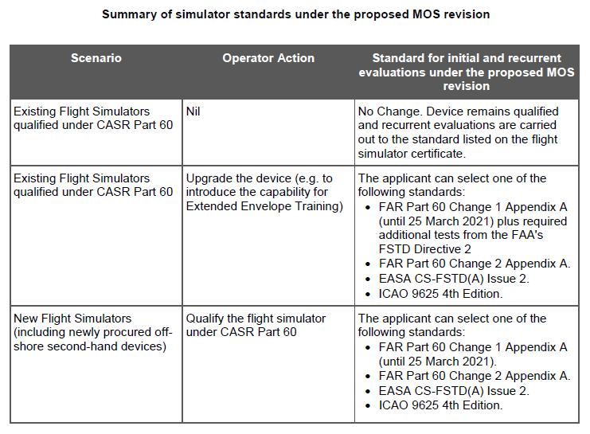
Please select only one item
☐ Yes
☐ Yes, some change/s required (please specify below)
☐ No, change/s required (please specify below)
☐ Not applicable
Comments

Question 2
Can you foresee any difficulties in complying with the proposed changes to Part 60 MOS?
Please select only one item
☐ No
☐ Yes, some change/s required (please specify below)
☐ No, some change/s required (please specify below)
☐ Not applicable
Comments

Page 5: Purchase of aeroplane flight simulators for 2019

Question 1:
Have you purchased an aeroplane flight simulator which is planned for delivery in 2019?

If your answer to the question above is yes, please provide details of

- the flight simulator
- the standard under which it would qualify in the new proposed standards.

Please enter your response in the comment boxes provided below.

Flight simulator details

Proposed Standard under which the flight simulator would qualify

Page 6: General comments

Do you have any additional comments about the proposed policy?

(Please note, this should not include points you have already raised)

Comments

