Consultation - Modernising Australia’s fatigue rules - proposed CAO 48.1 Instrument 2019 - (CD 1811OS)

Overview
CASA’s response <http://www.casa.gov.au/sites/g/files/net351/f/modernising-australia-fatigue-rules-casa-response-to-independent-review- recommendations.pdf> to the independent review of fatigue rules identified 54 actions to address the review team’s recommendations. The proposed Civil Aviation Order (CAO) 48.1 Instrument 2019, aims to address 12 of these actions to support the transition of high capacity regular public transport operators to the new rules by 30 September 2019. A further amendment to the rules may be required in 2019 to support the transition of other operators to the new rules by 26 March 2020.

The proposed instrument applies to Air Operator's Certificate holders, Part 141 certificate holders and flight crew licence holders. Changes from the current rules include:
- Revised prescriptive limits to more closely align with international averages
- Removal of daily flight time limits for most operations
- Revised augmented crew limits
- Replacement of late-night operations restrictions with new restrictions based on infringement of the window of circadian low
- Revised standby limits based on US Federal Aviation Regulations short call reserve provisions
- Replacing the prescriptive approach to re-assignment of flight duty with an outcome-based approach
- Revising FRMS change management processes and other provisions to reflect an outcome-based approach
- Permitting aerial application operators to operate in accordance with Subpart 137.Q of CASR.
- Incorporating all new fatigue rules into a single instrument.
- Updating provisions related to shared responsibility between operators and flight crew members in line with proposed Part 91 of CASR.

The proposed CAO 48.1 Instrument 2019 will repeal and replace CAO 48.1 Instrument 2013, CAO 48.1 Amendment Instrument 2016 (No 1) and the older fatigue rules. The proposed instrument provides transitional provisions allowing operators to conduct operations in accordance with their current rules until the applicable transition date.

There are no proposed changes for flight crew licence holders when operating in a private capacity. Paragraph 16.1 of the proposed instrument applies, in line with the current rules.

Why we are consulting
As part of modernising Australia’s fatigue rules, we are consulting with the aviation community to ensure the rules will work in practice as they are intended.

We understand that regulations can be difficult to read, so we’ve made it easier for you to have your say by highlighting the key issues that have changed. CASA will continue to look at ways to make the rules easier to read and understand before they are introduced.

The consultation will ask you questions on the proposed changes to CAO 48.1. Each question will include the relevant section of the amended rules. At the bottom of this page, we have attached all the documents that relate to the consultation— you do not have to read them in full.

You may comment on as many, or as few of these changes as you like and provide general comments.

Recent industry feedback

The independent review team, assembled by Dédale Asia Pacific, delivered its final report in March 2018. The report confirmed the need to modernise Australia’s fatigue rules and provided 24 recommendations to improve the rules.

The recommendations were published by CASA for public consultation between 21 March and 22 April 2018. Twenty-six responses were received from industry, including major airlines, operator associations, pilot associations and individuals, and CASA staff. Where permission was granted, responses were published on CASA’s Consultation Hub.

Subsequently, the Aviation Safety Advisory Panel <https://www.casa.gov.au/rules-and-regulations/standard-page/aviation-safety-advisory-panel> (ASAP) appointed a Technical Working Group (TWG), to review industry feedback and CASA's proposed responses to the feedback in July 2018. TWG comprised representatives from operators, pilot associations, industry associations and academia.

Industry feedback and the TWG broadly supported the need to modernise Australia's fatigue rules along with the review team's recommendations and CASA's proposed response. However, there were dissenting views on some issues.

CASA’s response to the Independent review of aviation fatigue rules <https://www.casa.gov.au/files/independent-review-aviation-fatigue-rules-operators-and-pilots> considered feedback from the public consultation, TWG and ASAP. This proposal seeks to achieve 12 of the actions identified in CASA's response.

The proposed CAO 48.1 Instrument 2019 has been reviewed by an industry TWG and feedback has been incorporated into the current draft and consultation questions.

Documents for review

A copy of the Summary of proposed change CD 1811OS and other documents related to this consultation are provided below in the ‘Related Documents’ section. This includes a downloadable MSWord and PDF copy of this consultation for ease of distribution and feedback within your organisation.

For your convenience and for ease of identification of the changes, the Exposure Draft CAO 48.1, is accompanied by a copy of the exposure draft containing the ‘track changes’ of the proposed updates to the CAO.

What happens next

Once this consultation has closed, we will register and review each submission received through this online response form. Unless you have requested that your submission remain confidential, we will make all submissions publicly available here on the Consultation Hub. We will also publish a summary of consultation which will summarise the feedback received.

Before the rules are finalised the ASAP will consider how CASA has incorporated feedback and will provide us with further advice. We will consider feedback from public consultation and advice from the ASAP prior to finalising proposed CAO 48.1 Instrument 2019.

To address the remaining actions identified in our response to the independent review, a further proposed amendment may be developed and publicly consulted.

Consultation contents
CAO 48.1 Instrument 2019 retains the majority of rules in CAO 48.1 Instrument 2013 as amended by CAO 48.1 Amendment Instrument 2016 (No 1).
The first three sections below are about the consultation and ask you for some information about yourself.
The next eleven sections relate to the changes to the rules. The last three sections are about the changes more generally and your priorities.
Unless an answer is required or mandatory, you can answer as few or as many of the questions as you like.
When you have completed the consultation, click the ‘Finish’ button at the bottom right of this page.

 | Page | Response
1 | About this consultation
2 | Personal information
3 | Consent to publish your submission
4 | Maximum flight duty periods
5 | Flight time limits
6 | Augmented crew limits
7 | Disruptive schedule management
8 | Standby
9 | Reassignment
10 | Fatigue risk management systems
11 | Aerial application
12 | Shared responsibility
13 | Consolidation and transitional provisions
14 | Other changes
15 | Policy questions
16 | General response
17 | Your priorities

PAGE 1: About this consultation

This consultation asks for your feedback on the proposed CAO 48.1 Instrument 2019 - (CD 1811OS).

We will ask you for:

- personal information, such as your name, any organisation you represent, and your email address
- your consent to publish your submission
- your responses to the proposed changes in the regulations
- any comments you may want to provide
- demographic information to help us understand your interest in the regulations

Should you wish, an option is available to upload a file containing your additional feedback on the General comments page within this survey. Our website contains more information on making a submission and what we do with your feedback.

PAGE 2: Personal information

First name
(Required)

Last name
(Required)

Email
(Required)
If you enter your email address, then you will automatically receive an acknowledgement email when you submit your response.

Do your views officially represent those of an organisation?
(Required)
Please select only one item
☐ Yes
☐ No
If yes, please specify the name of the organisation.

Where do you live or in which area do you operate?
Postcode

PAGE 3: Consent to publish your submission
In order to promote debate and transparency, we intend to publish all responses to this consultation. This may include both detailed responses/submissions in full and aggregated data drawn from the responses received.

Where you consent to publication, we will include:

- your name, if the submission is made by you as an individual or the name of the organisation on whose behalf the submission has been made
- your responses and comments

We will not include any other personal or demographic information in a published response.

Information about how we consult and how to make a confidential submission is available on the CASA website <https://www.casa.gov.au/rules- and-regulations/landing-page/consultation-process>

Do you give permission for your response to be published? Please tick only one box.
(Required)
Please select only one item
☐ Yes - I give permission for my response/submission to be published
☐ No - I would like my response/submission to remain confidential but understand that de-identified aggregate data may be published.
☐ I am a CASA officer.

Page 4: Maximum flight duty periods

This proposal amends prescriptive limits in Appendices 2 and 3, to better align with international averages.

CASA Action 3-1: CASA will amend the prescriptive flight duty period limits in Appendices 2 and 3 in accordance with Table 1 and provide a single flight time limit for each Appendix in accordance with Table 2.

Background

The independent review of fatigue rules identified that CAO 48.1 prescriptive limits are conservative when compared with similar international jurisdictions and that there are no unique aspects of the Australian operating environment that necessitate a more conservative approach.

We considered the recommendations of the independent review, the results of a survey of over 1,100 Australian pilots, fatigue science and feedback from industry. The proposed limits more closely align with international averages while continuing to address fatigue risks predicted by scientific research.

The flight duty period limits have been modified since we released our response to the independent review. This reflects feedback from the industry technical working group and provides a more consistent approach to increasing numbers of sectors.

The proposed new limits (acclimatised flight crew)

The limits for acclimatised flight crew members are based on the following:

- an acclimatised start time between 0700 and 1259 represents the optimal start time period to minimise fatigue whilst acknowledging a strong passenger demand for early departures. Flight duty periods of up to 13 hours are permitted in this start period.
- once the start time reaches 1300 the maximum flight duty period is reduced to 12 hours because these flights may encroach the window of circadian low (WOCL) and the potential for prolonged wakefulness; this continues until a start time of 1559.
- for start times between 1600 and 2259 the maximum flight duty period is further reduced to 11 hours due to the compounding effects of WOCL encroachment, likely prolonged wakefulness and a reduced propensity, quality and quantity of sleep during the day.
- flight duty periods commencing between 2300 and 0459 present the greatest fatigue risk due to increasing effects of WOCL encroachment, prolonged wakefulness and a reduced propensity, quality and quantity of sleep. These flight duty periods are limited to a maximum of 10 hours.
- maximum flight duty period increases by one hour at 0500 and a further 30 minutes at 0600 due to the improving opportunity to achieve sleep prior to the duty.
- the maximum flight duty period reduces, for periods with more than 3 sectors, by 30 minutes per sector to address the additional physical and cognitive fatigue associated with multiple approaches and departures.

Fact Bank: Table 1 revised flight duty period limits
Table 1 (below) provides the maximum flight duty period according to acclimatised start time and sectors to be flown. This table has additional detail compared to the table in the draft CAO, including hour by hour detail showing the end of duty time for a maximum flight duty period, with shading to demonstrate where the duty encroaches the WOCL.

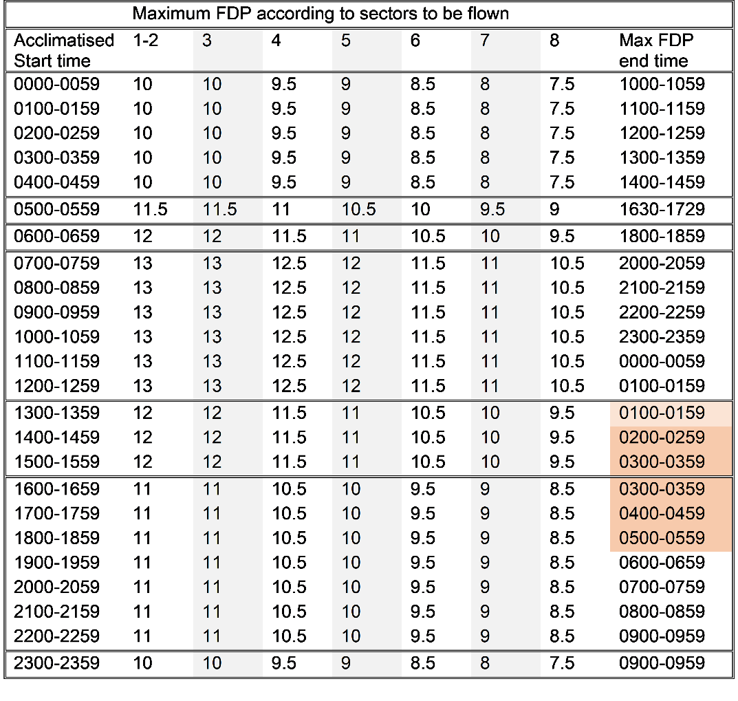

Fact Bank: Comparison with previous limits

This chart shows the proposed limits in comparison with the old Standard Industry Exemption and the current CAO 48.1.

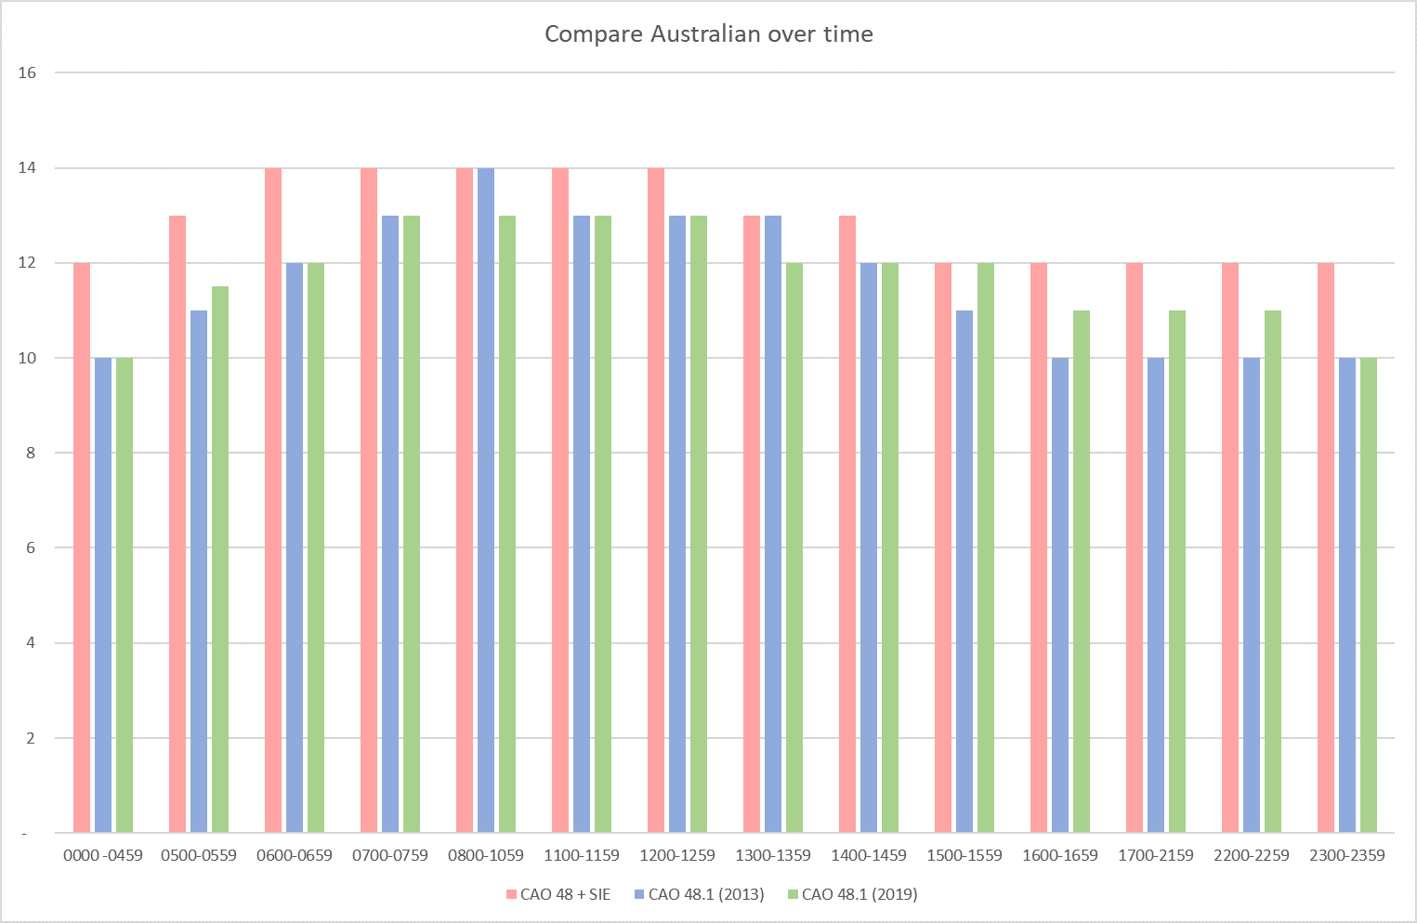

Fact Bank: Comparison with international limits
This chart shows the proposed limits in comparison with other regulators.

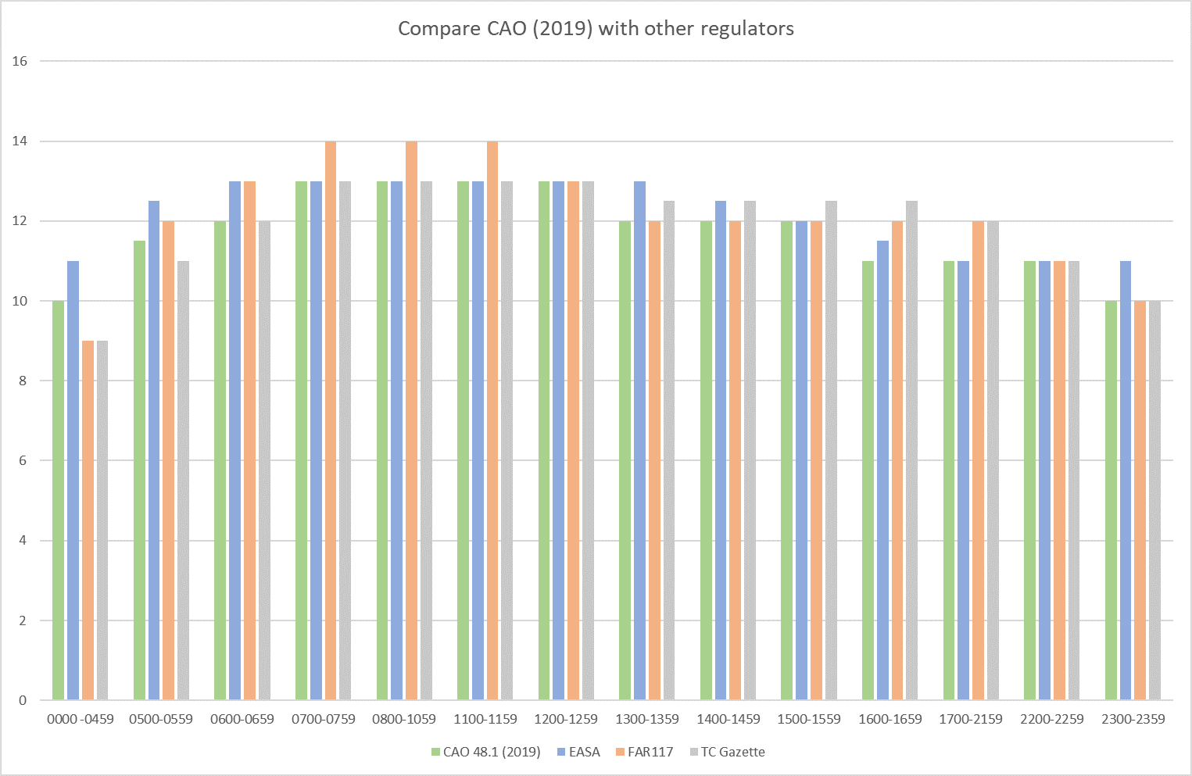

Fact Bank: Extracts from consultation draft - Appendix 2 Clause 2 and Table 2.1

APPENDIX 2 — MULTI-PILOT OPERATIONS EXCEPT FLIGHT TRAINING

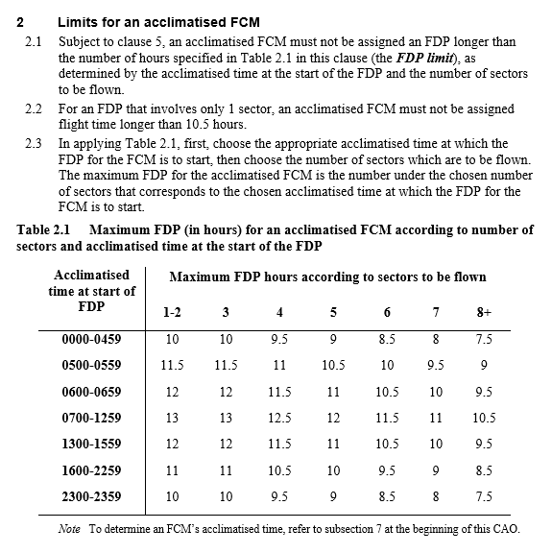

See also:

Appendix 3 Clause 2 and table 2.1

The flight duty period limits for flight crew members in an unknown state of acclimatisation, have been updated to align with Table 1.

Limits for crew members with less than 30 hours prior off-duty period, match the worst case acclimatised limits (2300-0459) reflecting the additional fatigue risk associated with time zone change.

Limits for crew members with more than 30 hours prior off-duty period, match the acclimatised limits for a start time of 0600-0659 limits, to reflect an improved ability to optimise sleep during an extended off-duty period whilst still reflecting the fatigue risk associated with time zone changes.

Fact Bank: Extracts from consultation draft - Appendix 2 Clause 3 and Table 3.1 APPENDIX 2 — MULTI-PILOT OPERATIONS EXCEPT FLIGHT TRAINING

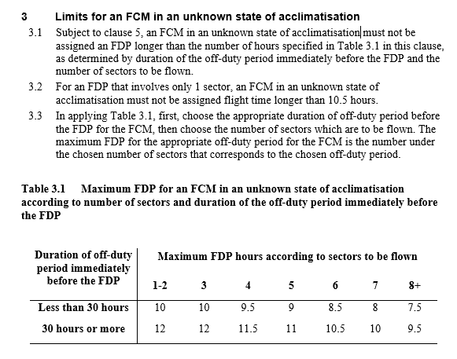

Fact Bank: Action 3-1: CASA response to recommendation 3

See Page 6-9 - CASA’s response <http://www.casa.gov.au/sites/g/files/net351/f/modernising-australia-fatigue-rules-casa-response-to-independent-review- recommendations.pdf>

Fact Bank: Independent review report recommendation 3
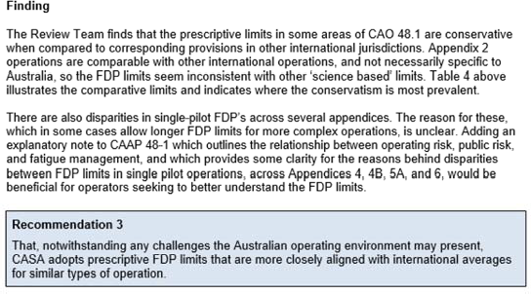

Does this proposal achieve the intended Action 3-1?
Please select only one item
☐ yes
☐ some change/s required (please specify below)
☐ no (please specify below)
☐ not applicable

Are there additional factors that CASA should consider in implementing this change?

PAGE 5: Flight time limits

This proposal simplifies management of daily flight time limits.

CASA Action 3-1: CASA will amend the prescriptive flight duty period limits in Appendices 2 and 3 in accordance with Table 1 and provide a single flight time limit for each Appendix in accordance with Table 2.

The research regarding daily flight time limits is scarce. However, there is general consensus that flight time is the most fatiguing aspect of a flight duty period. Whilst EASA and Transport Canada have removed limits for daily flight time, the FAA still prescribes daily limits for flight time. We identified in our response to the independent review, that we would simplify the management of flight time by removing flight time limits from the prescriptive limit tables and establishing a single flight time for each appendix.

After further consideration, we have determined that flight duty period limits do not need to be supplemented by daily flight time limits except in the following cases:

- Two pilot single sector - 10.5 hours to mitigate the effect of prolonged attention and monitoring
- Flight training - 7 hours to reflect the additional task demands of flight training.

The two pilot single sector limit is further reduced, depending on start time as the flight duty period becomes the more limiting factor.

We have not included a single pilot, single sector limit, as aircraft endurance is more limiting in single pilot aircraft.

Fact Bank: Extracts from consultation draft Appendix 2 sub-clause 2.2 and Appendix 6 sub-clause 2.2

APPENDIX 2 — MULTI-PILOT OPERATIONS EXCEPT FLIGHT TRAINING

APPENDIX 6 — FLIGHT TRAINING

See also:

Consultation draft Appendix 2 sub-clauses 3.2, 5.1, 5.2, 5.4 and Tables 5.1 and 5.2.

Consultation draft Appendix 3 sub-clauses 2.3, 3.2 and Table 2.1

Consultation draft Appendix 4 sub-clause 2.2 and Table 2.1 Consultation draft Appendix 4b sub-clause 1.2 and Table 1.1 Consultation draft Appendix 6 sub-clause 2.2 and Table 2.1

Fact Bank: CASA response to recommendation 3
See Page 6-9 - CASA’s response <http://www.casa.gov.au/sites/g/files/net351/f/modernising-australia-fatigue-rules-casa-response-to-independent-review- recommendations.pdf>

Does this proposal achieve the intended Action 3-1?
Please select only one item
☐ yes
☐ some change/s required (please specify below)
☐ no (please specify below)
☐ not applicable
Are there additional factors that CASA should consider in implementing this change?

PAGE 6: Augmented crew limits

This proposal revises the approach and limits for augmented crew operations.

CASA Action 25-5: CASA will review augmented crew flight duty limits and seek Technical Working Group feedback. Following feedback, amendments to the augmented crew limits may be proposed.

CASA reviewed the augmented crew limits with an industry technical working group. Appendix 2 Tables 5.1 and 5.2 have been amended to reflect a revised approach to augmented crew operations.

Class 1 and 2

Class 1 and 2 crew rest facilities are intended to be fit-for-purpose to achieve sleep. This allows flight crew members to plan their sleep both pre-flight and in-flight, to mitigate the effects of fatigue. The impacts of flight duty period start time are mitigated by the crew augmentation in conjunction with the related in-flight rest rules.

The revised flight duty period limits at Table 1 below, were derived by starting with a 13 hour maximum for two pilot operations and increasing the maximum duty period, depending on the class of rest facility and number of additional crew. This reflects research that the type of rest facility impacts both the quality and quantity of in-flight sleep. The class 1 and 2 augmented crew limits are the same for flight crew members in unknown states of acclimatisation.

This approach is similar to the approach of other regulators.

Flight duty periods in excess of 18 hours require specific risk mitigation within a CASA approved fatigue risk management system.

Fact Bank: Table 1 Augmented crew limits class 1 and 2
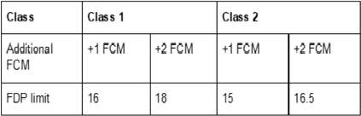

Class 3

Studies have shown that sleep quality and quantity is reduced in class 3 crew rest facilities; however, restorative rest can even be achieved in a cockpit environment with significant improvements in alertness and psychomotor performance. The additional flight crew members help to offset the worst effects of start times and extended duty periods.

The revised FDP limits for Class 3 crew rest facilities are at Table 2 below and a comparison with unaugmented limits is at Figure 1 below.

Fact Bank: Table 2 Augmented crew limits class 3
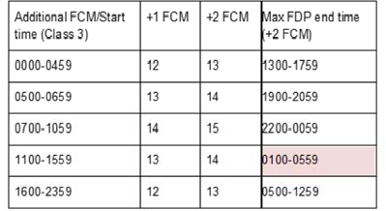

Fact Bank: Figure 1 Comparison of limits class 3
This chart shows that augmented crew provide the most beneficial effect for back of the clock operations, due to the in-flight rest opportunity.
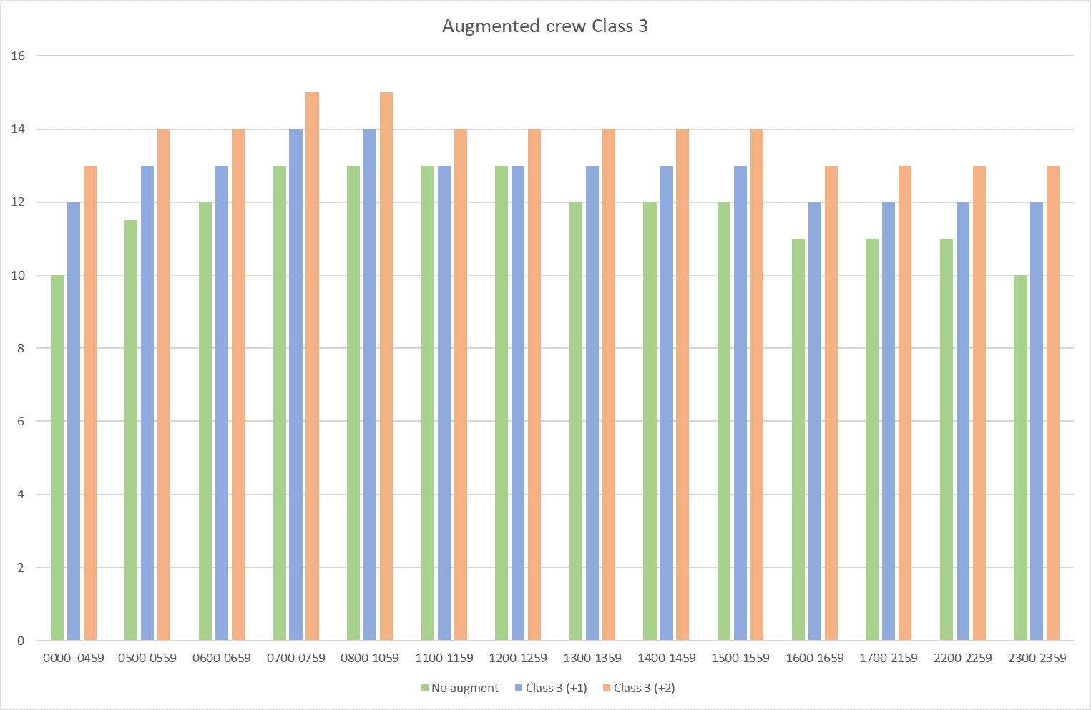

Fact Bank: Extracts from consultation draft - Appendix 2 Clause 5,5.1 and Table 5.1 and sub-clause 5.5 and Table 5.2 APPENDIX 2 — MULTI-PILOT OPERATIONS EXCEPT FLIGHT TRAINING
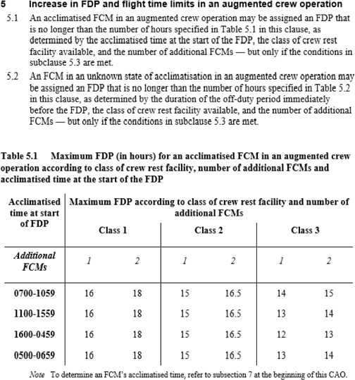

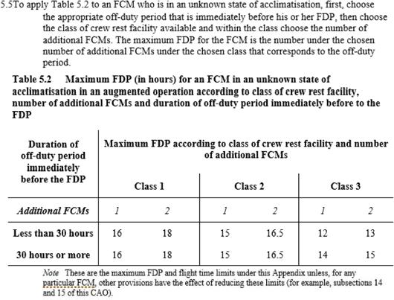

Fact Bank: CASA response to independent review report, Page 7

The Technical Working Group discussed start time windows and related limits for augmented crew operations. Some studies have demonstrated a propensity to sleep and wake based on homeostatic drive and societal norms regardless of rostering patterns. Conversely, anecdotal experience indicates that later start time windows might promote improved in flight rest due to alignment with natural circadian lows. CASA will review augmented crew start time windows and duty periods under action 25-5.

Does this proposal achieve the intended Action 25-5?
Please select only one item
☐ yes
☐ some change/s required (please specify below)
☐ no (please specify below)
☐ not applicable

Are there additional factors that CASA should consider in implementing this change?

PAGE 7: Disruptive schedule management

This proposal replaces late night operations provisions, with restrictions on consecutive infringement of the WOCL, in response to consultation and TWG feedback.

CASA Action 25-6: CASA will develop additional mitigations to deal with consecutive early starts using the approach in CAO 48.0 as a starting point and seek Technical Working Group feedback. Following feedback, amendments to the rules may be proposed.

CASA Action 25-11: CASA will consider whether there is benefit in explicitly defining a window of circadian low and seek Technical Working Group feedback. Some Technical Working Group members suggested a definition of 0200-0600; however, there was no consensus on the need for a definition, the associated time period or the additional mitigations that should be associated with the definition.

Background

Surveys of pilots in Australia and internationally have identified consecutive early starts, night operations and alternating early/late schedules as the most fatiguing rosters. We reviewed the management of disruptive schedules with an industry technical working group and explored a number of potential solutions. Consensus was not achieved and further industry input is sought to assist in resolving this issue.

Some members expressed concern that current rosters could not be achieved with the proposed rules and that the rules might drive schedule optimisers to generate alternating early / late patterns which are acknowledged as generating fatigue reports.

Other members expressed concern that the proposed rule does not adequately protect late night operations or alternating early / late patterns.

The current proposal replaces existing late night operations provisions with restrictions on consecutive infringement on the window of circadian low.

The window of circadian low will be defined as 0200-0559 local acclimatised time to align with ICAO definitions.

If a flight duty period infringes the window of circadian low, the next flight duty period must not commence until at least 24 hours after commencement of the first flight duty period. This avoids compounding fatigue risk by compressing the circadian day. The effect of this rule is that a roster cannot rotate backwards e.g., Day 1 – 0530, Day 2 – 0500, Day 3 – 0430.

After three consecutive flight duty periods which infringe the window of circadian low, the maximum flight duty period is reduced for subsequent infringing flight duty periods with a maximum of five consecutive infringing flight duty periods.

Fact Bank: Extracts from consultation draft - Part 1 Clause 6 definition - window of circadian low and Appendix 2 Clause 13 PART 1 GENERAL
6 Definitions
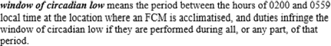

APPENDIX 2 — MULTI-PILOT OPERATIONS EXCEPT FLIGHT TRAINING
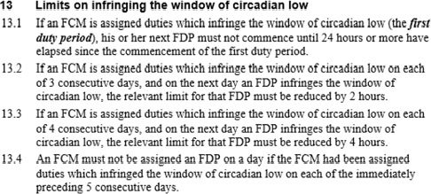
See also:

Appendix 3 Clause 11

Appendix 6 Clause 10

Fact Bank: CASA response to independent review - Actions 25-6 and 25-11 (Page 7)

Action 25-6 Review consecutive early starts
CASA will develop additional mitigations to deal with consecutive early starts using the approach in CAO 48.0 as a starting point and seek Technical Working Group feedback. Following feedback, amendments to the rules may be proposed.

Action 25-11 Window of circadian low definition

CASA will consider whether there is benefit in explicitly defining a window of circadian low and seek Technical Working Group feedback.

Some Technical Working Group members suggested a definition of 0200-0600; however, there was no consensus on the need for a definition, the associated time period or the additional mitigations that should be associated with the definition.

The Technical Working Group discussed the results of a survey of 1,132 Australian commercial pilots4. Consecutive early starts and switching from early to late starts were identified as frequent concerns, which align with scientific understanding of the window of circadian low and circadian dysrhythmia. This issue will be addressed by action 25-6.

Does this proposal achieve the intended Actions 25-6 and 25-11?
Please select only one item
☐ yes
☐ some change/s required (please specify below)
☐ no (please specify below)
☐ not applicable
Are there additional factors that CASA should consider in implementing this change?

PAGE 8: Standby

This proposal amends standby requirements in response to industry feedback.

CASA Action 25-13: CASA will review the management of standby under CAO 48.1 and seek Technical Working Group feedback on any proposed changes to the rules.

Background

We reviewed standby provisions with an industry working group and compared the approaches of other regulators. The FAA short call reserve provisions provide a suitable basis to manage fatigue related to standby.

Fact Bank: Extracts from consultation draft - Appendix 2 Clause 8

APPENDIX 2 — MULTI-PILOT OPERATIONS EXCEPT FLIGHT TRAINING
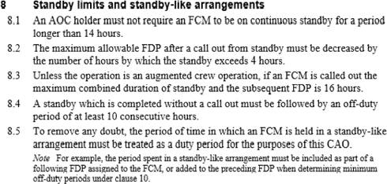

See also:

Appendix 3 clause 6

Appendix 4 clause 6

Appendix 6 clause 5

Fact Bank: CASA response to independent review - Action 25-13

Action 25-13 Standby

CASA will review the management of standby under CAO 48.1 and seek Technical Working Group feedback on any proposed changes to the rules.

Does this proposal achieve the intended Action 25-13?
Please select only one item
☐ yes
☐ some change/s required (please specify below)
☐ no (please specify below)
☐ not applicable

Are there additional factors that CASA should consider in implementing this change?

PAGE 9: Reassignment

This proposal replaces the prescriptive approach to re-assignment of flight duty with an outcome-based approach

CASA Action 12-1: CASA will replace the 4 hour limit in subclause 7.1 of Appendix 2 with a requirement for explicit acknowledgement that flight crew are sufficiently rested before re-assigning a longer flight duty period.

Explicit acknowledgement that flight crew are sufficiently rested prior to re-assigning longer duty periods is preferable to the prescriptive limit in the current rules.

Fact Bank: Extracts from consultation draft - Appendix 2 sub-clause 7.1

APPENDIX 2 — MULTI-PILOT OPERATIONS EXCEPT FLIGHT TRAINING
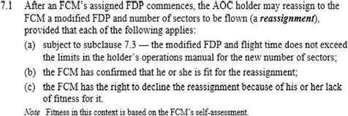

See also:

Consultation draft Appendix 3 sub-clause 5.1

Consultation draft Appendix 4 sub-clause 5.1

Consultation draft Appendix 6 sub-clause 4.1

Does this proposal achieve the intended Action 12-1?
Please select only one item
☐ yes
☐ some change/s required (please specify below)
☐ no (please specify below)
☐ not applicable

Are there additional factors that CASA should consider in implementing this change?

PAGE 10: Fatigue risk management systems

This proposal amends fatigue risk management system requirements, to achieve a more outcome-based system in response to recommendations 5 and 6.

CASA Action 5-1: CASA will incorporate an FRMS change management process based on the draft Part 119 of CASR significant change process.

CASA Action 6-1: CASA will improve the distinction between legal requirements, guidance material and acceptable means of compliance in CAO
48.1 and supporting guidance material.

Background

This proposed change provides operators enough flexibility to modify their fatigue risk management system in response to data, while ensuring appropriate regulatory oversight for significant changes.

CASA approval will only be required for significant changes such as any proposed increase in maximum flight duty periods, any proposed decrease in minimum off-duty periods and any other change that is not likely to maintain or improve aviation safety.

The distinction between legal requirements and guidance has been improved in several sections. Some material has been removed from the CAO and will be replaced with improved guidance material.

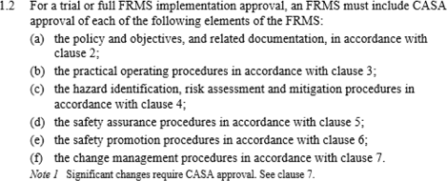
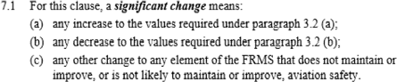
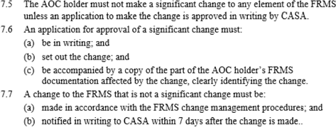
Fact Bank: Extracts from consultation draft - Appendix 7 sub-clause 1.2, Note 1, sub-clauses 7.1 and 7.5 - 7.7

APPENDIX 7 — FATIGUE RISK MANAGEMENT SYSTEM (FRMS)

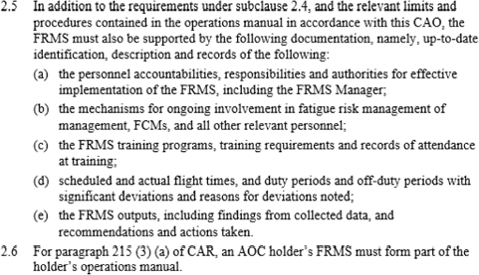
Fact Bank: Extracts from consultation draft - Appendix 7 sub-clauses 2.3(g), 2.5, 2.6, 3.1, 3.3, 4.3, 4.4, 4.6d, 5.1, 5.4b,c, 6.2a
APPENDIX 7 — FATIGUE RISK MANAGEMENT SYSTEM (FRMS)

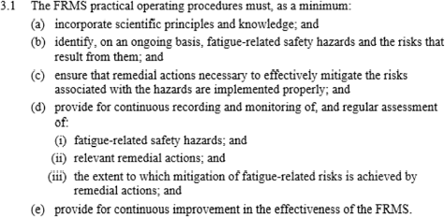
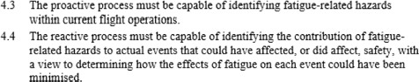

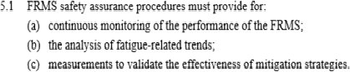
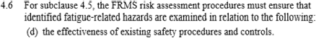
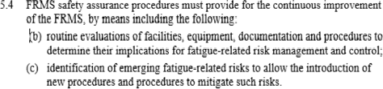
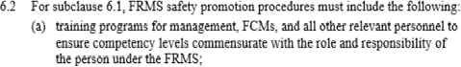

Fact Bank: Action 5-1: CASA response to independent review recommendation 5
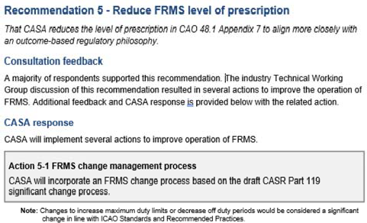

Fact Bank: Action 6-1: CASA response to independent review recommendation 6
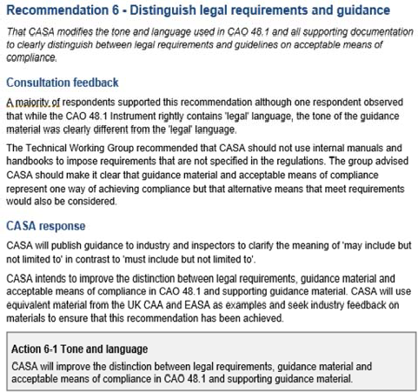

Fact Bank: Independent review report recommendation 5
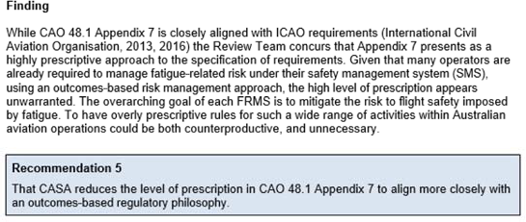

Fact Bank: Independent review report recommendation 6
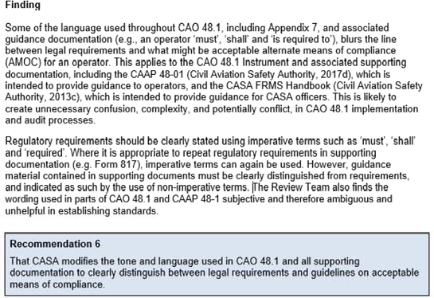

Does this proposal achieve the intended Actions 5-1 and 6-1?

Please select only one item
☐ yes
☐ some change/s required (please specify below)
☐ no (please specify below)
☐ not applicable

Comments?

Please provide feedback on specific ways to further improve tone and language in the draft CAO.
Comments

PAGE 11: Aerial application

This proposal permits aerial application (aeroplane) operators to continue operating in accordance with Subpart 137.Q of CASR in response to recommendation 8.

CASA Action 8-1: CASA intends to incorporate the intent of CASA EX92/16 – Exemption CAO 48.1 Instrument 2013 – aerial application operations (in aeroplanes) into an amended CAO 48.1.

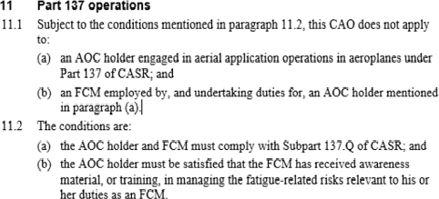
Fact Bank: Extracts from consultation draft - Part 1 Clause 11

PART 1 GENERAL

Fact Bank: Action 8-1: CASA response to independent review recommendation 8
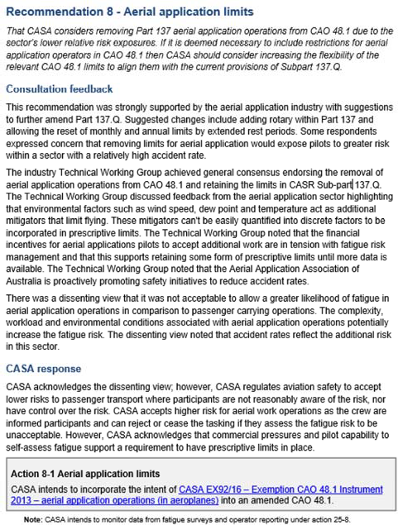

Fact Bank: Independent review report recommendation 8
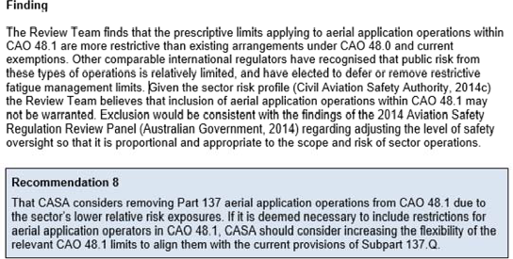

Does this proposal achieve the intended Action 8-1?
Please select only one item
☐ yes
☐ some change/s required (please specify below)
☐ no (please specify below)
☐ not applicable

Comments?

PAGE 12: Shared responsibility

This proposal aligns the shared responsibility between flight crew and operators in line with proposed measures in Part 91 of CASR, in response to recommendation 9.

CASA Action 9-1: CASA will update the CAO to reflect the dual responsibility provisions in the consultation draft of Part 91 of CASR.

Fact Bank: Extracts from consultation draft - sub-clauses 14.1, 14.2, 16.1 and 16.2

PART 1 GENERAL
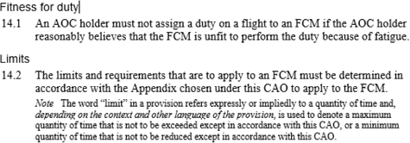
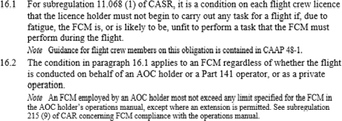

Fact Bank: Action 9-1: CASA response to independent review recommendation 9
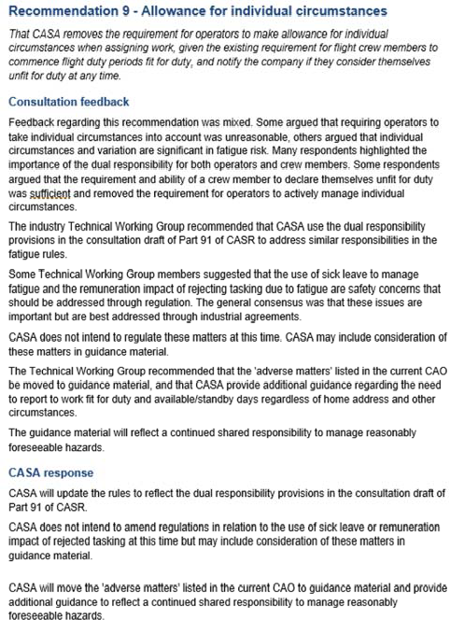
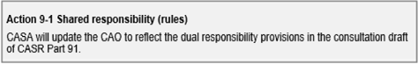
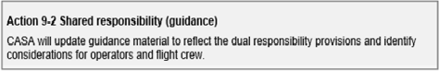

Fact Bank: Independent review report recommendation 9
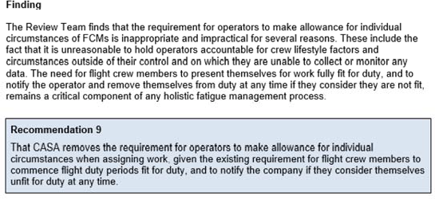

Does this proposal achieve the intended Action 9-1?

Please select only one item
☐ yes
☐ some change/s required (please specify below)
☐ no (please specify below)
☐ not applicable

Comments?

PAGE 13: Consolidation and transitional provisions

This proposal replaces existing fatigue rules to provide clarity of what rules apply and provides a staggered approach to implementation in response to recommendation 9.

CASA Action 18-1: CASA will update the website to clearly explain which rules and guidance apply. The legislative changes from this review will be incorporated into a single instrument.

The proposed instrument would repeal all existing fatigue rules while providing transitional provisions for existing operators. The transitional provisions aim to allow operators to continue operating to their current rules until the relevant transition date:

- 30 September 2019 for high capacity regular public transport operators that have not already transitioned to the new rules
- 26 March 2020 for other operators.

New operators would be required to comply with the proposed rules upon commencement of the rules.

Fact bank: Extract from consultation draft - Clause 4

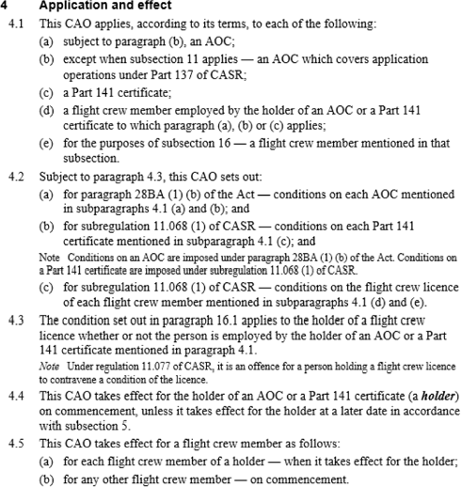
PART 1 GENERAL

Fact Bank: Extract from consultation draft - Clause 5
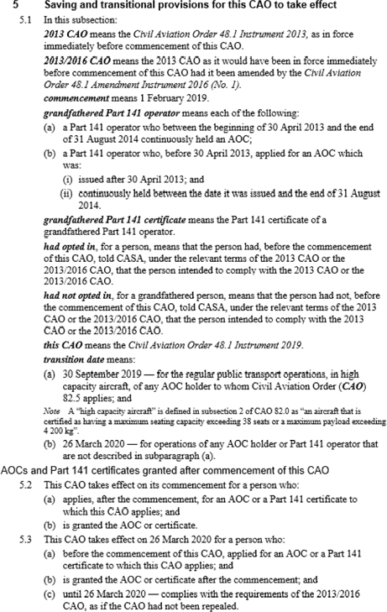
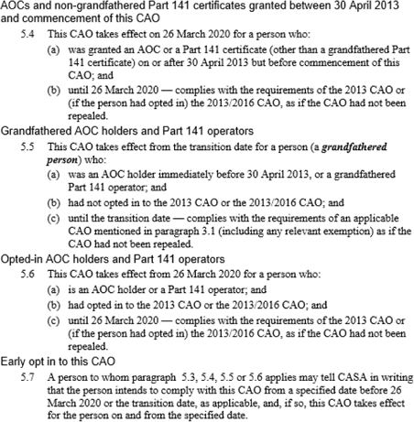

Fact Bank: Action 18-1: CASA response to independent review recommendation 18

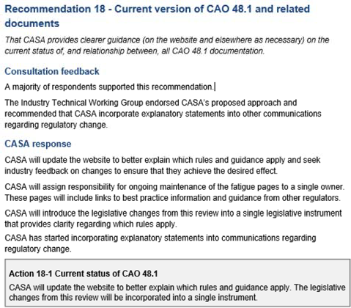

Fact Bank: Independent review report recommendation 18
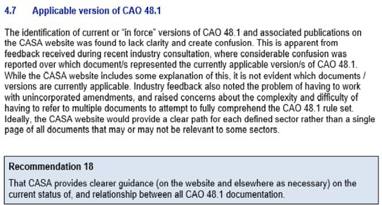

Does this proposal achieve the intended Action 18-1?
Please select only one item
☐ yes
☐ some change/s required (please specify below)
☐ no (please specify below)
☐ not applicable

Comments?

PAGE 14: Other changes

This proposal includes other minor changes.

Fact Bank: Extracts from consultation draft

PART 3 LIMITS and REQUIREMENTS
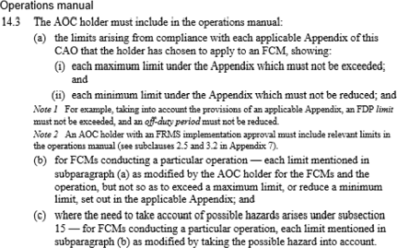
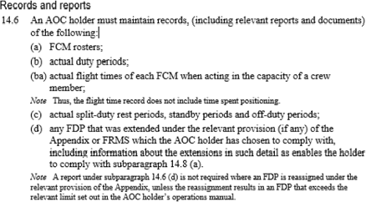
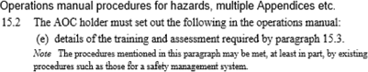

APPENDIX 1 — BASIC LIMITS
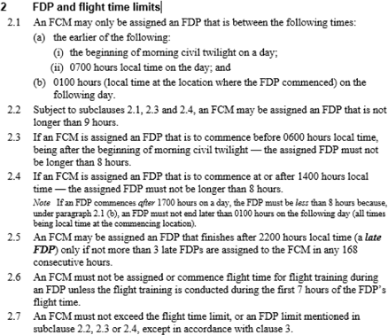

APPENDIX 5A — DAYLIGHT AERIAL WORK OPERATIONS AND FLIGHT TRAINING ASSOCIATED WITH AERIAL WORK
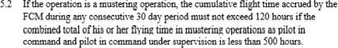

APPENDIX 7 — FATIGUE RISK MANAGEMENT SYSTEM (FRMS)

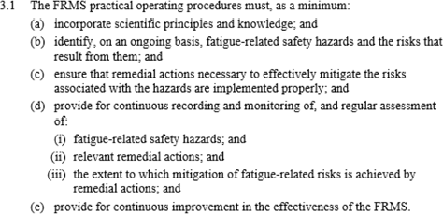

Do the minor changes introduce unintended consequences?

Please select only one item
☐ yes
☐ some change/s required (please specify below)
☐ no (please specify below)
☐ not applicable

Comments?

PAGE 15: Policy questions

Several issues were raised during the technical working groups that require further consideration. Industry input is sought to assist in resolving these issues.

TWG issue 19 – Days off when transitioning appendices

Background

The cumulative off-duty periods for operations under appendices 4B, 5 and 5A are less restrictive than other appendices. A problem arises when a flight crew member has been operating under one of these appendices and then seeks to operate under appendix 2 as they may not meet the cumulative off-duty requirements.

The simplest way to enable transitioning between appendices is to always meet the more restrictive cumulative off-duty requirements (ie 7 days off-duty in previous 28 days and 24 days off-duty in previous 84 days).

If this is not possible, Clause 13A provides a discounted method for meeting the 24 days off-duty in previous 84 days requirement.

Industry feedback has highlighted that this approach is overly complex. CASA is seeking industry input of alternative ways to meet this requirement.

Comments?

Alternative approach to transitioning appendices

Some operators have proposed an alternative approach to transitioning appendices by providing an opportunity for a limited flight duty period regardless of prior duty. This would permit flight crew members operating under Subpart 137.Q or appendices 4B, 5 and 5A to conduct limited passenger carrying or training flights without the need for an extended off-duty period. A potential approach is detailed below.

A flight crew member may conduct passenger transport operations following a period of operations under CASR Part 137.Q or Appendices 4B, 5 or 5A if:

  - the off-duty period undertaken immediately prior to the FDP was at least 12 hours including a local night
  - the previous FDP was less than 8 hours
  - the proposed FDP will be less than 8 hours.

CASA is seeking industry feedback on this approach.

Would this approach resolve issues related to transitioning between appendices for a single flight duty period?
Please select only one item
☐ yes
☐ some change/s required (please specify below)
☐ no (please specify below)
☐ not applicable
Comments?

TWG issue 22 – Split duty restrictions for charter

Background

A TWG member identified that the 6 hour limit on flight duty period following split duty in Appendix 2 subclause 4.5 was overly restrictive for some charter operations.

CASA is seeking industry feedback on:
- whether this is a broad issue and
- any proposed options for resolution.

Fact Bank: Extract from consultation draft - Appendix 2 Clause 4

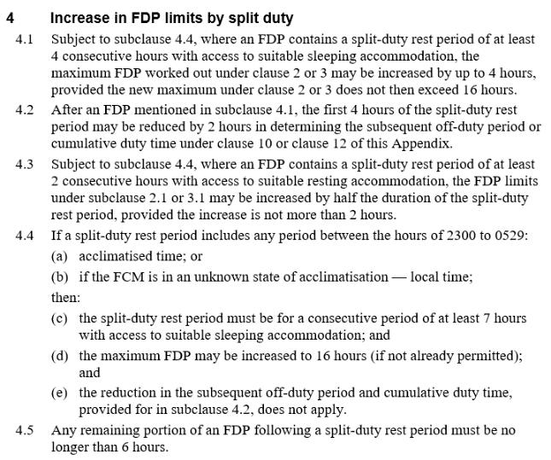

Comments?

TWG issue 26 – Flight crew working on casual day impacts future roster

Background
A TWG member identified a concern with the cumulative off-duty requirements in Appendix 2 clauses 10.5 and 10.6.

When crew accept a duty on a rostered casual day they may be inadvertently impacting future cumulative off-duty requirements that will prevent them fulfilling the remainder of the roster.

Some TWG members suggested that accepting duty on a casual day should be counted as an off-duty period, as if it were recreational flying. This was not broadly supported; however, CASA is seeking industry feedback.

Comments?

PAGE 16: General response

Are the proposed changes to the fatigue rules appropriate and can they be complied with by industry without undue burden?

Please select only one item
☐ yes
☐ some change/s required (please specify below)
☐ no (please specify below)
☐ not applicable

Comments?

Please identify any specific rostering issues that you expect due to these changes. Please provide as much information as possible to assist us to resolve potential issues. If required, attach any supporting documents on the final page of this survey.
Comments?

Are there any significant aviation safety risks which have not been addressed in the draft CAO 48.1 Instrument 2019?

Please select only one item
☐ yes (please specify below)
☐ no
☐ not applicable

Comments?

PAGE 17: Your priorities

When you reflect on the feedback you have provided throughout this consultation, what are the three matters you consider most important?
Priority 1
Priority 2

Priority 3

Additional documentation?

Please attach a copy of any documents you wish to include to this printout.
You may wish to upload a file as part of your submission. Select 'Browse' below and navigate to the file you wish to include. Please note pdf is preferred.

